Forum: Special Conference
Issue: Mitigating the effects of Greece’s debt crisis on the world economy
Student Officer: Gleb Tsikhanovich
Position: President of the Special Conference

Introduction
For the past two decades, Greece has been recovering from a major economic crisis. Troubles such as high unemployment rates, overwhelming taxes, and decreased public spending on welfare have plagued the Greek economy. Greece has the highest unemployment rate in all of Europe, totaling to about 22.3% as of 2020, the highest recorded was 27.8% as of September 2013.
When unemployment strikes, governments tend to support their unemployed population by increasing government spending on welfare programs. But Greece can only afford to spend a minimal amount on welfare programs since most of its government spending is directed towards paying off the massive debt that it has accumulated over the years.
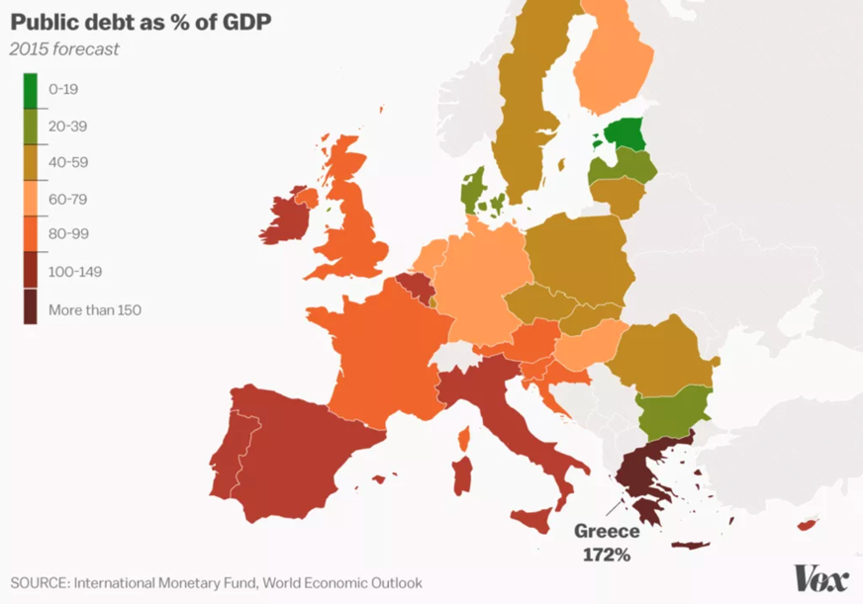
In cases of high unemployment or any economic downturn for that matter, governments have the option of stimulating the economy by manipulating their currency to boost consumer spending. This allows businesses and corporations to grow and hire more workers, therefore reducing unemployment rates. However, Greece is barred from doing so, because just like most nations in the European Union (EU), Greece uses the Euro as its official currency. Since the Euro is used across many nations issued by the European Central Bank (ECB), no particular government has control over it. This forbids Greece from enacting currency-related measures, such as quantitative easing which reduces its arsenal when it comes to maneuvering an economic crisis.

Table #1: Public debt as % of GDP in the EU by country as of 2015

Definition of Key Terms

Unemployment

A term that describes individuals that are actively seeking a job but are unable to find one. Unemployment is the most common measure of the ‘health’ of the economy.
Unemployment rate
An indicator that shows how many people are unemployed out of the total labor force, or the total number of people that are deemed physically fit to work. The unemployment rate is expressed in terms of percent.
Public spending
Money spent specifically by the government, through any of its entities or institutions.
Inflation
Inflation happens when the total demand in the economy increases too rapidly for the total supply to increase at the same rate. If supply doesn’t adjust quickly enough and the demand keeps rising, the prices may begin to increase at a rapid pace causing price inflation. This means that the value of the currency will depreciate causing people to afford fewer goods and services.
Monetary policy
Policy measures related to the money supply that a government can adopt in case of economic instability. With this policy, the government can manipulate public spending as well as interest rates. Monetary policy is split into two categories, expansionary monetary policy, and contractionary monetary policy.
Expansionary monetary policy
This type of monetary policy is used when the economy is ‘slowing-down’ or when the level of consumer spending in the economy is falling. The government can increase public spending and/or reduce interest rates. Public spending will create more jobs, as different projects will require labor, those workers can then spend the wages earned to stimulate the economy. The reduction in interest rates will allow more individuals and businesses to borrow money which they can spend on the purchase goods and services which will also serve as a stimulant for the economy.
Contractionary monetary policy
This type of monetary policy is used when the economy is ‘overheating’ or when the level of consumer spending is rising too rapidly, this can result in high inflation rates, as the total supply in the economy can’t meet the total demand. In this case, the government can reduce public spending and/or increase interest rates. Reduced public spending will discourage corporate activity, hence less spending. The increase in interest rates will encourage individuals as well as businesses to save more and spend less, which will also help ‘slow-down’ the economy.
Fiscal policy
A policy measure related to the tax system that a government can adopt in case of economic instability. With this policy, the government can manipulate government spending as well as tax rates.
Expansionary fiscal policy
This type of fiscal policy is used when the economy is ‘slowing-down’ or when the level of consumer spending is falling. In this case, the government can either increase public spending and/or reduce taxation. An increase in public spending will boost employment and increase spending. A reduction in tax rates will allow individuals and corporations to spend more of their incomes which will also stimulate the economy.
Contractionary fiscal policy
This type of fiscal policy is used when the economy is ‘overheating’ or when consumer spending is rising too rapidly, which can result in high inflation rates. The government can either reduce public spending and/or increase taxes. A fall in government spending will reduce firm activity, and an increase in tax rates will discourage individuals and corporations from spending.
Quantitative easing
A measure used by governments to reduce the value of the national currency, by increasing its total supply and issuing more banknotes, in hopes of increasing consumer spending in the economy.
Default
A default, in macroeconomic terms, is when a country’s government is either unable or unwilling to fully pay off its debt with interest in time.

History & Developments

The Early 2000s
In the late 20th century, Greece was classified as a wealthy, developed economy. It had a large tourism industry, one of the largest per capita in the world, with millions of tourists every year. Greece has a rocky terrain that is unsuited for any type of farming, as well as very few natural resources, but Greece adapted to this by developing a large services sector, with about 80% of the population working at a service-based job. But probably the most profitable industry that Greece had was the shipping industry. Having the largest merchant marine fleet, Greece’s shipping companies could ship supplies and products to large contractors. This meant that global trade was for the most part dependent on Greece and its shipping fleet.
The Euro
In 1999, the EU decide to launch a new currency, the Euro. It would be shared amongst all member nations of the EU who have met the requirements. This would help nations boost their economies as it would allow nations with weaker economies to rely on the currency’s strength and stability to attract investment. At that time, Greece was part of the EU, however, it failed to meet the proper requirements. Due to its low taxes, and high government spending, Greece had accumulated a large amount of debt. One of the requirements set by the EU was that nation had to have a debt of 60% or below of the total GDP, at the time Greece’s debt was 97% of the GDP. To bring this debt down the government would have to go through economic reforms and drastically cut down on spending. All of this would take a lot of time and effort, as for the people of Greece, this would mean fewer government benefits and higher income taxes. However, Goldman Sachs, a commercial investment bank based in the United States, proposed a solution and offered Greece a deal. Greece would legally mask their debt, by making currency swaps, and making it appear as if the debt has been reduced. This made Greece eligible for the Euro. But in reality, the debt was still there. Not only that, but it was now growing at an even faster rate because Goldman Sachs was lending Greece money at absurdly high-interest rates.
Globalization
The early 2000s was a time of rapid economic expansion as globalization was at its peak of growth. The transportation of goods, services, money, ideas, and information was faster than ever before. And due to its massive merchant marine fleet, Greece was one of the largest profiteers of rapid globalization, as it brought a large influx of profits and revenue for the country. Most countries at that time who were benefiting from globalization and large cash-flows decided to take a careful approach by raising the taxes and cutting down on public spending. This would ensure that if a crisis were to strike, they would have enough finance to stimulate their economy and prevent the economy from dipping too low. Greece on the other hand, took a much less conservative approach, and boosted public spending on a variety of social welfare programs and made large investments in all sorts of projects. On top of that, the government also decided to cut taxes and allowed people to spend money more freely while depleting their budget. This led to a large increase in debt, as the government was becoming more reliant on loans.

The financial crisis of 2008
When the global financial crisis struck in 2008, Greece was caught completely off guard. The government had been saving less money while investing in social welfare, wages, and firms, simultaneously keeping taxes low. Moreover, Greece did not have a strong domestic industry, as it heavily relied on large shipping fleets as well as its tourism industry. With the global recession, the need for shipping had fallen drastically, and people began refraining from making overseas trips, which caused Greece’s revenue to fall rapidly. As a result, money was becoming harder to come by to support the public welfare programs. Greece was in a dire position as the use of the Euro was preventing it from using quantitative easing to boost demand and increase prices, to stabilize the economy. With a falling revenue and negative budget, the government was forced to raise taxes, which only worsened the situation and dragged Greece farther into recession.

The early 2010s

In 2009 it was uncovered that the government has been hiding the real economic figures. The original estimate for the budget deficit, announced by the government, was 6.7%. However, in 2009 it was revealed that it was more than double that, amounting to around 15.4%. This caused the country’s credibility in the eyes of investors to fall. Borrowing costs increased, investors fled the country and a large amount of brain-drain began to occur. In 2010 Greece’s debt-to-GDP was at 127%. Fears of a Greek default began to emerge as it was becoming evident that Greece was sinking into debt. The European Commission (EC), the ECB and the International Monetary Fund (IMF) formed a group called The Troika in an attempt to prevent a Greek default. The Troika formed an agreement with the Greek government, it would lend Greece 110 billion Euros, which Greece would use to pay off some of its bigger debts. Greece also agreed to raise taxes, and reduce government spending, which reduced its budget deficit. This was a great risk as increasing taxes and reducing public spending during a recession, would drag the economy into an even greater recession. But Greece had no option since this was the only way to prevent a default. On May 4th,2010, the new policy was launched but with negative consequences. The increase in taxes and fall in public spending, unsurprisingly pulled the country deeper into a recession as Greece’s GDP plummeted even more. The government had no choice but to start borrowing again, which resulted in the dept-to-GDP increase from 127% to 172%. In light of this, The Troika decided to come up with a new strategy. This time, they would lend Greece another 130 billion Euros to pay off creditors, whom, after negotiations, decided to cut Greece’s IOU (a document that acknowledges the debt owed) by 53.5%. This allowed Greece to pay off less of its debt. To balance out the budget, the Greek government still had to raise taxes and reduce public spending. Two years following the program’s launch in 2012, Greece’s government began reporting a budget surplus. However, the high taxes, falling wages, and rising unemployment rates caused the people in Greece to revolt. These protests were against The Troika’s brutal economic terms because people were being dragged further into poverty. In 2015 when the party elections occurred, the Greeks elected the Syriza party, a party that promised to reduce taxes, raise government spending and re-negotiate terms with The Troika. Tensions between The Troika and Greece rise as Greece stops abiding by the terms and begins to rapidly boost public spending. Amidst this, creditors flee Greece once again. Unable to secure any finance, and with an incredible amount of debt, Greece finally defaults, missing 1.6 billion Euros to the IMF. Short on finance, the government began to shut down state facilities, the stock exchange, and the banking system. On July 16th, 2015, with no more leverage for negotiation the Greek government accepts 86 billion Euros from The Troika, with an agreement to increase taxes and reduce public spending, once again dragging its populace into poverty.

Conclusion

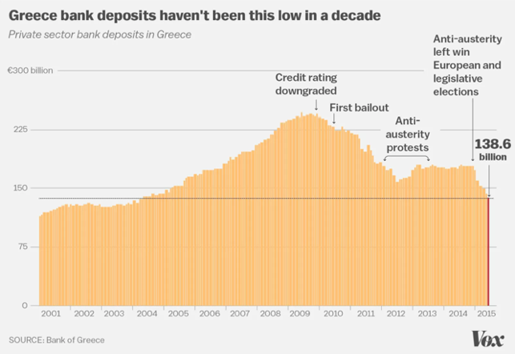
All in all, as a result of the crisis, up until 2015, Greece’s real GDP had fallen by 25%. In 2015, Greece’s financial agreement with The Troika elapsed, with divided opinions on whether the terms have helped the economy or not. The economy remains in a shattered state, with a debt-to-GDP at 180%, 1 in 3 Greeks remain at risk of living in poverty.

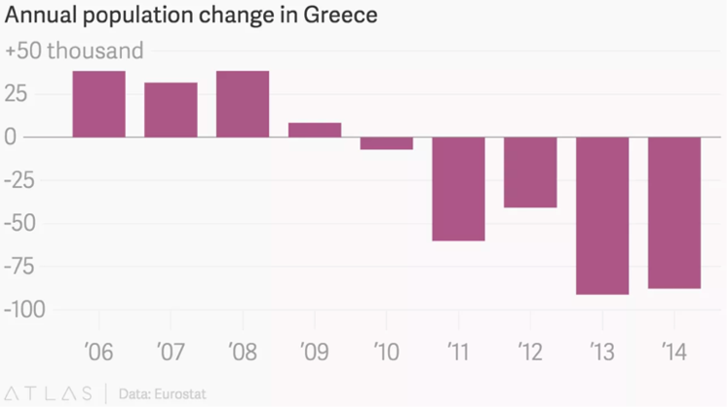

Table #2: Greece’s annual population change (2006-2014) Table #3: Annual commercial bank deposits in Greece (200-2015)

Geopolitics
Throughout the Greek economic crisis, Greece and The Troika have been at the epicenter of a disaster, with Greece suffering the most damage to its economy. However, Greece wasn’t the only victim of its crisis, as some of the EU states have also suffered the consequences.

Greece
Greece has been the main focus of this crisis from the very start. The Greek government spent a large portion of its revenue on welfare, healthcare, and wages, and made large investments into numerous projects while lowering taxes. This goes against all the rules of economic policy. After the acquisition of the Euro, Greece fueled this reckless expansion even more. Due to the increase in trade, Greece experienced growth and benefits, but it did not increase its savings for the future. When the economic crisis of 2008 struck, Greece was unable to recover as it didn’t have enough finance to boost its economy and recover from a recession. The fall in GDP forced Greece to borrow more money to finance itself, and the Euro was preventing it from stabilizing via quantitative easing. After 3 bailout attempts, social and political unrest, Greece is on its way to a very long recovery.

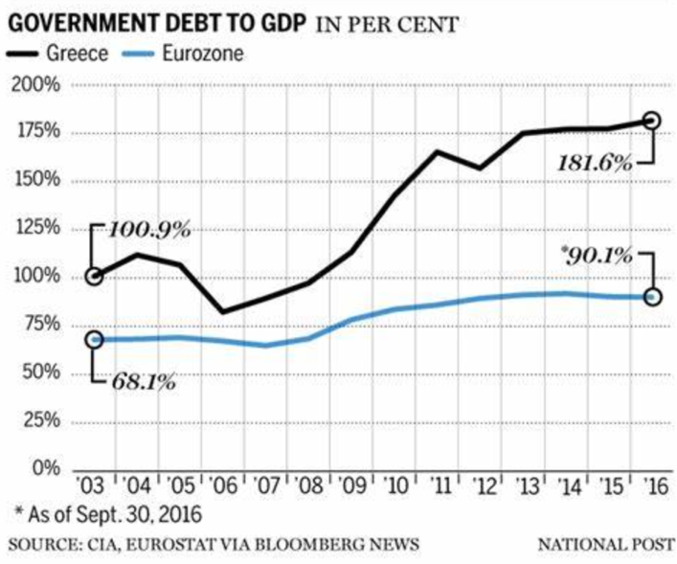

Table #4: Greece’s debt-to-GDP ratio from 2003-2016

The Troika
The Troika is an organization consisting of the EC, the ECB, and the IMF. This was the first organization that tried to save Greece from an economic downturn and a debt default. The Troika intended to prevent Greece from defaulting on its debts and leaving creditors without their money being returned. In addition to that, most countries in the EU all use a shared currency, and if one country is experiencing a major economic downturn, it can have an impact on the value of the currency, which causes other nations to experience economic instability and a fall in investor trust. The issue is that at the time it wasn’t just Greece that was undergoing a severe recession. Spain, Portugal, and Ireland were all in a similar situation. Also, The Troika attempted to prevent a widespread Eurozone crisis, by encouraging economic reforms and handing out bailouts to the more economically unstable nations.

Goldman Sachs

Amongst other banks, Goldman Sachs was the primary instigator of the legal currency swaps that allowed Greece to mask its debt, and receive an approval for the acquisition of the Euro. In exchange for the currency swaps, Greece borrowed money from Goldman Sachs and under a very large interest rate, which only worsened Greece’s debt crisis. Goldman Sachs was aware of all the issues that Greece could suffer as a result of this deal, but their only interest was to profit from Greece’s misfortune.

Germany
Greece and Germany have a long history of disputes and disagreements. When Nazi Germany invaded Greece in 1941, with large casualties from warfare and hunger as Greek banks were preoccupied with funding the war. In addition to that, the Germans massacred an additional 200 000 Greeks in 1944, as punishment for the deaths of 7 Nazi soldiers. After the war, in 1960 Germany paid Greece 60 million Euros as compensation and for war reparations. Greece however, insisted that Germany owed them much more. In 1997 a Greek court proved that Germany still owed more compensation for the 1944 massacre. In 2012, The Hague established that Germany could no longer be held financially accountable for the war damage, and was immune from lawsuits in this regard. In 2015 the Greek Prime Minister claimed that the 279 billion Euro compensation paid over by Germany for the 1944 massacre would cover the majority of the foreign debt that Greece had accumulated. Germany denying this, as it was immune from any World War II-related lawsuits. Greece, then threatened to cease German property, claiming that it would act as additional compensation for the war damage.

European Union

Despite Greece being the main victim of its debt crisis, the EU was also in a very undesirable position. The Greek economy as it is at the moment, is very weak and unstable, which tends to weaken and cause currencies to fluctuate. And even though the Euro can maintain its stability and strength through other powerful economies like Germany or France, Greece’s impact still cannot be ignored. Moreover, small fluctuations that Greece has on the Euro can harm strong economies like Germany and France, as it can tamper with the supply and demand of these countries. Constant and unpredictable fluctuations in the currency will discourage investors from pouring in money into EU countries, and fewer foreign firms would want to set themselves up in the Eurozone. This can lead to countries of the EU to have sluggish economic growth and brain drain, as business conditions will become stale with fewer opportunities for growth and development.

Previous Attempts to Solve the Issue
The first attempt to solve the Greek economic crisis was a bailout proposed by the Troika in April of 2010. The Troika lent Greece 110 billion Euros so that it could pay off its debt to the more expensive and influential creditors. This allowed Greece to reduce its debt burden on GDP preventing a default and closing off government facilities such as schools and hospitals. However, the Troika also set harsh conditions along with the bailout money, Greece was to dramatically cut on government spending and increase taxes. The Troika and the Greek government were both aware that the following actions may only worsen the recession, as contractionary economic policy, is specifically used to slow down the economy. But this was the only alternative since Greece’s priority was to pay off its debts, therefore it needed at least some budget surplus. In the end, the bailout attempt failed, as high taxes and low government spending hampered economic growth even further, reducing the GDP by a large margin, increasing the debt-to-GDP percentage from 127% to 172%. The Troika had no choice but to propose another bailout program.
In February of 2012, the Troika launched the largest sovereign debt restructuring in history. By carrying out negotiations with numerous large creditors, the Troika managed to convince the creditors to cut Greece’s IOU by 53.5%, which would forgive Greece more than half of its debt, allowing it to pay it off much faster. The Troika would also lend Greece another 130 billion Euros to pay off its debts, and reduce public spending to near zero and further increase taxes to help bring back a budget surplus. The program was successful but it exerted a burden of economic pressure on the Greek population. Incomes were low, taxes were high, and public spending on social security and welfare was minimal. After two years of tax and fiscal reforms, wage cuts, and layoffs, Greece began reporting a budget surplus.

Relevant UN Treaties and Events
- External debt and development: towards a durable solution to the debt problems of developing countries, 3 February 2009 (A/RES/63/206)
- Recovering from the world financial crisis: a Global Jobs Pact, 23 July 2010 (E/2010/64)
- External debt sustainability and development, 4 February 2011 (A/RES/65/144)

Possible Solutions
Even though Greece’s lack of foresight and planning before the economic crisis was the primary cause of its downfall, a large portion of the blame can be put on the Euro. While it was optional for Greece to acquire the Euro, it was still heavily influenced, as most of the EU nations at the time, except for the United Kingdom (UK), have received permission to adopt the Euro as an official currency. The Greek government also had acquired the Euro prematurely, by masking its debt with the help of Goldman Sachs. This has been one of the biggest causes of an economic crisis in Greece since the government’s hands were tied when it came to monetary policy and economic stimulus. Today, ten years after the crisis, the Greek government is still struggling to provide the economic stimulus needed to boost the economy and bring it out of a recession. The solution seems obvious, Greece should stop using the Euro as its national currency and return to using its own currency. This solution will be much more flexible to the fluctuation of the weaker Greek economy and it will allow the Greek government to provide the correct stimulus needed via quantitative easing. This will also be a smaller burden for the EU, as Greece will no longer drag the euro and the eurozone along with it which will make the euro a much more stable and strong currency.
Another solution would be to discourage private lenders such as commercial banks and investment firms to hand out loans to Greece, and only allow Greece to borrow money from trusted international parties such as the World Bank and the ECB, or by selling off government bonds, as a means of borrowing money from the public. This would protect Greece from exploitations and prevent it from falling into another debt trap like it did in the case of Goldman Sachs, where the investment fund was profiting off of Greece’s misfortune and charging unreasonably high-interest rates.
Lastly, a solution that could help both Greece, the EU, and potentially the world is for EU member states as well as UN member states to support Greece economically by making use of its goods and services. For instance, nations can use Greek ships to transport goods, make arrangements for cheaper and more efficient trade routes, promote tourism in Greece, and ease trade restrictions on Greek imports. All of this will help Greece boost its economy, and allow it to recover from the crisis.

Bibliography
Altman, Daniel. “Foreign Policy: 5 Easy Solutions To The Greek Crisis.” NPR, NPR, 18 May 2012, www.npr.org/2012/05/18/152990481/foreign-policy-5-easy-solutions-to-the-greek-crisis
Amadeo, Kimberly. “Understand the Greek Debt Crisis in 5 Minutes.” The Balance, 18 May 2020, www.thebalance.com/what-is-the-greece-debt-crisis-3305525
Bostan, Yahya. “Greece's Burden on EU Citizens.” Daily Sabah, Daily Sabah, 29 June 2020, www.dailysabah.com/opinion/columns/greeces-burden-on-eu-citizens
Chappelow, Jim. “Monetary Policy Definition.” Investopedia, Investopedia, 21 Apr. 2020, www.investopedia.com/terms/m/monetarypolicy.asp
Chappelow, Jim. “Unemployment.” Investopedia, Investopedia, 7 Apr. 2020, www.investopedia.com/terms/u/unemployment.asp
“The Greek Crisis: How the European Union Got the Euro Wrong.” International Policy Digest, 14 July 2020, www.intpolicydigest.org/2020/07/13/the-greek-crisis-how-the-european-union-got-the-euro-wrong/
“The Greek Debt Crisis Story in Numbers.” BBC News, BBC, 10 July 2015, www.bbc.com/news/world-europe-33407742
Klein, Ezra. “Greece's Debt Crisis, Explained in Charts and Maps.” Vox, Vox, 1 July 2015, www.vox.com/2015/7/1/8871509/greece-charts
The New York Times. “Explaining Greece's Debt Crisis.” The New York Times, The New York Times, 17 June 2016, www.nytimes.com/interactive/2016/business/international/greece-debt-crisis-euro.html
Picardo, Elvis. “The Alpha and Omega of Greece's Debt Crisis.” Investopedia, Investopedia, 9 Apr. 2020, www.investopedia.com/articles/personal-finance/061115/origins-greeces-debt-crisis.asp

