Forum: Security Council II
Issue: Reevaluating the extent to which states can conduct unilateral humanitarian interventions
Student Officer: Claire Yin
Position: President of Security Council II

Introduction
The extent of humanitarian interventions has always been a topic of debate. Whether a state is intervening solely on behalf of human welfare or for its own interests is a rather controversial question. Another question raised is whether a unilateral intervention infringes upon national sovereignty. It can be argued that a degree of humanitarian intervention is needed at times, but on whose account? The use of military forces in humanitarian interventions often inflicts more harm than good. However, if an intervention is successful---do the ends justify the means? Does a threat to human rights justify the use of military force against the inflictor? Since the creation of the United Nations, the international community has had an obligation to end violations of human rights. Today, the international community has not yet found a way to balance the responsibility to protect the innocent with an abstinence from violence and the respect for national sovereignty.

Definition of Key Terms
Unilateral humanitarian intervention
Unilateral humanitarian interventions are military interventions conducted without the agreement of the specific country/region, including the UN Security Council. The interventions are done in order to preserve human welfare in the specific country/region. The military aspect of the intervention is used to protect civilian population from war crimes and violations of human rights such as: mass murders, ethnic cleansing, genocide, and rape.
Sovereignty
Sovereignty is a nation’s right to govern itself and maintain autonomy. State sovereignty is outlined in Article 51 of the United Nations Charter.
War crimes
A war crime is an action conducted during war that violates the international laws of war, as outlined in the Rome Statute of the International Criminal Court. War crimes include: crimes against peace, murder, ill-treatment, deportation, and genocide.
Responsibility to Protect (R2P)
The Responsibility to Protect is defined by its three main pillars: “Pillar One: Every state has the Responsibility to Protect its populations from four mass atrocity crimes: genocide, war crimes, crimes against humanity and ethnic cleansing. Pillar Two: The wider international community has the responsibility to encourage and assist individual states in meeting that responsibility. Pillar Three: If a state is manifestly failing to protect its populations, the international community must be prepared to take appropriate collective action, in a timely and decisive manner and in accordance with the UN Charter.”
United Nations Charter
The UN Charter is the treaty on which the UN was founded on. The charter includes articles addressing the goals and limitations of the UN. The concept of state sovereignty, established by the UN Charter, is undermined by unilateral humanitarian interventions because of the lack of UN authorization.

History & Developments

The start of humanitarian interventions
Preceding the founding of the United Nations, humanitarian interventions occurred throughout the global community. Religious rivalries fueled most of the foreign interventions in the name of sending humanitarian aid. In 1877, during the Russo-Turkish War, the Russians sent a military force to Bulgaria to protect it from the Ottoman Empire. Prior to Russian intervention, Bulgarian uprisings were harshly put down by Turkish armies, and numerous massacres and war crimes were committed. Consequently, Russian military entered Bulgaria to protect civilians against the Turkish and Ottoman armies.
In 1898, the United States conducted its first “humanitarian” intervention in the Spanish American War. The US supported the Cubans in their fight for autonomy from the Spanish. The US intervention was justified by humanitarian efforts to “protect” the Cubans from the Spanish. However, after defeating the Spanish with the Treaty of Paris, the US’ ulterior motives became visible. The United States gained control of Puerto Rico, Philippine Islands, and Guam. For Cuba, the US passed the Platt Amendment which allowed the US to establish military bases in Cuba (Guantánamo Bay) and maintain a military presence in Cuba. As a result, the US gained territory and military power from intervening in the war.
In 1945, the United Nations was established with the UN Charter. The UN was created with intentions to maintain global peace and security. Under the UN Charter, UN member states are responsible for protecting human welfare and promoting international stability, but with the limits of having to respect other states’ sovereignty; as a result, state-conducted unilateral humanitarian interventions became a question of legality.

Cold War

The Cold War lasted from 1947 to 1991 between the US and the Soviet Union (presently Russia) and its proxies, the Western bloc nations (US and NATO) and the Eastern bloc (Soviet Union, East Europe). It reflected the geopolitical tensions between the United States and the Soviet Union post-World War II, grounded in an ideological conflict between democracy and communism. The United States practiced the policy of “containment”, in which the US used military force and interventions on the basis of humanitarian aid to contain the spread of communism. The Truman Doctrine provided aid to Turkey and Greece to limit the influence of the Soviet Union. The Marshall Plan provided economic assistance to Western Europe after World War II. However, the tensions between the US and Soviet Union escalated into a proxy war. Both nations used human rights violations to justify the need for humanitarian intervention.

Korean War

The Korean War began as a civil war between the Democratic People’s Republic of Korea (North Korea) and the Republic of Korea (South Korea). In June 1950, the civil war became grounds for a proxy war for the two Cold War nations, the US and Soviet Union. The Soviet Union provided aid to North Korea. The involvement of the United States can be justified as a "humanitarian intervention”. From the perspective of the US, communism was a threat to freedom and democracy. The US military sought to preserve the freedom and democracy of South Korea by entering the war against North Korea. Although the United States entered the war on behalf of the UN Security Council, the US national interest in maintaining its position in the Cold War outweighed its reasoning of protecting human rights from communism.

Vietnam War

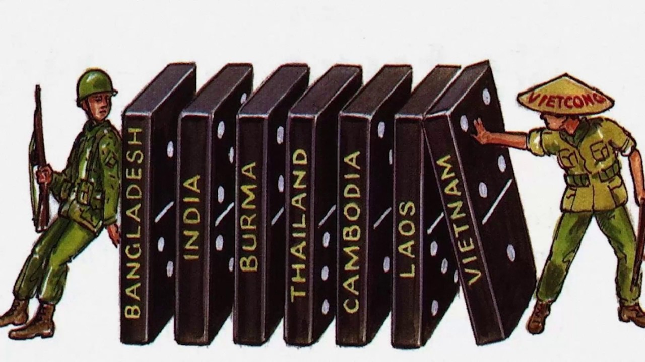
The United States once again used the claim of fighting for independence and liberty to justify its intervention in the Vietnam War. The communist Viet Cong was support by the Soviet Union, thus the US intervened in support of the South Vietnamese, in order to protect the nation from the threat of the communism. The intervention only caused more threats to human welfare in Vietnam. The US used napalm, a chemical weapon used to start fires, and Agent Orange, a chemical herbicide used against guerilla warfare, which led to civilian casualties. The United States believed that the intervention was essential to prevent the domino theory from taking place in Southeast Asia, which claimed that if one Southeast Asian nation fell to communisms, the remaining nations would follow and become communist (see figure 1). Whereas, in reality the support provided served the interests of the United States global position. The United States intervention ultimately failed, resulting in 58,000 casualties and lasting health issues in Vietnam.
Figure #1:Cartoon depicting the 'domino theory'

Humanitarian intervention in the Cold War

Political ideology blurs the lines of unilateral humanitarian intervention. The proxy wars of the Cold War demonstrate how political ideology can cause a state to intervene on behalf of social welfare. However, the sovereignty of nations is disregarded in the process. The United States reasoned that the interventions in Korea and Vietnam were to protect the civilians from the threat of communism. The US supported democratic ideologies and viewed the communist ideology as a threat and felt the need to intervene. The Cold War saw the United States and Soviet Union compete for global superpower through the development of nuclear weapons and intervention in foreign conflicts.

Lack of humanitarian interventions

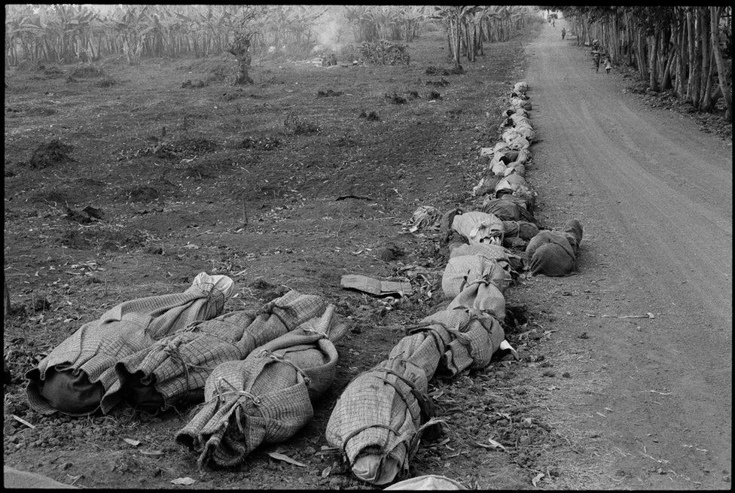
The call for humanitarian intervention increased during the early 2000s because of past failures to prevent threats to human rights. The Rwandan Genocide in 1994 marked the international community’s failure to respond to the massacre and war crimes committed. The genocide was preceded by lingering ethnic tensions between the Hutu and Tutsi minority group in Rwanda. A civil war broke out in Rwanda after the death the Hutu President. The genocide witnessed 800,000 Tutsis killed by Hutus in a span of one hundred days (see figure 2). The UN failed to intervene during the mass murder of hundreds of thousands of people. Only after the genocide had begun, the UN SC voted to send peacekeeping troops to Rwanda. Despite peacekeeping troops sent in by the UN Security Council, the peacekeepers made little positive impact in protecting the Rwandan civilians. The peacekeeping troops withdrew after facing casualties without making any significant progress towards ending the genocide and war. The international community did not send any aid to protect the welfare of the Rwandans, the United States and United Kingdom were informed prior to the genocide but both refused to send aid. The consequences of the Rwandan genocide proved the need for a degree of humanitarian intervention, but throughout the following years the lack of willingness from nations is evident.
Figure #2: Bodies of Tutsis in Rwanda

“Successful” humanitarian interventions

Unilateral humanitarian interventions remain controversial not only because of its violation of state sovereignty, but also because of the complexity of its outcomes. The successes of these interventions are often only measured by one side of the conflict, commonly the side receiving foreign support; hence, determining the success of an intervention often favors the intervening state. Therefore, no outcomes of interventions can be considered entirely “successful” despite seemingly positive results.

India in Bangladesh

India’s intervention in the Bangladesh Liberation War demonstrates positive results from humanitarian intervention. The Bangladeshi War began in 1971 and was an independence war against East Pakistan. During the war, the Pakistani army conducted mass murder, rape, and genocide. The bordering nation, India, intervened on December 3, 1971, and only 13 days later the war ended with Bangladesh’s independence. India’s support for Bangladesh in the war resulted in Bangladesh’s independence and end of the genocide and war crimes. However, India’s involvement in the war reveals other motives driven by national interest. Firstly, India’s geopolitical situation as a neighboring country of both Bangladesh and Pakistan provided reason to intervene. Prior to Indian troops in Bangladesh, the Pakistani forces grew in Bangladesh which posed as a threat to Indian borders. Consequently, India joined the war in support of Bangladesh to defend its borders and minimize the Pakistani threat. Secondly, India’s conflict with Pakistan would be a reason to want to intervene in order to weaken Pakistan. However, despite the national interests present in India’s intervention in the war, the intervention ultimately proved to be a successful humanitarian intervention.

NATO in Kosovo

NATO’s intervention in the Kosovo War in 1999 marked another successful intervention, this time by an alliance of nations. The Kosovo War began in 1998 with an armed conflict between ethnic Albanians and the ethnic Serbs and Yugoslavia government. During the war, the Yugoslavian and Serb forces practiced ethnic cleansing of Albanians and caused a flood of refugees to leave the region. The horrors of the war reached the international stage; as a result, the UN Security Council imposed an arm embargo, but the bloodshed continued.

Within the UN Security Council, NATO members attempted to call for action, but China and Russia opposed. Consequently, without UN SC authorization, NATO members agreed upon Operation Allied Forces. The objective of the operation was to end the war crimes committed by the Yugoslav forces, and ultimately end the war. On March 24, 1999, NATO launched air strikes on Yugoslav military bases. NATO members Italy, Germany, and the United States contributed aircraft and supplies for the bombings.

After a 78-day campaign of bombings, Yugoslavia and NATO signed a peace agreement, marking the end of the Kosovo War. Although the NATO airstrikes helped end the war, the bombings caused severe destruction to infrastructure and civilian casualties. Following the end of the war, the UN Security Council adopted UNSCR 1244 which mandated Kosovo Force (KFOR) led by NATO to enter Kosovo. The KFOR operation aimed to support peace in Kosovo and ensure public safety. The operation continues its role in peacekeeping in Kosovo today, with troops provided by NATO nations including USA, UK, and Italy. Despite the success of the NATO airstrikes, the legality of the unilateral humanitarian intervention remains debated.

Failed humanitarian interventions

Certain past humanitarian interventions have seemed to be “successful”, but many interventions have also been failures. This is because of the national interests behind humanitarian interventions, the nations intervening often do not take responsibility for the aftermath caused by the intervention.

United States in Iraq

The 9/11 attacks in the United States by the al-Qaeda terrorist group ignited the “War on Terror” against Middle-Eastern nations. In 2003, the “War on Terror” began with an invasion of US troops in Iraq authorized by President George W. Bush. The US invasion in Iraq was conducted outside of the UN because of the Security Council’s failure to achieve an agreement over the aftermath of the 9/11 attacks. The US government justified their means for an intervention with speculation that Saddam Hussein, the President of Iraq at the time, possessed or was in the process of obtaining weapons of mass destruction (WMD). However, after invading Iraq, the United States did not find any evidence of WMDs; therefore, the entire intervention was based on unjustified reasons.

In 2011, after facing casualties, the United States officially withdrew from Iraq. After Hussein’s capture by the US, the nation was left in shambles with an unstable government and deteriorating economy. The instability of the government led to a rise in sectarian conflict between Shias and Sunnis. Violent insurgent groups began to grow within the nation, not only committing atrocious war crimes on civilians, but also causing millions to be displaced. Despite the end of Hussein’s dictatorial rule in Iraq, the United States contributed to causing even more violations of human rights in Iraq that continue today.

Somali Civil War

The Somali Civil War began in 1991 and is an ongoing conflict today. The war broke out because of a collapse in the government that led to clan-based warfare between warlords. By 1992, around 350,00 Somali civilians died. Consequently, the United Nations authorized Operation Restore Hope, a military mission to help Somalis. The United States led the operation through protecting civilians and providing supplies and food. However, after two US helicopter were shot down the US ended the operation and formally withdrew troops. The mission failed to restore hope and end the dangerous fighting in Somalia. Following the end of Operation Restore Hope, warlords continued to wage war causing the death of thousands of Somalis.

Recently, the United States have conducted unilateral strikes in Somalia against extremist groups. The US intervention in Somalia began in 2013 with a small number of troops working with the new Somali government to fight extremist groups. However, since 2017 with President Trump’s administration, the US has been increasing airstrikes in Somalia. According to an Amnesty International researcher, “due to the nature of the attacks, the U.S. government is violating international humanitarian law and these violations may amount to war crimes." Although the airstrikes claimed to be targeting extremist groups in Somalia, evidence has shown that the airstrikes killed civilians without ties to the extremist groups.

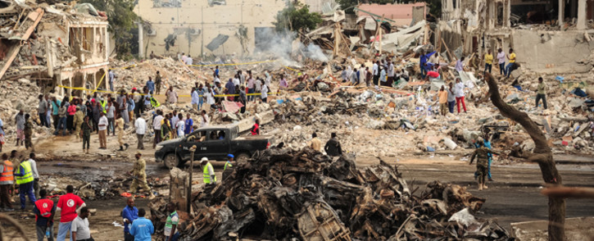
Currently, Somalia is still in a state of unrest and insecurity. Within the nation the number of displaced people has reached an estimate of 2.7 million. The warring forces have committed and continue to commit war crimes against civilians, including the abuse of children, rape, and sexual violence. Outside of war and violence, Somalis are facing famine and drought. It is estimated that a total of 500,000 people have been killed in Somalia since 1991. Despite the past UN attempts and other nations’ intervention in the war, Somalis continue to face threats against their welfare and violations of human rights every day.
Figure #3: Homes destroyed because of the war in Somalia

Current humanitarian interventions

The conflict in Syria began with peaceful uprisings against President Bashar al-Assad. The “Arab Spring” in neighboring countries contributed to the eruption of uprisings in Syria during 2011. The government responded to the protests with military force, turning the peaceful protests into a full-scale civil war. As the war continued, the existing tensions between Shia Muslims and Sunni Muslims escalated. According to the Violations Documentation Center, violations of human rights and international humanitarian law were recorded.

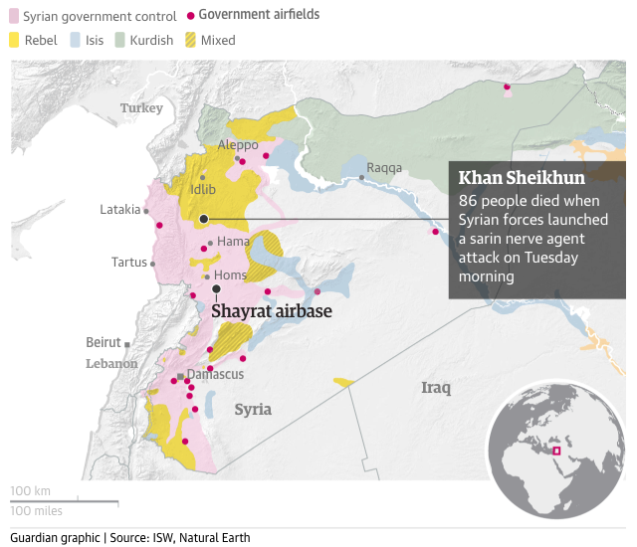
Currently, the main forces in the nation are the Syrian government, Syrian National Army, Islamic State of Iraq and the Levant, and international forces. International involvement in the war started in 2015, with Russia supporting President Assad and the Syrian government. Following Russia’s involvement in the war, Iran, Israel, Qatar, Turkey, Saudi Arabia, and the United States intervened with troops and support for different groups. The humanitarian crisis in Syria has resulted in a displacement of 7.6 million Syrians and a civilian death toll of 200,000.

The use of chemical and biological weapons (CBW) in Syria have incited President Donald Trump and the US government to consider launching more airstrikes in Syria to combat the “affront to humanity.” In 2017, the United States under President Trump had already launched 59 missiles on a Syrian Government controlled air base, Shayrat. The reasoning behind the airstrike was for the “national security interest of the United States to prevent and deter the spread and use of deadly chemical weapons”, as Trump stated. Once again in 2018, the US, with support from Britain and France, launched a missile strike on Syria due to suspicion of chemical weapons. Both airstrikes were conducted without UN SC authorization because of Russia’s threat of vetoing. However, the past and potential airstrikes cannot be considered fully as unilateral humanitarian intervention as the United States has refused asylum to hundreds of Syrian refugees. Similarly, other countries involved in the war are not acting solely for humanitarian reasons, but also for national interests.
Figure #4: 2017 Shayrat missile strike map

Geopolitics

United States of America
The United States stands at the center of humanitarian interventions. The origins of the nation being built on liberty and freedom has fueled the nation to intervene in many foreign fights for independence, such as Vietnam and Korea. All the interventions that the US claims are for the welfare of the people have underlying motives in line with national interests.
The United States “War on Terror” led by former President George W. Bush following the 9/11 attacks can be considered a humanitarian intervention. The US sent military troops to Iraq and Afghanistan. Despite the lack of approval from the UN Security Council, the United States invasion in Iraq claimed that it was protecting the entire world from the alleged weapons of mass destruction possessed by the Iraqi President. As a result of the “humanitarian” intervention by the United States, around 400,000 Iraqi civilians were killed.
The United States primary interest in humanitarian interventions have been motivated by political interest rather than humanitarian reasons. The tension between the United States and Russia over political ideologies has led to multiple “humanitarian interventions” in the form of proxy wars.

Russian Federation
Russia’s involvement in humanitarian interventions have primarily been due to geopolitical concerns. Many of Russia’s interventions have led other nations to respond, especially the United States. However, Russia’s use of vetoes in the UN Security Council— notably Kosovo, Libya and Syria— have reflected concerns with state sovereignty in interventions. As a result of Russia’s vetoes/threats to veto, other nations and organizations such as NATO have been compelled to send military force outside of UN authorization.

North Atlantic Treaty Organization
The North Atlantic Treaty Organization is a military alliance created in 1949 after World War II and currently consists of 29 European and North American countries. Its creation is meant to “to safeguard the freedom and security of all its members by political and military means.” NATO’s collective defense clause stipulates that “an attack against one Ally is considered as an attack against all Allies.” This principle article allows for NATO nations to set up standing forces in other NATO nations.
NATO has conducted several humanitarian interventions outside of the UN’s authorization. Most of its troops and military equipment are supplied by the United States. However, NATO’s role in intervening generally all have reasons for self-interest, especially geopolitical interests. The neighboring nations and geopolitical stability proved to be in NATO’s interest during its humanitarian intervention in the Kosovo War. NATO’s unilateral humanitarian interventions have mainly been caused by Russia’s veto threats on resolutions to intervene in the UN Security Council.

Previous Attempts to Solve the Issue
The issue of the legality of unilateral humanitarian intervention has been debated. But due to the interchangeable definitions of humanitarian interventions, the UN Security Council has been unable to create boundaries to the interventions.

Responsibility to Protect (R2P)
At the 2005 World Summit, a global commitment to the Responsibility to Protect (or R2P) was affirmed by member states of the United Nations. Due to the international community’s failure to respond to genocides in Rwanda and the Balkans, the concept of the Responsibility to Protect was created. The R2P seeks to address genocide, war crimes, crimes against humanity, and ethnic cleansing (Global Centre for the Responsibility to Protect). The establishment of R2P marks the only progress towards limiting the use of “humanitarian” military interventions.
However, R2P differs from the idea of humanitarian intervention. R2P focuses on the duty of a nation to protect its own people, whereas humanitarian intervention refers to the use of military force and focuses more on the right to intervene. Despite the differences, the third pillar of R2P brings controversy because of its vagueness in defining “appropriate collective action”, in which military intervention could be justified. As a result, the R2P has not proved to be completely successful in establishing a legal method to humanitarian intervention.
The limitation of the R2P lies in its dependency UN SC authorization. The SC on occasion can be ineffective in decision-making due to the veto power of P5 nations, such as the aforementioned examples of Russia’s use of vetoes. Ultimately, however, R2P has proved to be the only international attempt at resolving the legality of humanitarian interventions thus yet.

Relevant UN Treaties and Events
- 1877: Russo-Turkish War
- 1898: USA intervention in Cuba against Spain
- 1945: United Nations Charter
- 1947-1991: Cold War
- 1971: Bangladeshi Liberation War
- Question of the implications for human rights of United Nations actions, including the humanitarian assistance in addressing international humanitarian problems and in the promotion and protection of human rights, August 1993, adopted by UN Subcomission on Prevention of Discrimination and Protection of Minorities
- 1994: Rwandan Genocide
- 1999: Kosovo War
- 1999: NATO Operation Allied Forces airstrike on Kosovo
- 1999: UNSCR 1244 adopted for KFOR forces to enter Kosovo
- 2005: Responsibility to Protect at the World Summit
- 2011: Syrian Civil War
- The escalating grave human rights violations and deteriorating humanitarian situation in the Syrian Arab Republic, April 2012, (A/HRC/RES/19/1)

Possible Solutions
Despite the aforementioned international attempts to define and limit humanitarian interventions, countries continue to practice unilateral humanitarian interventions.
Firstly, in order to address the legality of humanitarian interventions, a universal definition of the term is needed. The primary issue is that the term “humanitarian intervention” is expendable, and nations use different reasons to justify their interventions. At this point, without a solid definition of the term, any military intervention can be justified as one promoting human rights. While humanitarian intervention driven by national interests have occasionally been successful in the past, they have also led to disastrous consequences, not to mention that it infringes upon national sovereignty. Delegates need to consider a new definition that addresses state consent, sovereignty, the extent of military force, and the specific conditions under which unilateral humanitarian interventions are permitted. Delegates should consider the nations choosing to intervene and if the nation’s intentions are solely based on humanitarian reasons. To identify a nation’s intentions, an organization, UN subcommittee or the International Court of Justice can be tasked to judge potential intervening nations on specific criteria outlined in the universal definition, such as circumstance or the nation’s relationship with the conflict. Moreover, the current idea of unilateral humanitarian aid only includes military forces, delegates may choose to consider a definition including humanitarian aid, sanctions, etc.
Secondly, the selectiveness of unilateral humanitarian intervention presents another issue for delegates to examine, as interventions are primarily motivated by national interests. The issue is that nations are often unclear with their intentions and purposes on intervening with military force. In the past, the international community has witnessed nations selectively picking interventions that benefit national interest, and lack of interventions in cases where national interests were not at stake. A possible solution could be for the UN to create a set of guidelines or parameters to evaluate nations seeking to intervene. On the other hand, another possible solution could be to prohibit all unilateral interventions, and to only rely on UN or international organizations to conduct interventions.
Finally, the use of military forces in humanitarian interventions must be addressed. In past interventions, it is evident that humanitarian military forces have caused casualties and threats to human welfare. Delegates may consider solutions that limit military force in interventions or consider alternatives to military action. The outcomes from the use of military forces are often costly and bloody. The UN’s involvement and lack of involvement in the humanitarian interventions raises the question of who is responsible for deaths. As a result, delegates could consider methods to limit or increase the UN’s power in legitimizing humanitarian interventions.
Ultimately, the extent to which nations can conduct unilateral humanitarian interventions poses a challenging and controversial topic. Delegates must consider both the perspectives of intervening nations and nations in the conflict, as well as the unreliability of interventions witnessed in history. Humanitarian interventions in the past have had a number of successes and failures. Moreover, state-conducted humanitarian intervention may not be the best option in some cases. Delegates may choose to look to other options than state humanitarian interventions.

Bibliography
"About R2P." Global Centre for the Responsibility to Protect, www.globalr2p.org/about_r2p. Accessed 2 July 2019.
Bajoria, Jayshree. "The Dilemma of Humanitarian Intervention." Council on Foreign Relations, 12 June 2013, www.cfr.org/backgrounder/dilemma-humanitarian-intervention. Accessed 5 July 2019.
BBC. "Rwanda genocide: 100 days of slaughter." BBC, 4 Apr. 2019, www.bbc.com/news/world-africa-26875506. Accessed 5 July 2019.
---. "Rwanda: How the genocide happened." BBC, 17 May 2011, www.bbc.com/news/world-africa-13431486. Accessed 5 July 2019.
---. "Why is there a war in Syria?" BBC, 25 Feb. 2019, www.bbc.com/news/world-middle-east-35806229. Accessed 5 July 2019.
BEINART, Peter. "Striking the Syrian Regime Is Not Legitimate." The Atlantic, Apr. 2018, www.theatlantic.com/international/archive/2018/04/syria-is-not-a-humanitarian-war/557897/. Accessed 5 July 2019.
Bell, Andrew. "Syria, Chemical Weapons, and a Qualitative Threshold for Humanitarian Intervention." Just Security, Apr. 2018, www.justsecurity.org/54665/syria-chemical-weapons-international-law-developing-qualitative-threshold-humanitarian-intervention/. Accessed 5 July 2019.
Bell, Duncan. "Humanitarian intervention." Encyclopædia Britannica, Mar. 2019, www.britannica.com/topic/humanitarian-intervention. Accessed 5 July 2019.
Britannica, The Editors of Encyclopaedia. “Iraq War.” Encyclopædia Britannica, Encyclopædia Britannica, Inc., www.britannica.com/event/Iraq-War.
"Chapter VII." United Nations, www.un.org/en/sections/un-charter/chapter-vii/index.html. Accessed 1 July 2019.
"Civilian Deaths in the NATO Airstrike." Human Rights Watch, www.hrw.org/reports/2000/nato/Natbm200.htm. Accessed 1 July 2019.
Cooper, Helene, et al. “U.S., Britain and France Strike Syria Over Suspected Chemical Weapons Attack.” The New York Times, The New York Times, 14 Apr. 2018, www.nytimes.com/2018/04/13/world/middleeast/trump-strikes-syria-attack.html.
Encyclopædia Britannica. "Spainish-American War." Encyclopædia Britannica, Apr. 2019, www.britannica.com/event/Spanish-American-War. Accessed 1 July 2019.
“Endless War: a Brief History of the Somali Conflict.” Conciliation Resources, 23 July 2015, www.c-r.org/accord-article/endless-war-brief-history-somali-conflict.
Global Policy Forum. "Humanitarian Intervention?" Global Policy Forum, www.globalpolicy.org/humanitarian-intervention.html. Accessed 5 July 2019.
Gordon, Michael R., et al. “Dozens of U.S. Missiles Hit Air Base in Syria.” The New York Times, The New York Times, 6 Apr. 2017, www.nytimes.com/2017/04/06/world/middleeast/us-said-to-weigh-military-responses-to-syrian-chemical-attack.html.
Hogg, Annabel Lee. “Timeline: Somalia, 1991-2008.” The Atlantic, Atlantic Media Company, 22 Dec. 2008, www.theatlantic.com/magazine/archive/2008/12/timeline-somalia-1991-2008/307190/.
"Kosovo conflict." Encyclopædia Britannica, Feb. 2019, www.britannica.com/event/Kosovo-conflict. Accessed 1 July 2019.
Millett, Allan. "Korean War." Encyclopædia Britannica, June 2019, www.britannica.com/event/Korean-War. Accessed 3 July 2019.
"NATO's role in Kosovo." North Atlantic Treaty Organization, www.nato.int/cps/en/natolive/topics_48818.htm. Accessed 2 July 2019.
Peralta, Eyder. “U.S. Airstrikes In Somalia May Amount To War Crimes, Says Rights Group.” NPR, NPR, 20 Mar. 2019, www.npr.org/2019/03/20/705090399/u-s-airstrikes-in-somalia-may-amount-to-war-crimes-says-rights-group.
The Politic. "The Humanitarian Interventions of the UN." The Politic, Aug. 2013, thepolitic.org/the-security-councils-humanitarian-intervention/. Accessed 6 July 2019.
Reddie, Andrew. "Regional Organizations and Humanitarian Intervention." Council on Foreign Relations, 22 July 2013, www.cfr.org/blog/regional-organizations-and-humanitarian-intervention. Accessed 5 July 2019.
"RESPONSIBILITY TO PROTECT." United Nations Office on Genocide Prevention and the Responsibility to Protect, www.un.org/en/genocideprevention/about-responsibility-to-protect.shtml. Accessed 1 July 2019.
“Somalia Country Profile.” BBC News, BBC, 4 Jan. 2018, www.bbc.com/news/world-africa-14094503.
UN. "History of the UN." United Nations, www.un.org/un70/en/content/history/index.html. Accessed 4 July 2019.
"War Crimes." United Nations Office on Genocide Prevention and the Responsibility to Protect, www.un.org/en/genocideprevention/war-crimes.shtml. Accessed 1 July 2019.
Zorthian, Julia. "Who's Fighting Who In Syria." Time, Oct. 2015, time.com/4059856/syria-civil-war-explainer/. Accessed 1 July 2019.

