Forum: Special Conference on Defining Citizenship
Issue: Reconsidering Voluntourism and the effectiveness of foreign aid
Student Officer: Michelle Huang
Position: President of the Special Conference on Defining Citizenship

Introduction
Foreign aid remains a relatively new concept in world history. Beginning first as a means for European colonial powers to maintain their colonies’ prosperity, foreign aid has since evolved to become a dominant global language affecting all countries’ economic and political interests, as well as redefining the growing humanitarian movement. As the West prospered throughout the 19th century, countries began to see giving foreign aid as vital to their national security. Western sentiments supporting foreign aid ranged from seeing aiding the poor as a constitutional and moral requirement, to seeing its massively untapped potential in spreading political and economic influence. Paired with the rise of globalization came a rising necessity to see beyond a country’s borders in order to maintain national security. Foreign aid became a medium in which establishing international altruism and national philanthropic fronts prospered; welfare economics shifted to prioritize health and education worldwide, and democracy spread across its recipient nations.
However, the underlying factors that have driven foreign aid for decades have recently come under scrutiny––while foreign aid delivering humanitarian support such as food and sanitation have spread indisputable benefits, larger monetary loans with heavy political backdrops are facing accusations of entrenching, rather than alleviating the inequalities that it claims to oppose. Concerns for donor countries profiting more from foreign aid than the recipient countries rise as efforts spiral beyond the staple resources needed to spur growth, and the delivery of such aid become more commercialized.
Voluntourism, the act of doing service in a community as a means to vacation, exists as one of foreign aid’s most commercialized branches. While all those in favor of raising the global quality of life support service missions by professionals such as doctors or teachers, the concern lies in commercializing relatively small acts of service by untrained vacationers, such as bricklaying for a school, and packaging it as a blanket solution for the causes that it falls under, such as improving education in the long-term. The repercussions that ensue move beyond having empty, NGO-built schools without enough trained personnel to staff it––as voluntourism becomes a booming business lush with donations and volunteers, institutions and services inherently detrimental are kept running. Local workers experience temporary unemployment as imported untrained labor replaces them, with just the voluntarist organization profiting from the exchange, and money that would otherwise have staffed local professionals for months are spent instead on airplane tickets to impoverished regions, believed to be a better investment by vacationers.
As giving ‘aid’ becomes more and more of an exploitative process, delegates are invited to reevaluate the purposes, if any, that drive foreign aid and voluntourism today.

Definition of Key Terms

Voluntourism
The act of doing service, typically under a non-governmental organization, in the community where one goes to vacation.
Foreign aid
The international transfer of goods, services, or capital from a donor body to a recipient country. Aid can be classified as direct aid, in which a donor country gives directly to the recipient country, or multilateral aid, in which aid is funneled through international organizations like the World Bank and then to the recipient country.
Foreign dependency
A political and economic phenomenon in which weaker countries are economically dependent on stronger countries that may or may not be their foreign aid donors, allowing the stronger countries to exercise significant control on their domestic political and economic behavior.

History of Foreign Aid
Although inter-state aid has existed for centuries, foreign aid coined by modern standards remains a concept that continues to evolve past its recent 100 years of progress. From military strategies to the more humanitarian missions it now serves, foreign aid has grown to be a vital source of influence for all countries if they wish to compete in the global arena today.

Early 18th century: Military assistance among warring parties
The earliest form of foreign aid was not so much a show of philanthropy between states as it was a form of tactical military partnership. Its use in the 18th century was headed by Prussia’s King Frederick the Great in the 18th century, who integrated foreign aid into his diplomatic strategies that turned Prussia’s military and territorial influence into the greatest power in a warring Europe. After invading strategically valuable lands, Prussia subsidised its weaker allies economically, thereby preventing them from falling under the influence of enemy states. This larger military reach ensured both Prussia’s victories as well as its national morale in the wars that ensued.

19th century: Colonialist powers and economic assistance

Following economic revolutions such as the Industrial Revolution (1820-1840) and the rise of global empires like the British Empire, foreign aid took on a different purpose. Colonialist powers like Britain, France, and Germany began to deliver large amounts of monetary aid to their colonies in order to boost their economic productivity and their infrastructure. Money towards improving tobacco, tea, and sugar farms in North and South American colonies, mining capability in African colonies, and cotton farms in Asian colonies, among others, increased the rate and quality of exports, thereby benefitting colonialists’ economies. Investments in building infrastructure such as ports, railways, and roads, and the invention of steamships and trains, while streamlining the exporting process, also improved the living conditions of the colonies. By the 1920s and ‘30s, colonialist powers were providing regular foreign aid to their colonies.

Foreign aid developments in the 19th century launched most of the world into globalised trends still evident today. Undoubtedly, colonies experienced many social and economic benefits––with a steady economic partnership at its base, both the donors and the recipients of foreign aid were stable to develop. With monetary incentive pouring into raw material exports and enriching the colonies, more people became employed and could afford a higher quality of living with newly introduced infrastructure, such as schools and hospitals; cultures began to diffuse.

However, this branch of foreign aid, which catered to maintaining long-term influence of powerful countries over weaker countries, lead to many pervading harms that continue to exist today. National economies reliant on exporting finite, natural resources to their foreign benefactors have entrenched many colonies in foreign dependency and long-term poverty.

20th century: World Wars, the Cold War, and shifting political allegiances

As the world relapsed once more into international warfare, nations took to giving and receiving foreign aid with more political frenzy than before. What influenced aid delivery in this century were the many social precursors set by foreign aid in the late 19th century. Even after colonies became independent from many European superpowers, the idea of an elitist bar separating Western Europe and countries like Australia and Canada from the rest of the world still existed, framing their socioeconomic status as the one other countries should aspire to reach. The previous aid-givers, in turn, also adapted this mindset and steered many of the political allegiances that formed during wartime. After World War II, the United States launched the Marshall Plan––a major aid initiative to rebuild a war-torn European economy. This major development in foreign aid set the stage for much of the later actions that launched the 21st century.

From the late 1940s to the 1950s, aid became much more institutionalized with the establishment of the World Bank, International Monetary Fund, and the United Nations. Foreign aid became more and more regulated and systematic; budgets were funded by a large number of governments and allocated in transparent ways, dwarfing foreign aid’s predecessors in efficiency and reach. Similar programs began in Asia, as the conversation of aid in politics spilled beyond the Western hemisphere. Nevertheless, the new systems in place allowed for the biggest aid donors to exercise influence in other ways.

During the Cold War, the United States and the Soviet Union, as leading parties of the conflict, used foreign aid as a diplomatic instrument––giving to foster allies strategic advantages, and withholding to keep states from switching political allegiances. Aid took form as military weapons, capital, and political encouragements.

Throughout wartime, conversations on the purpose of foreign aid shifted again as citizens began to emphasise its capacity for delivering moral relief. Following the economic recession in the 1970s, aid, lead by a new generation of philanthropists driven by moral, rather than political callings, began focusing on delivering food, shelter, sanitation, budding democracy, and healthy economic growth to developing countries.

21st century aid: an imperfect, ongoing struggle

The effectiveness of aid and whether or not it should still be a pervading medium on the international stage continues to be debated today. While some, including the United Nations itself, see foreign aid as a crucial weapon against poverty, others hold the belief that it ultimately harms those it wish to lift out of hardship in the long term. The arguments that currently stand against foreign aid concern three major fields that determine a country’s wellbeing: many believe foreign aid to be economically ineffective, and politically and socially unethical.

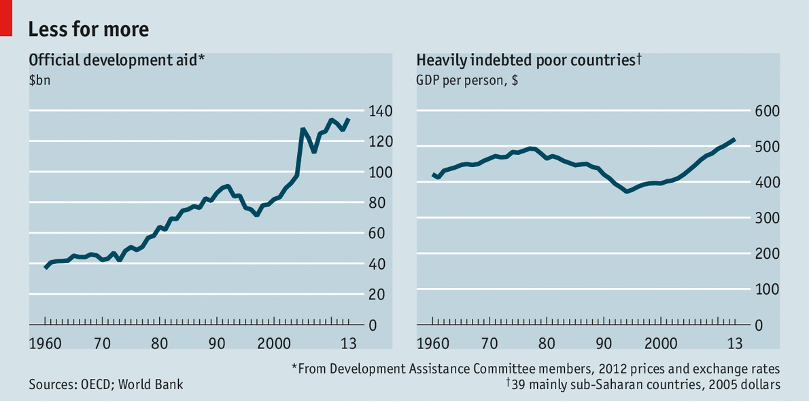
Critics of foreign aid’s economic benefits claim that donor countries breed dependency and corruption in recipient countries. This is often rooted in historical bonds the donor countries have with their recipients. When a country becomes entrenched in heavy loans that are currently propping up their people’s wellbeing, their economy and politics shift to better accommodate the donor country’s preferences. Foreign businesses may end up dominating the local markets, economic partners may be limited to those accepted by the donor, and social aspects of the recipient country may erode over time. These beliefs are also supported by the positive correlation with foreign aid expenditures and indebted countries after 2000. However, delegates must note the difficulties with trying to assess the causality between aid versus growth. In some circumstances, growth from a developing country could be an effect of helpful policymaking, which would have driven productivity regardless of foreign aid but yielding a positive correlation between the two nonetheless. In other circumstances, causality cannot be seen in a country simply because the aid given has been directed to the most economically sluggish areas.

Figure #1: Graphs from the Economist detailing the correlation between aid and indebted countries

Additionally, a vast majority of foreign aid comes in the form of loans––by which many developing countries become crippled through accumulating debt. Donor countries, in certain instances, receive more in interest payments than they spend on aid. In the 2008 financial crash, this was used to their advantage, as the aid they had previously given could now be exploited for interest.

Secondly, critics of foreign aid see it as a tool for donor countries to exercise political control in morally abhorrent ways. Aid, while delivering short-term economic and social benefits, simultaneously projects the donor’s foreign policy aims. A recent example is the EU making their aid to African countries increasingly conditional on curbing their migrations to Europe. Similarly, China’s recent efforts in Africa with the Belt-and-Road initiative can also be tied to promoting the purchase of Chinese goods. In these instances and more, subjecting one’s country to foreign aid means becoming vulnerable to policy changes that, for example, prevent a country from using strategies to restrict their economies from the open market. Critics of the biggest aid donors like the United States also point out the country’s prioritization on giving aid based on political considerations, rather than developmental ones. They cite the nation’s increase in aid to allies against the war on terrorism in 2001, regardless of their commitments to human rights or democratic values. Similarly, the United Kingdom focuses most of its aid not on the poorest countries in the world, but rather those with geopolitical importance or valuable markets. Such trends are shared by virtually all of the globe’s biggest givers in aid.

Finally, there exists skepticism on whether or not foreign aid is always delivered with the most social responsibility. While aid focusing on developmental aspects such as disaster relief and infrastructure remain indisputably good, the concern lies in larger overseas projects whose potential benefits outweigh its economic costs. This is an argument that can be most validated by all the taxpaying citizens of the large donor powerhouses they are supporting. Add the statistical difficulties with justifying the effects of aid, heavy political climates surrounding its usage, and the colossal amounts of citizen earnings aid consumes, and the case for aid becomes increasingly weakened among citizens.

Today, as foreign aid expenditures grow, so do the myriad of problems that challenge its effectiveness. In an increasingly intertwined world, every deed by one country for another comes not without political implications––it becomes the responsibility of delegates to analyse and weigh the ultimate benefits or harms that come from these initiatives before acting.

Emerging Voluntourism

Voluntourism’s origins date back to the 1950s and 60s, where philanthropic notions became more and more popularized in the Western, post-war world. Some of the earliest service organizations include the United Kingdom's Volunteer Service Organization established in 1958, as well as the United States’ Peace Corps, which was founded in 1960 after a speech delivered on university grounds by President John F. Kennedy. Missions carried out by these organizations involve training health workers and teachers in impoverished areas, along with rejuvenating their economies and infrastructure. Since then, similar organizations have been established across the world. The increasing push for volunteer work, especially among youth, has also had major cultural impacts. Terms like “gap year” began to normalise service work in everyday lives.

The transition from volunteering as an act of activism to tourism began in the 1970s. In the United States, funding for scientific field work began to dry up. As a response, a now-international environmental charity program introduced tourism as a means of raising money. Tourists––mainly an affluent, older working class crowd––were put to work gathering data and assisting researchers in the field. As the projects were only designed to last a few days or weeks, voluntourism became more accessible to people who vacationed but still had time-constraints and other commitments.

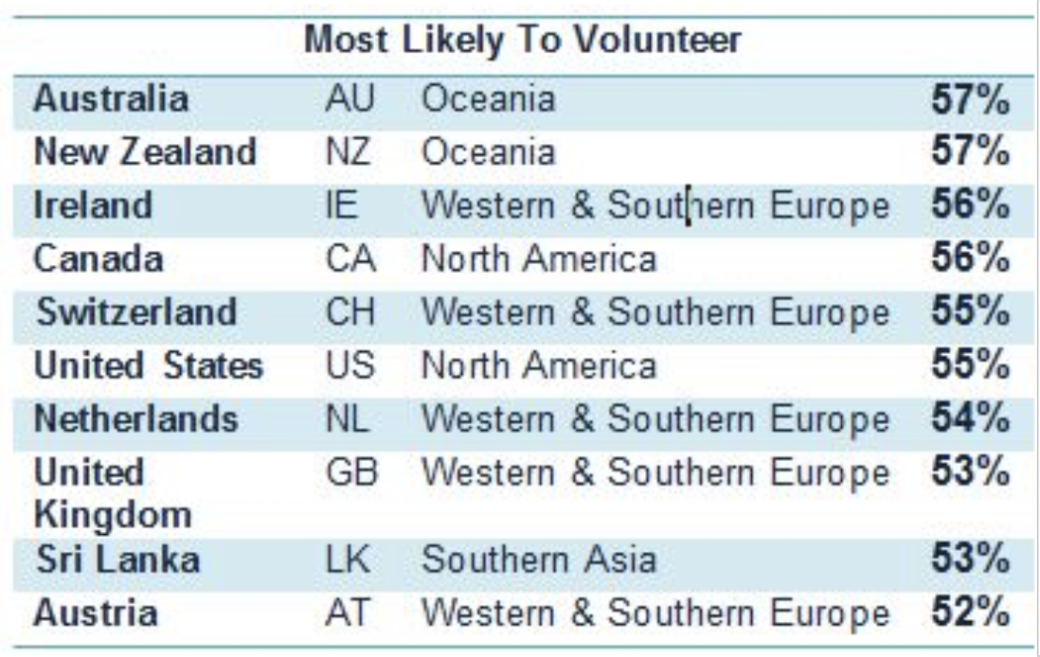
Today, voluntourism has grown from a niche market to a full-blown industry. Research now suggests that this service annually generates up to $2.6 billion of revenue worldwide and continues to grow each year. Along with voluntourism’s massive success, however, comes growing skepticism around its effectiveness and ethics.

Figure #2: Data from aidforum.org highlighting the percentage of people to have volunteered in their respective countries. Note that most come from developed, western nations.

Criticisms

Data around voluntourists around the world show that most come from financially-affluent countries such as the United States, United Kingdom, Canada, and Australia. While the issue of motivation behind every voluntourist––be it celebrity, political figure, religious missionary, or vacationer––remains an entirely separate issue of ethics and social impact, critics have also pointed out the objective harms of this practice among the locals it affects.

One of the biggest arguments is the over-endorsement of untrained workers. While vacationers spend thousands of dollars on flights, lodgings, and time at volunteer sites building, for example, schools, locals affected by the voluntourism industry are temporarily unemployed. Critics frequently argue that the money put into this commercialized service could be drastically better put to use had they been given to locals for supplies and training. What paid a week-long trip for an unskilled American volunteer could support a local teacher for months, or medical supplies for a local surgeon.

Additionally, voluntourist acts are typically not designed for the long-term: poorly-built buildings must be taken down and reconstructed by the locals, and orphanage visits rarely result in an increase of adoption rates or improved living conditions. However, the harms of unregulated, untrained work do not stop there. Research in South Africa showed “orphan tourism” has shown an increase in numbers, in which charities have turned into opportunistic businesses purposely exploiting the misguided beliefs of tourists. Children were forming unstable attachments to constantly fleeting, short-term, and foreign caregivers.

Geopolitics

United Kingdom

The United Kingdom is among the world’s top five largest aid donors, rivalled only by the United States of America. In the post-Brexit world, Prime Minister Theresa May stated that the UK aid trajectory will move to better promote the political and economic interests of the UK, leaving room for potential rifts with the European Union. UK foreign aid now targets many Commonwealth nations in the African region, delivering both humanitarian and military assistance.

United States of America

The United States, being the world’s largest donor nation, uses foreign aid to fulfil many aspects of its foreign policy. However, ideas on how foreign aid should be spent and where it should go face both internal and external controversy. Under the Trump Administration, there have been numerous proposals for aid cuts. Other sources of concern involve the type of foreign aid the US has delivered, with a great percentage of its aid being counter-terrorism, military support to Middle Eastern countries.

China

As yet another stakeholder in global foreign aid distribution, China uses foreign aid to its advantage in many ways similar to the US and the UK. With the Belt and Road Initiative, China’s foreign aid efforts targeting Africa aim to foster bipartisan relationships that focus on its goods and services.

European Union

Being a coalition of numerous states with differing historical ties with colonialism and foreign aid, the European Union currently faces issues with disunity. Data shows that while the UK prefers aiding Commonwealth countries, France rallies for Francophone nations, just as Spain pushes for Latin American funding. Additionally, the ongoing struggle of managing migration within Europe is further hindered by a lack of consolidated vision on where to direct funds.

Previous Attempts to Solve the Issue

Relevant UN Treaties and Events
- The Marshall Plan, officially known as the European Recovery Program (ERP) was an American initiative to rebuild Western Europe economies after the end of World War II. This was among the historic efforts that set the path for modern foreign aid.
- Resolutions A/73/L.61, A/73/L.18/Rev.1, and A/73/170 are all recent resolutions addressing relief protocol and fund allocation.
- Resolution A/RES/73/140 was one of the major General Assembly resolutions passed in 2018. Titled “Volunteering for the 2030 Agenda for Sustainable Development,” the resolution called for integrating all people and governments to aid in a global volunteering effort.

Possible Solutions
Before writing resolutions, delegates should have a full grasp on their country’s past and present relationship with foreign aid and voluntourism. Distinguishing factors such as recipient/donor statuses and relationships, voluntourist industries, and history of colonialism, if applicable, will be crucial in forming a delegate’s realistic approach to this integrated issue.
With the political climate currently rife with different superpowers at conflict with one another, delegates will need an increased understanding of how different allocations of foreign aid are affecting both the recipient and the donor nations. In areas that need the most humanitarian assistance, delegates should work to preserve and streamline the positive aspects of foreign aid. In areas currently receiving military and/or politically-charged aid, such as the conditional aid in Africa in exchange for curbing migration rates to the EU, delegates should work to understand both sides of the partnerships and set limitations that prevent aid from becoming exploitative and detrimental in the long term. Delegates also need to curb the social and economic impacts of foreign presence in receiving nations, so that citizens are neither oppressed by foreign-instilled values and markets, nor prevented from beneficial exposure to foreign aid.
As for voluntourism, delegates should be looking at ways to regulate and screen non-governmental practices for effectiveness and ethicality. Consider setting standards and oversight methods that protect both the communities subjected to negligent voluntourism from exploitation, as well as improve the long-term productiveness of service programs. While delegates focus on change within NGO programs, delegates should not forget to also involve governmental action. Often, governments of areas that need the most aid will allow foreign-funded groups––whether capable or exploitative—to take care of the vulnerable, so that they do not have to. Delegates will need to find ways to rally political will in both governmental and non-governmental sectors.

Bibliography
Alexander, Colin. “Foreign Aid: Less about Helping Poor Countries than Maintaining a Power Imbalance.” The Conversation, 13 Feb. 2019, theconversation.com/foreign-aid-less-about-helping-poor-countries-than-maintaining-a-power-imbalance-110136.
Australian Broadcasting Corporation. “The History of Foreign Aid - World.” ReliefWeb, 17 Dec. 2013, www.reliefweb.int/report/world/history-foreign-aid.
Banik, Dan, and Nikolai Hegertun. “Why Do Nations Invest in International Aid? Ask Norway. And China.” The Washington Post, WP Company, 27 Oct. 2017, www.washingtonpost.com/news/monkey-cage/wp/2017/10/27/why-do-nations-invest-in-international-aid-ask-norway-and-china/?utm_term=.2448ea6fbe66.
Benhamou, Michael. “The EU's Misplaced Foreign Aid.” Foreign Affairs, Foreign Affairs Magazine, 9 Feb. 2017, www.foreignaffairs.com/articles/europe/2017-02-09/eus-misplaced-foreign-aid.
Britannica. “Foreign Dependency.” Encyclopædia Britannica, Encyclopædia Britannica, Inc., 7 Feb. 2014, www.britannica.com/topic/foreign-dependency.
The Economist. “Aid to the Rescue.” The Economist, The Economist Newspaper, 14 Aug. 2014, www.economist.com/finance-and-economics/2014/08/14/aid-to-the-rescue.
“Foreign Aid by Country: Who's Getting the Most - and How Much?” Concern Worldwide US, 21 Mar. 2019, www.concernusa.org/story/foreign-aid-by-country/.
Glassman, James K. “Foreign Aid: The Good And Bad.” Forbes, Forbes Magazine, 30 May 2011, www.forbes.com/sites/jamesglassman/2011/04/08/foreign-aid-the-good-and-bad/#269e205e7257.
International Development Forum. “International Volunteer Day.” AID &amp; International Developement Forum, 5 Dec. 2015, www.aidforum.org/topics/disaster-relief/international-volunteer-day/.
Kushner, Jacob. “The Voluntourist's Dilemma.” The New York Times, The New York Times, 22 Mar. 2016, www.nytimes.com/2016/03/22/magazine/the-voluntourists-dilemma.html.
Malik, Kenan. “As a System, Foreign Aid Is a Fraud and Does Nothing for Inequality | Kenan Malik.” The Guardian, Guardian News and Media, 2 Sept. 2018, www.theguardian.com/commentisfree/2018/sep/02/as-a-system-foreign-aid-is-a-fraud-and-does-nothing-for-inequality.
May, Catriona. “DUCK Expeditions Are a Load of Quack.” Palatinate Online, 2 Apr. 2018, www.palatinate.org.uk/duck-expeditions-are-a-load-of-quack/.
Pariyar, Sujan. “Annual $173 Billion Worth Of Volunteer Tourism Industry Is Enough To Make A Change.” Thrive Global, 16 Oct. 2017, thriveglobal.com/stories/annual-173-billion-worth-of-volunteer-tourism-industry-is-enough-to-make-a-change/.
Popham, Gabriel. “Boom in 'Voluntourism' Sparks Concerns over Whether the Industry Is...” Reuters, Thomson Reuters, 29 June 2015, www.reuters.com/article/us-travel-volunteers-charities/boom-in-voluntourism-sparks-concerns-over-whether-the-industry-is-doing-good-idUSKCN0P91AX20150629.
Project, Borgen. “Speaking About the Timeline of the History of Foreign Aid.” The Borgen Project, Borgen Project Https://Borgenproject.org/Wp-Content/Uploads/The_Borgen_Project_Logo_small.Jpg, 22 Aug. 2017, borgenproject.org/history-of-foreign-aid/.
“Questions Raised about Benefits of Volunteer Tourism.” ABC News, 29 Nov. 2014, www.abc.net.au/news/2014-11-29/questions-raised-about-benefits-of-volunteer-tourism/5926344.
“Resolution on 'Volunteering for the 2030 Agenda for Sustainable.” Resolution on 'Volunteering for the 2030 Agenda for Sustainable Development' Formally Adopted by UN General Assembly, United Nations, 19 Dec. 2018, www.unv.org/news/resolution-volunteering-2030-agenda-sustainable-development-formally-adopted-un-general.
Rosenberg, Tina. “The Business of Voluntourism: Do Western Do-Gooders Actually Do Harm?” The Guardian, Guardian News and Media, 13 Sept. 2018, www.theguardian.com/news/2018/sep/13/the-business-of-voluntourism-do-western-do-gooders-actually-do-harm.
Sabbagh, Dan. “May Begins Africa Trip with Nod to Rightwing Tories on Overseas Aid.” The Guardian, Guardian News and Media, 27 Aug. 2018, www.theguardian.com/politics/2018/aug/27/may-africa-trip-rightwing-tories-overseas-aid.
Williams, Victoria. “Foreign Aid.” Encyclopædia Britannica, Encyclopædia Britannica, Inc., 12 May 2015, www.britannica.com/topic/foreign-aid.

