Forum: Human Rights Council
Issue: Protecting the rights of copper-cobalt miners and the wellbeing of local communities in the
Democratic People’s Republic of Congo.
Student Officer: Chloe Hui
Position: President of the Human Rights Council

Introduction

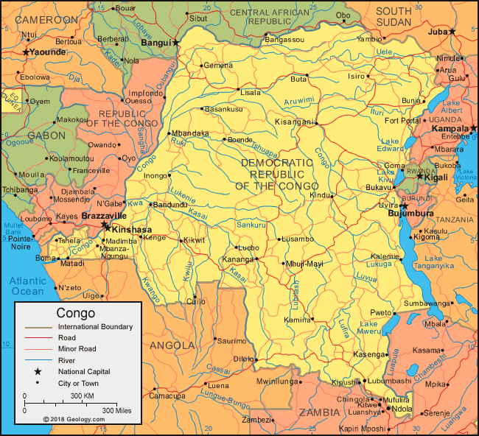
The Democratic Republic of Congo located in Central Africa is best known for its natural resources. Though being one of the richest countries in the world in terms of natural resources, Congo has a long history of exploitation. During the age of industrialization, King Leopold II of Belgium colonized DRC for its rubber plantation and land. While the Europeans treasured the natural resources of Congo, they brutally enforced their governing rules onto the Congolese people, treating them like slaves. Decades later, a similar issue remains prevalent in today’s Congo, however, in a more subtle way: More Economically Developed Countries (MEDCs) taking advantage of this underdeveloped land covered in minerals they demand. The issue of protecting the rights of copper-cobalt miners and the wellbeing of local communities in the Democratic People’s Republic of Congo is one that is extremely intricate as both industrial mines and artisanal mines co-exist, and such artisanal mines support the livelihood of thousands of Congolese. Issues like these that may seem small to the public eye often involve consequences that we as a global community fail to foresee, thus connecting it to this year’s theme of “The Butterfly Effect.”

Figure #1: Map of Congo

As technology advances through decades of development, resources mined in the Democratic People’s Republic of Congo have found extended applications. During the last few years, global effort in creating a greener environment sparked a trend for a climate-neutral economy. Among other ingredients, copper-cobalt is one of the most important materials required to produce lithium-ion batteries used in electric vehicles and other electric devices. It is estimated that 60 percent of the world’s copper-cobalt supply originates from Congo and that in 2019 alone, DR Congo produced a total of 100,000 metric tons of cobalt. With this being said, only 35 percent of copper-cobalt is recycled from old batteries while the other 65% are mined.

Unfortunately, behind a greener environment is a supply chain that abuses human rights. In addition to human rights violations, the growing demand for copper-cobalt is also causing an increase in price, causing negative effects on the wellbeing of local communities.

Both the international community and the local community of DR Congo are spending minimal efforts in ensuring the safety of Congolese people involved in cobalt mining. Although the Congolese mining legislation requires mining companies to maintain constructive communication with communities impacted by their work, this rarely happens. In addition, the Congolese government and mining companies fail to supply miners with adequate safety protection suitable for the environments they work in. However, organizations like the United Nations and Centre for Research on Multinational Organizations (SOMO) have been collaborating with other organizations to conduct investigations.

As the demand for copper-cobalt continues to surge worldwide, the chances of jeopardizing the wellbeing and miners and local communities become significantly higher. Previous solutions to similar issues around the world could be revised and amended into feasible ones to be debated on within the house. Delegates must rectify the lack of human rights enforcement by protection agencies and collaborate with governmental organizations and Non-Governmental Organizations to adequately fulfill their mandates. Lastly, it is of key importance that delegates suggest solutions that provide protection for the local environment, Congolese miners, and transparency within the supply chain.

Definition of Key Terms

Copper-Cobalt

A metal obtained through the mining of copper used primarily for lithium-ion batteries. This kind of metal has high thermal and electric conductivity, allowing it to be a key component to batteries for mobile phones and electric vehicles. Cobalt is primarily extracted as a byproduct of nickel and copper and requires smelting to be obtained.
Mining
The extraction of geological materials and resources, such as ores and minerals that cannot be grown or manufactured. The process of mining exposes workers to mining dust, a likely causation of deadly lung disease.
Artisanal Miners (ASM)
Miners who lack protective gear, adequate equipment, and aren’t officially employed by a mining company. However, works independently to support themselves and usually mines by hand.
Large Scale Mines (LSM)
Industrial mines that usually involve a company with many employees. Miners working here tend to have better safety equipment and are working under legal conditions.

History & Developments

The Copper-Cobalt Supply Chain
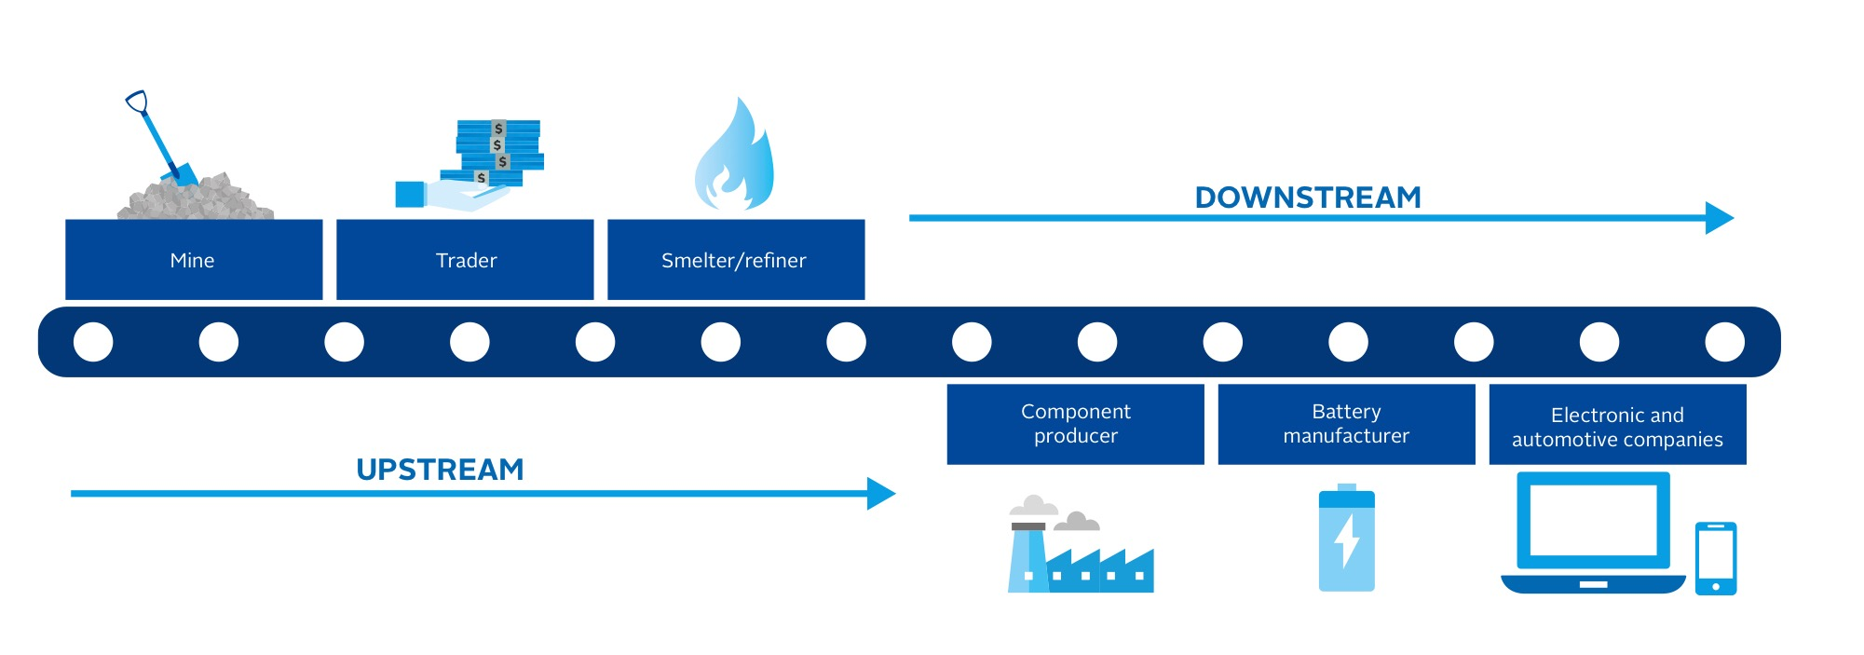
The copper-cobalt supply chain is highly complex and globalized; with the Democratic People’s Republic of Congo being the world’s biggest exporting country. As it is used in a wide variety of products spread throughout the market, its supply chain involves several middlemen and countless processors and traders from all around the world. As a result of its intricate nature and the lack of effort from local officials, the ability to trace the legality of copper-cobalt becomes extremely low. Also, it is important to note that Large Scale Mines (LSM) and Artisanal Mines (ASM) copper-cobalt supplies can be intertwined as traders sell ASM supplies to large scale mines. The supply chain of copper-cobalt is often divided into two separate parts; namely upstream and downstream. The issue at hand of protecting the rights of copper-cobalt miners and the wellbeing of the local community tends to focus more on the upstream.
Figure #2: Upstream and Downstream Supply Chain

Artisanal Mines

Artisanal mines (ASM) are most active in the copper-cobalt belt, which is located in southern Congo where the Katanga Province used to be. It wasn’t until the Mining Liberalization of 1990 and several policy changes in the early 2000s when ASMs became more popular and widespread.

In 2017, CEGA conducted an extensive survey across the copper-cobalt belt to assess the number of people involved in ASMs and how it has impacted them. According to the report, 90 percent of miners living in the mining community work in artisanal mines, and of those, only 10 percent are formally employed by an industrial mining company to legally extract copper-cobalt. Similarly, in 2009, a report by Global Witness estimated the number of one to two million artisanal miners active in DRC. It is only certain that the number of artisanal miners has increased during the past decade as demand for cobalt surged.

Risks and Working Condition

The legality of artisanal mines in DRC is often a controversial topic, where different parties would have a different answer. Nonetheless, it is important to keep in mind that ASMs are technically legal as defined by the local government. However, while ASMs are legal in the Democratic People’s Republic of Congo, the government rarely takes preventative measures to ensure the safety and working environment of artisanal miners.

Unlike industrial mines that are well monitored by air-conditioned offices, artisanal mines aren’t properly managed. Often times, ASMs are made up of men and sometimes boys under the age of 18 who work underground many hours per day with basic tools like picks, shovels, and panning equipment. These underground shafts dug by hand have poor ventilation, significantly increasing miners’ susceptibility to asphyxiation (state of which someone is deprived of oxygen). Similarly, due to the lack of safety equipment, artisanal miners are at an increased risk for injuries that are usually fatal. In June 2019, a landslide incident took the lives of 43 ASM miners and injured many more. This is just one of the many tragic incidents. Out of all the factors, landslides, falling boulders, and asphyxiation result in the most death of miners every year. In addition to risks caused by inadequate safety equipment, artisanal miners face threats from police and private security guards who sometimes overwatch mine sites. These officials use their authority to physically assault miners to their liking without any consequences.

Unfair Treatment

It is also important to recognize that artisanal miners also earn a lot less than industrial miners for the same minerals they extract. Dissimilar to industrial miners who have a steady wage issued by their mining company, ASM miners sell directly to traders. These traders ruthlessly exploit miners by paying them extremely low in comparison to the market price. Despite that, artisanal miners are often forced to accept what is offered as they need to survive and support their families. In an interview with Amnesty, an ASM miner said, “they feel like they are cheated by traders.”

While this all may seem extremely unethical of traders, the government is partially responsible as well. Government officials failed to oversee the process of trading and do not have a standard procedure for it to follow. Additionally, there is currently no system in place that helps ensure artisanal miners get paid a good price. As a result, traders use this as an advantage to pay artisanal miners the minimum while benefitting greatly later in the supply chain.

Impacts on the Local Communities

In addition to artisanal mines, the negative impacts brought upon the local communities are also devastating. As mining makes up such a big portion of the country’s total economic sector, many citizens from towns and villages near mining sites are often forced to sacrifice their wellbeing.

Villages and towns near mining sites are frequently exposed to serious air and water pollution. When Mark Dummett (Head of Business, Security, and Human Rights) visited DR Congo he said, “When you visit this area [copper cobalt chain] of the DRC, one of the most striking things you see is just how polluted it is, and just how little is being done by the government and mining companies to prevent pollution and protect people living and working there. “They simply can’t escape the dust.” When thousands of trucks travel back and forth each day through villages to mine sites, mining dust is heavily exposed to citizens, significantly increasing their risk of severe lung disease. Furthermore, originally safe water source also becomes contaminated when mining sites are near local communities. When wastewater from mining sites flow into the water sources of local communities, the water quality becomes unfit for human consumption and agricultural purpose.

Another common impact on local communities as a result of mining sites is the cut off of farmland or even complete relocation. In many cases, farmland of towns and villages are cut to accompany the mining project taking place nearby. In extreme cases, entire villages are forced to relocate with notice only a few days in advance. One example of this is the Kishiba Village. Congolese people in the Kishiba Village were forced to move to another area known as Kimfumpa. Unlike their original community, Kimfumpa lacks the most basic services and needs such as a clean water source, fertile farmland, schools, and even health care.

Geopolitics

Democratic People’s Republic of Congo
Since attention has been drawn to sustainable mining practices and artisanal mines in Congo, the Congolese government has been trying to approach the issue at hand from different angles and has expressed hopes of improving the status quo in said industry. However, surveys conducted by several organizations such as Amnesty and Global Witness aimed towards a similar goal has denied any improvements and even criticized the Congolese government for its lack of effort.
Although little is known about what the local government has done to improve the working condition for miners, they did establish a branch called Service for Assistance and Organization of Artisanal and Small-Scale Mines (SAESSCAM). It is said that SAESSCAM officials are responsible for training artisanal miners with safety practices and help miners when a problem occurs. Despite good intentions, this governmental agency lacked enforcement and oversight causing it to be ineffective.
In addition, the Democratic People’s Republic of Congo does have several laws in place that aims to regulate the mining industry. For instance, the Mining Code adopted in 2002 and the Mining Regulation adopted in 2003 are two examples of Congo’s national laws that mandate solving issues like the one at hand. Despite having these two laws, due to a lack of enforcement and inspection, these laws are often broken without officials knowing.
Overall, Congo’s stance on the issue is towards protecting the right of cobalt miners and has already taken several measures. With this being said, the government hasn’t done anything to prevent negative impacts brought upon local communities. Although the mining industry makes up much of the country’s economy, the local government should strictly enforce regulations to protect its citizens.
International Labour Organization (ILO)
The ILO is an agency established in 1919 as part of the Treaty of Versailles that ended World War I and became part of the UN in 1946 after its establishment. Its mandate is to ensure social justice for people at work. The International Labour Organization brings governments, employers, and workers of the 187 member states of the United Nations to set labor standards, develop policies, and devise programs that promote decent work for all men and women. The ILO has been tackling issues that arise from the mining industry since the beginning of its establishment. Over the years, the ILO has adopted several international regulations such as the Safety and Health in Mines Convention and the Hours of Work Convention. In its recent works, the ILO has been putting their focus on small scales mines and urges member nations to find sustainable solutions for miners.

People’s Republic of China

The People’s Republic of China is crowned to be the world’s largest importer of copper-cobalt and has several influential companies operating in Congo. Chinese company Huayou Cobalt is one of the top global suppliers of cobalt used primarily in lithium-ion batteries. In the past year, Huayou Cobalt has been in collaboration with German company RCS Global and Volvo to improve the conditions in ASMs by tracking accidents and deaths.
As both a leading world power and the largest importer of copper-cobalt, China is said to be the dominant force in the electric vehicle industry by 2025. In other words, China is and will become one of the most influential nations in determining how the supply chains and mines will be operating in Congo.

Previous Attempts to Solve the Issue
Various forms of actions have been taken in the past with the intent to solve or at least improve the status quo of the issue at hand, but unfortunately, none have been successful. Nonetheless, it is worthy of considering past attempts. For instance, various companies around the world such as Volvo and IBM have been trying to track their source of mica and prevent using mica sources that do not practice sustainable mining. Since then, many other companies have attempted the same practice. While this approach originates from good intention, companies are often unsuccessful with their tracking due to the lack of documentation. For this solution to work, it is imperative there be transparency throughout the copper-cobalt supply chain. If better transparency is put into practice, copper-cobalt miners as well as local communities could benefit greatly. Similarly, participation of more companies could also make a significant difference.
Without a doubt, certain conventions and laws have been passed to tackle this specific issue and issues similar to this, but due to the lack of enforcement, they have not been as successful as intended. For instance, the International Labour Organization (part of the United Nations) has passed numerous convention regarding issues like this one, including the Safety and Health in Mines Recommendation of 1995 and the Minimum Age Convention of 1965. Though the United Nations have passed conventions like these in hope of bettering the situation, countries like DR Congo lack enforcement.
Relevant UN Treaties and Events
- Hours of Work Convention, 1931 (31)
- Underground Work (women) Convention, 1935 (45)
- Universal Declaration of Human Rights, 10 December 1948 (217)
- Minimum Age (Underground Work) Convention, 1965 (123)
- Conditions of Employment of Young Persons (Underground Work) Recommendation, 1965 (125)
- Safety and Health in Mines Recommendation, 1995 (183)

Possible Solutions
When attempting to devise solutions for copper-cobalt miners and the local communities, delegates must examine the failures of past attempts and ensure that the same mistakes do not emerge in their own. Delegates must remember that in this case, previously implemented national and international laws and UN conventions failed to solve the issue effectively due to loopholes and the lack of enforcement. Seeing as inadequate enforcement led to the failure to numerous attempts in the past, it is crucial for delegates to submit resolutions with an emphasis on strong enforcement. It is also vitally important for delegates to remember many families in DRC reply on mining as a source of revenue for their livelihood; so, focusing on eradicating ASMs without substitutions would not be the most effective solution for the issue at hand. Thus, delegates must strive to come up with new, realistic, and attainable solutions to provide miners in DR Congo the fundamental rights they have lacked for decades.
Seeing as this topic focuses on the copper-cobalt mining industry in Congo, it is essential to bring in the cooperation of the local Congolese government. When looked upon, the Congolese government fails to ensure a safe environment for all miners. Though DRC’s government is committed to protecting miners of all types including artisanal miners, reports in recent years do not indicate that numbers have gone down. For this reason, it is evident that there is a lot more the local government can still do to improve the status quo. For instance, delegates could incentivize the Congolese government to amend the Labour Code adopted in 2002 and other national laws to cover existing loopholes that fail to ensure the safety of artisanal miners. Although the current Labour Code includes several laws relating to health and safety at work, it does not explicitly include workers who do not have a clear employer. With adequate safety preventative measures taken into action, diseases related to mining could be significantly reduced. Another possible solution that could effectively tackle the root of the issue is establishing a monitoring system where licensed officials examine mines regularly for better transparency in the copper-cobalt supply chain. In addition to amending pre-existing laws, this regular examination can ensure proper enforcement of safety precautions. Not only does this solution benefit the well-being of local miners, it also benefits international organizations as this increases the transparency of copper-cobalt. This sort of transparency is crucial since many organizations cannot identify whether or not the supplies of their cobalt involved illegal miners currently. With this done, the monitoring process for the effectiveness of implemented laws would become more straightforward.
The issue of child labour involved is primarily due to the widespread poverty in many areas of Congo and especially near the copper-cobalt belt. Without a minimal amount of education provided to the younger generation, issues like these would only reappear in the future. Ensuring free and compulsory education in a neighborhood school up till the age of fourteen would be a practical and possible solution to this topic. With the collaboration between governmental organizations, NGOs, and the local government, this solution is capable of keeping the younger generation away from the possibility of becoming a child worker and allows them to have access to basic education. Though this minimal amount of education may not ensure a high paying job for these children in the future, it provides them with a better chance and a wider variety of career choices in the future.
Rather than eradicating artisanal mines, delegates could aim to create a national labour organization which allows artisanal miners to receive higher payment. In addition to increasing their basic revenue, this national labour organization could be extremely important when attempting to regulate safety precautions in artisanal mines. Although abolishing artisanal mines sounds like it would be functional, it is not in this case. Many families in the copper cobalt belt region reply on these mines to support their family. For this reason, creating a national labour organization would be the better solution as of currently.
Last but not least, solutions regarding the protection of local communities should be part of their resolution as it is the second part to the issue at hand. Delegates could urge the collaboration between the local government, mining companies, and various organizations to establish a set of guidelines that help prevent extensive air and water pollution. Among different types of pollution local communities are possibly exposed to, air and water are the most important as those fundamentally support the human life.

Bibliography
“Calls for Sustainable Mining after 43 Artisanal Miners Killed in DRC Landslide.” IndustriALL, 4 July 2019, www.industriall-union.org/calls-for-sustainable-mining-after-43-artisanal-miners-killed-in-drc-landslide.
“Community Rights Widely Abused by Cobalt Mining in Democratic Republic of Congo.” SOMO, 9 May 2017, www.somo.nl/community-rights-widely-abused-by-cobalt-mining-in-democratic-republic-of-congo/.
“The Democratic Republic of the Congo Has Some of the World's Most Important Mineral Reserves. For More than a Decade the Extraction of These Resources Has Been Linked to Conflict, Human Rights Abuses and Corruption.” Amnesty International USA, 2013, www.amnestyusa.org/reports/profits-and-loss-mining-and-human-rights-in-katanga-democratic-republic-of-the-congo/.
Dehman, Nabylah Abo. PRI, UNEP, UN Global Impact, 2018, pp. 1–14, Drilling Down Into the Cobalt Supply Chain: How Investors Can Promote Responsible Sourcing Practices.
“Democratic Republic of the Congo Map and Satellite Image.” Geology, geology.com/world/democratic-republic-of-the-congo-satellite-image.shtml.
Garside, M. “Cobalt Production DR Congo 2019.” Statista, 17 June 2020, www.statista.com/statistics/339834/mine-production-of-cobalt-in-dr-congo/.
Gaughran, Audrey. “Inside the DRC's Artisinal Mining Industry.” Amnesty International USA, Amnesty International, 16 Aug. 2013, www.amnestyusa.org/inside-the-drcs-artisinal-mining-industry/.
González, Alejandro, and Esther de Han. “Community Rights Widely Abused by Cobalt Mining in Democratic Republic of Congo.” SOMO, 9 May 2017, www.somo.nl/community-rights-widely-abused-by-cobalt-mining-in-democratic-republic-of-congo/.
Gordon, James. “Cobalt Mining in the DRC: the Dark Side of a Clean Future.” Raconteur, Raconteur Media Ltd., 20 Feb. 2020, www.raconteur.net/business-innovation/cobalt-mining-human-rights.
Jones, Peter Tom. “Does Cobalt and Copper Mining Lead to Birth Defects in DR Congo?” First of a Kind Commercial Compact System for the Efficient Recovery Of CObalt Designed with Novel Integrated LEading Technologies, 28 Apr. 2020, h2020-crocodile.eu/2020/04/28/does-cobalt-and-copper-mining-lead-to-birth-defects-in-dr-congo/.
Mining (Coal; Other Mining) Sector, International Labour Organisations, 2020, www.ilo.org/global/industries-and-sectors/mining/lang--en/index.htm.
Sanderson, Henry. “Congo, Child Labour and Your Electric Car.” Subscribe to Read | Financial Times, Financial Times, 7 July 2019, www.ft.com/content/c6909812-9ce4-11e9-9c06-a4640c9feebb.
“‘They Can't Escape the Dust.’” Amnesty International, 6 May 2020, www.amnesty.org/en/latest/news/2020/05/drc-alarming-research-harm-from-cobalt-mine-abuses.

