Forum: Security Council
Issue: Question of the Somali Civil War
Student Officer: Eva Yuan
Position: Deputy President of the Security Council

Introduction
Since 1991, Somalia has been home to chaos and nebulous grasps at power. For three decades, clans, insurgencies, and foreign powers have attempted to control the African nation. The conflict has left millions of Somali displaced, thousands dead, and freedoms stripped from all. Somalia, a once-proud nation full of traders and warlords, has now been weakened by a history of coups and uprisings. The seemingly endless war, in the last ten years, has fallen from public attention.
After years of fighting, the Somali Civil War is now standing on the line between peace and disorder. With the correct strategy and right approach, relations between Somali civil society, combatants, and the government could improve and stabilize. However, without the proper caution and wisdom, the situation could easily worsen, extending the war for longer.

Definition of Key Terms

Somalia
Somalia is the easternmost African country, bordered by Ethiopia, Kenya, and Djibouti. Roughly 11 million people live in Somalia, as of July 2020. Within Somalia, there are two self-declared autonomous regions, Somaliland in the north, and Puntland in the northeast. Although citizens of Somalia are called “Somali,” “Somali” also refers to an ethnic group that exists in the Horn of Africa.

Somaliland
Somaliland is a self-governed autonomous region within Somalia. It was established in 1991 and consists of the land formerly under a British protectorate. Somaliland is relatively stable compared to the rest of Somalia, with a functioning federalist republic. It seeks international recognition as an independent nation. Due to their proximity, Somaliland has border disputes with Puntland, Somalia’s second autonomous region.

Puntland
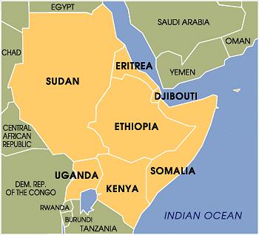
Puntland is the second autonomous region in Somalia. In 1998, the Somali Salvation Democratic Front established Puntland in the northeast, to escape the warfare in the south. Similar to Somaliland, it governs through a clan-based federalist republic.
Horn of Africa
The Horn of Africa is a geographical region describing a portion of Eastern Africa that extends into the Arabian Sea. It forms the south side of the Gulf of Aden, and is home to Djibouti, Eritrea, Ethiopia, and Somalia.
Islamist
Islamist describes those who support the establishment of an Islamic state and is used to refer to political Islamic issues. Extreme Islamist groups are sometimes militant in nature, which differentiates them from other peaceful followers of Islam. Examples of extreme Islamist groups would include the Islamic State (IS, ISIS or Da’esh), the Taliban, and Boko Haram.

Map of the Horn of Africa.
Clans
Somalia is a clan-based society, meaning it is organized by nomadic clan families, which are connected by lineage. The five noble clans in Somalia are the Darod, Hawid, Isaaq, Dir, and Rahanweyn. These four clans have minority clans within them. Each clan, patriarchally structured, is led by warlords. In the war, minority warlords sometimes defend their own independence, but most clans associate with one combatant or another.

History & Developments

Background

New Imperialism and the Colonization of Somalia
During the late 19th and early 20th centuries, Western powers expanded their grasp over the world through imperialism and colonization. During this period, colonial powers, such as Western Europe, the United States, Russia, and Japan seized total or partial control of some Asian regions and nearly all of Africa. Somalia, as a general region and not yet a nation-state, was colonized by Britain and Italy. In the 1880s, the British protectorate was declared over northern Somalia, though British rule existed exclusively on the coast for economic advantage. Later in 1889, Italy, through the Treaty of Wichale, Britain and Italy established protectorates over Ethiopia and also gained southern Somalia. Respectively, these were referred to as British Somaliland and Italian Somaliland.

Independence

After World War II, colonial powers lost interest in Somalia. Under the UN, from 1950 to 1960, Italy prepared southern Somalia for independence. On June 26 1960, the British protectorate became independent. Days afterward, on July 1, the Italian protectorate did the same, and the two regions joined as one – the Somali Republic.

The Somali Republic ruled democratically from 1960 to 1969. During this period, it faced a number of political issues. First and foremost, the hurried joining of the former British and Italian territories called for new, cohesive systems for communication, laws, and justice. Second, Somalia urged the reunification of ethnic Somali groups, not only in Somalia, but in the Ogaden, French Somaliland, or modern-day Djibouti, and northern Kenya. A number of border disputes, and the Western funding of Ethiopia and Kenya, led Somalia to turn to the Soviet Union for funding.

In 1969, the Somali Prime Minister, Abdirashid Ali Sharmarke was assassinated by one of his own bodyguards, for unknown reasons. Following his funeral, the Somali Army, led by Mohamed Siad Barre, staged a coup and took power. Barre and his Supreme Revolutionary Council (SRC) held power until 1991 when the Somali Civil War started. Barre’s military regime became increasingly brutal and authoritarian. Barre pushed an ideology known as “Scientific Socialism” and allied himself with the Soviet Union and China. During this time, Somali became a written language, which strengthened literacy in the country.

Ogaden War (1977-78)

In 1977, Somalia invaded Ethiopia, for the majority-Somali region of Ogaden. Barre justified his actions through calls for national unity. Though at first, Somalia gained most of Ogaden, the invasion caused backlash from the international community. The Soviet Union withdrew support for Somalia and instead funded Ethiopia. Ogaden was retaken by Ethiopia.

The Ogaden War presented a new issue. After what was seen as unnecessary spending and a burden to Somali society, Somali clans protested. In 1978, a military coup formed two opposition groups to Barre’s government: the Somali Salvation Democratic Front (SSDF) and the Somali National Movement (SNM). Both were backed by regional powers.

Beginning of the Civil War

State Collapse (1991)

In May 1988, northern tribes in former British Somaliland rebelled against Barre’s government, calling for the establishment of an independent region, Somaliland. The state cracked down upon them, resulting in thousands of deaths, but not complete eradication. Three years later, SNM had settled in the North, and clans from the whole of Somalia launched a new rebellion. This time, Barre had few allies, his people hated him, and he was unseated. The northern tribes declared themselves an independent, autonomous Somaliland, which stands to today. SNM established a provisional government, and Somaliland has since transitioned into a multi-party democracy. However, the rest of the country fell into civil war. Barre’s downfall had left a power vacuum for warring clans, insurgents, and internationally backed factions to aim for.

UN Intervention (1992-95)

One year into the conflict, the UN began intervening in Somalia, both through peacekeeping forces and diplomatic engagement. The UN Operation in Somalia (UNOSOM), at the beginning of 1992, was limited in its ability to curb fighting. However, in December, the US deployed forces to join UNOSOM, which reinforced the effort to stop the civil war. As a result, Somalia began receiving international attention, food supplies were secured through reopened ports, and the economy was reformed. Diplomatic UN missions managed to assist local agreements. However, this victory was short-lived. UNOSOM proved futile in ending the conflict and uniting Somalia. While, at the beginning of the mission, humanitarian aid was the goal, the second phase of UNOSOM was much more interventionist, and much more politically focused, attempting to install a new government. UNOSOM only awarded aid to those that supported the mission, and attempted to detain those who did not. The chaos caused by the UNOSOM mission only served to enforce warlord hierarchies, encourage fracturing, and failed to implement a sustainable peace. By the end of the mission, UNOSOM itself had become the target of insurgent groups, leading to the departure of US troops. Some believe the backlash against the operation and the result of anti-West sentiment, led to the creation of militant Islamist groups.

Combatants

During the Civil War, countless clans and tribes fought against each other. Warlords established spheres of influence and ruled small territories. However, only a few groups held significant land and power. In 1998, the SSDF, originally formed to oppose Barre before the civil war, established the Puntland State of Somalia, a self-governed autonomous region, in northeast Somalia. The land between Puntland and Somaliland is disputed. In addition, Ethiopia’s fear of Al Itihaad Al Islamiya, an Islamist militant faction in Somalia, led Ethiopia to actively fight against Islamist extremists, especially considering that Ethiopia is a majority-Christian country.

Return of a Federal Government

Transitional National Government (TNG)

In 2000, the town of Arta, Djibouti, held the Somali National Peace Conference. This conference, unlike previous attempts, consulted members of the Somali society, including minorities, women, and faction leaders. During this conference, the Transitional National Government (TNG) was established in order to temporarily govern Somalia until a democracy could be achieved. The TNG became the first Somali administration to sit at the UN since the civil war had begun. It was supported by a handful of Arab countries, but did not win approval from Ethiopia, and other major donors. Ethiopia, a majority-Christian and landlocked country, disapproved of the Islamist-affiliated TNG, but sought control over Somali ports. In addition, the TNG did not fulfill what it had hoped to do. It failed to address the rise of Islamist militant groups, and even associated themselves with powerful factions. Though it was, more or less, functional, many still opposed the TNG. Namely, the Somali Restoration and Reconciliation Council (SRRC), an anti-Islamist group, was backed by Ethiopia. In 2004, the TNG was succeeded by the Transitional Federal Government (TFG). The TFG no longer had Islamist ties, but was federalist and supported by Ethiopia.

Islamic Courts Union (ICU)

The latter years of the civil war have been characterized by a rise of Islamic movements. The Islamic Courts Union (ICU), a coalition of Islamic courts, rose to prominence when they took Mogadishu, the capital of Somalia. The ICU gained popular favor for its effective security and governance. However, in 2006, Ethiopian forces, supported by Western powers, alongside the US, entered Somalia and drove the ICU from Mogadishu, reinstalling the TFG. The ICU took refuge in Eritrea, and support for the TFG strengthened.

Current State of Conflict

Start of the Current Civil War

The ICU, while recuperating from the 2006 intervention, splintered into smaller factions. One of these branches, Al-Shabaab, is the youth brand of the ICU. In 2009, four Islamist groups united to create the Hisbi Islam, a coalition aimed to overthrow the Somali government and install one that was fundamentalist Islamic and followed sharia law. In addition, Al-Shabaab, supported by Al-Qaeda, joined the fray. These groups emerged in response to the new president of the secular TFG, Sheik Sharif Sheik Ahmed, a former leader of the ICU.

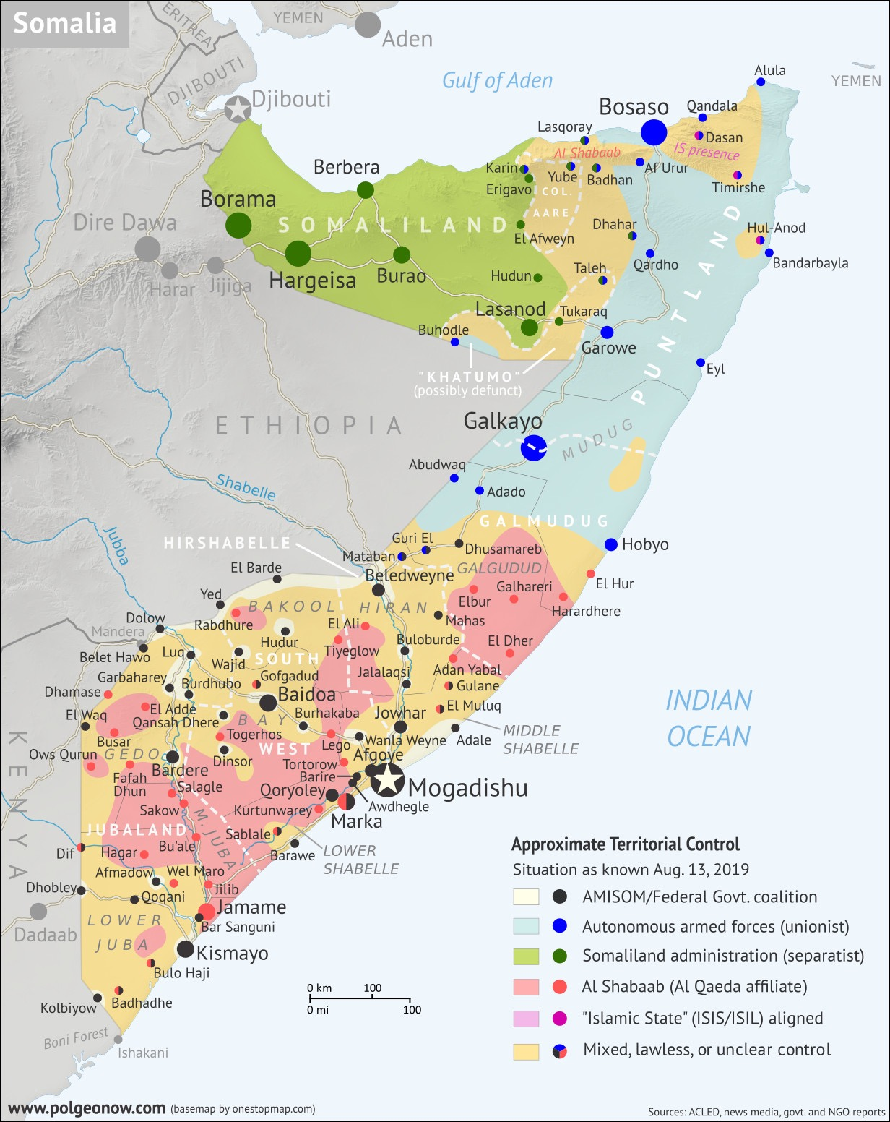
Since the start of the war, three major layers have emerged. First, the conflict is a struggle for political power. All of the leading influences in the war — Ethiopia, the ICU, the West — aim to grasp control over the Federal Government of Somalia (FGS). Each group is motivated by their political ideologies or national security interests. Second, identity politics, especially in a clan-based society, is a strong motivator. This is what drove Somaliland and Puntland to establish themselves as autonomous regions, based on historical identification and clan-based federalism respectively. Identity politics is also what compels Somalis take up arms for their own clans. Third, the war is entwined with economic interests as well. Militant groups often supplement themselves through economic means. For example, combatants will specialize in trading sugar and charcoal, tax and extort civilians, and control key seaports and roads. This is partly what makes distribution of food provisions difficult.

The current control of major combatants in Somalia, as of August 2019.

Foreign Influence and Intervention

The new state of the civil war has brought more international powers into the fold. Western powers, including the US, UK, and the European Union (EU), all either fund or fight among the FGS’s forces. The West has a vested interest in Somali stability. For one, the Islamist militant groups in Somalia represent an international threat. The presence of Al-Qaeda in Somalia has strengthened the extremist cause internationally, and Somalia’s Islamist movement has become known for training jihadist combatants. Second, Somalia’s geographical location makes it a significant point for sea trade. The proliferation of piracy in the waters around Somalia is a direct result of political instability. Stopping Somali pirates would mean billions of dollars in saved goods.

In addition, the African Union (AU) created the African Union Mission in Somalia (AMISOM), supported by the UNSC, for the purpose of peacekeeping and conflict resolution in Somalia. Originally named IGASOM, AMISOM consists of contingents from Uganda, Burundi, Ethiopia, Kenya, Djibouti, and Sierra Leone. AMISOM’s goal, at conception, was to deliver humanitarian aid, assist transitional governments, and promote national security. Since then, it has evolved to battle Al-Shabaab directly, after Al-Shabaab was blamed for the bombings in Kampala, Uganda. AMISOM fights in the FGS coalition.

Foreign influence and intervention in Somalia must strike a balance between overbearing and necessary. While the FGS is not strong enough to defeat Al-Shabaab without help, the aid of the US, UK, EU, AU, and UN has been used as fear-mongering rhetoric by Al-Shabaab. Al-Shabaab creates an “us versus them” narrative and weaponizes a nationalistic fear of foreigners to recruit Somalis into fighting for them. Though defeating Al-Shabaab is essential, too strong of an approach may be inflammatory.

Humanitarian Concerns

The Somali conflict has been the source of a number of human rights abuses, from both sides of the war. According to the UN Office for the Coordination of Humanitarian Affairs (OCHA) in 2019, Somalia has 5.2 million people in need of humanitarian aid, over 42% of the population. To complicate things further, Somalia has been suffering from a drought for over ten years, decreasing access to food and water. Rampant food insecurity has exacerbated social issues, including child marriage, lack of education, and child soldiers. According to UNICEF, 3 million Somali children do not attend school, not just because of the conflict, but because of poverty, lack of infrastructure, and gender inequality. In addition, the conflict makes it difficult to properly distribute provisions to the population.

The civil war has also been the source of a Somali refugee crisis. According to the UNHCR in January 2020, over 750,000 Somali refugees reside in nearby countries, such as Kenya, Yemen, and Ethiopia. Somali refugee camps have existed for almost 30 years, Though over 90,000 refugees have been repatriated, much of the country is still subject to conflict, rampant food insecurity, and environmental disasters. Meanwhile, over 2.6 million – roughly 23% of the population – are internally displaced, with many leaving their homes in search of food and water.

Geopolitics

Ethiopia
Ethiopia is an African country east of Somalia, which shares a border with Somalia. Ethiopia still has a significant ethnic Somali population. Unlike Somalia, Ethiopia is mostly Christian, and is thus incentivized to fight Islamic militant groups in Somalia. In addition, past border disputes between Ethiopia and Somalia, including, but not limited to the Ogaden War, drive Ethiopian decisions about backing Somali insurgents.

Al-Shabaab
Al-Shabaab is the main belligerent in the current Somali civil war. It is an Islamist militant group associated with Al-Qaeda and has been labelled a terrorist organization by the US and the UK.

United States (US)
The US supported and fought with the UNISOM mission in the first years of the civil war. However, UNISOM eventually became entangled in the conflict itself, resulting in two US Black Hawk helicopters being shot down. The US is mainly involved in the conflict through a handful of unmanned airstrikes. However, under the administration of President Donald Trump, the airstrikes have proliferated in number.

European Union (EU)
The EU provides funds for the government coalition in the civil war. Though in the West, the EU has two main motivations to be involved in the conflict. First, the belligerents are Islamist militants associated with Al-Qaeda, and train international terrorists. Members of the EU, such as but not limited to, France, Belgium, and Spain, have all been the targets of Islamist terrorist attacks. Suppressing the Islamist movement in Somalia is not just war, but counterterrorism. Second, the EU, due to its proximity to the Middle East and North Africa, takes the brunt of refugees traveling to developed countries. In order to not overburden their countries with these refugees, the EU is incentivized to stabilize conflicted regions.

Previous Attempts to Solve the Issue
At the beginning of the war, when militants first attacked the government, they were met with negotiations. The leader of Al-Shabaab, Sheikh Mukhtar Robow, met with President Sharif Ahmed. Sharif Ahmed agreed to enforce sharia law, as Al-Shabaab demanded. However, this compromise did not seem to satisfy the group, as the war continued. In addition, Sharif Ahmed advised African countries to abstain from sending more troops, as it would likely embolden Islamist rhetoric and feed into the narrative that foreign powers controlled Somalia.
Currently, the UN has a peacekeeping mission in Somalia, called the UN Assistance Mission in Somalia (UNSOM), established in 2013. It is overseen by the Security Council, and collaborates with AMISOM and the Federal Government of Somalia. However, UNSOM is substantially less influential than AMISOM or Western backers.
In May 2017, a conference to discuss the security, economy, and governance of Somalia took place in London, citing progress on resolving the conflict. The conference focused on new plans to combat Al-Shabaab and discuss new President Mohammed Abdullahi Farmajo’s governance.

Relevant UN Treaties and Events
- UNSC Resolution 751, 24 April 1992 (S/RES/751)
- UNSC Resolution 794, 3 December 1992 (S/RES/794)
- UN Operation in Somalia (UNOSOM) in 1992-95

Possible Solutions
Though many involved Western nations, including the US and UK, view the civil war as an issue with terrorists, it is merely the result of the larger civil war. The fragility of the FGS, as well as the majority Muslim population, are crucial proponents of the rise of Islamist militants in Somalia. Resolving the conflict is not just a matter of counterterrorism, but also a matter of strengthening the FGS, and making it more representative of the Somali people. This would include incentivizing international ties, in forms such as, but not limited to, trade agreements/organizations, political support, and international recognition. In addition, the current parliament of the FGS is clan-based, rather than democratically voted in. Though Sheik Sharif Sheik Ahmed was the first democratically elected president in 20 years, his previous ties to the ICU angered the group, who viewed him as a traitor. Rather than enforcing a secular democracy, delegates may consider adopting government systems similar to Iran, a combination of theocracy and democracy.
In addressing the well-being of the general population, the current forms of aid are largely inefficient. Simply sending through ports leaves food for the combatants that control the ports, not the civilians. In addition, this fails to address Somalia’s lack of self-reliance. Somalia cannot survive on foreign aid completely. Last, displaced Somalis find it difficult to start a stable life amidst conflict and drought; hence, solutions may focus on providing economic opportunities. This would include, for example, creating peaceful special economic zones centered around foreign investment. According to the BBC, Somali and Djibouti exported more livestock than anywhere else in the world. Revitalizing previous trades would also require supporting livestock trade, which has failed in the past years due to malnutrition and drought. In addition, with the assistance of OCHA and individual nations, the UN could use equipment, like drones, to send provisions to landlocked civilians. Finally improving the state of refugee camps and focusing on successful repatriation is crucial. For repatriation, the UNHCR has returned 90,000 Somali refugees to their home country, and helped them with beginning a new, sustainable life.
Al-Shabaab insurgencies often capitalize on Somalis’ lack of education and desperation to recruit in rural areas. Improving educational infrastructure, while difficult in conflicted or Al-Shabaab controlled regions, would help curb this advantage. This would include collaborating with UNICEF to establish sanitary, well-staffed schools in areas under FGS control, creating online courses, and including education plans in negotiations moving forward. However, the most effective solutions concern the security of Somalia. Al-Shabaab controls the infrastructure of its territory, making it nearly impossible to send aid to those who need it. As long as people in their territory are desperate, Al-Shabaab will continue recruiting. Redoubling the FGS coalition to fight Al-Shabaab is essential, but is ineffective without some semblance of unity. With Somalia as a fractured, clan-based country, and more factions declaring themselves independent, it is difficult to find cohesion in plans to attack Al-Shabaab and distribute emergency resources. Unifying these regions, including but not limited to, the South West State, Galmudug, and Hirshabelle, would reduce infighting and strengthen the counterterrorist effort. While difficult, this would include resolving clan-based conflicts, fostering inclusive governance, and ensuring proper distribution of resources.

Bibliography
Al Jazeera. “Somalia: The Forgotten Story.” War & Conflict | Al Jazeera, Al Jazeera, 2 Nov. 2016, www.aljazeera.com/programmes/aljazeeraworld/2016/10/somalia-forgotten-story-161027115655140.html.

“AMISOM Mandate.” AMISOM, amisom-au.org/amisom-mandate/.

Bowden, Mark. “The Legacy of Black Hawk Down.” Smithsonian.com, Smithsonian Institution, Jan. 2019, www.smithsonianmag.com/history/legacy-black-hawk-down-180971000/.

Centanni, Evan, et al. “Somalia Control Map &amp; Timeline - August 2019.” Political Geography Now, 13 Aug. 2019, www.polgeonow.com/2019/08/somalia-control-map-timeline-august-2019.html.

The Editors of Encyclopaedia Britannica. “UNOSOM.” Encyclopædia Britannica, Encyclopædia Britannica, Inc., 14 Aug. 2014, www.britannica.com/topic/UNOSOM.

Fedirka, Allison. “Why the US Cares About Somalia.” Geopolitical Futures, 25 Apr. 2019, geopoliticalfutures.com/us-cares-somalia/.

Felter, Claire, et al. “Al-Shabab.” Council on Foreign Relations, Council on Foreign Relations, 10 Jan. 2020, www.cfr.org/backgrounder/al-shabab.

Harper, Mary. “How Do You Solve a Problem like Somalia?” BBC News, BBC, 11 May 2017, www.bbc.com/news/world-africa-39855735.

Hartwig, Jason. “How to End the Civil War in Somalia: Negotiate with Al-Shabaab.” War on the Rocks, 13 May 2019, warontherocks.com/2019/05/how-to-end-the-civil-war-in-somalia-negotiate-with-al-shabaab/.

Healy, Sally, and Mark Bradbury. “Somalia.” Endless War: a Brief History of the Somali Conflict | Conciliation Resources, 1 Feb. 2010, www.c-r.org/accord/somalia/endless-war-brief-history-somali-conflict.

Iversen, Katja. “Long-Term Action Plan for the Horn of Africa.” Food and Agriculture Organization of the United Nations, 31 Oct. 2000, www.fao.org/News/2000/001004-e.htm.

Lewis, Ioan M., and Jörg H.A. Janzen. “Civil War.” Encyclopædia Britannica, Encyclopædia Britannica, Inc., 6 Dec. 2019, www.britannica.com/place/Somalia/Civil-war.

“The London Conference and Prospects for Peace and Stability in Somalia.” Crisis Group, 11 May 2017, www.crisisgroup.org/africa/horn-africa/somalia/london-conference-and-prospects-peace-and-stability-somalia.

McDougall, Walter A., and Harry Magdoff. “New Imperialism.” Encyclopædia Britannica, Encyclopædia Britannica, Inc., 26 June 2020, www.britannica.com/topic/New-Imperialism.

Mohieldin, Mahmoud. “A Visit to Refugee Camps in Somalia.” World Bank, 14 July 2017, www.worldbank.org/en/news/feature/2017/07/14/a-visit-to-refugee-camps-in-somalia.

Prime Minister's Office, 10 Downing Street. “Why a Stable Somalia Is in Our Interests.” GOV.UK, GOV.UK, 22 Feb. 2012, www.gov.uk/government/news/why-a-stable-somalia-is-in-our-interests.

“Somalia Refugee Crisis Explained.” How to Help Refugees - Aid, Relief and Donations, 7 Jan. 2020, www.unrefugees.org/news/somalia-refugee-crisis-explained/.

Williams, Paul. “The Positive Impacts and Challenges Facing the African Union Mission in Somalia - Somalia.” ReliefWeb, 3 Dec. 2019, reliefweb.int/report/somalia/positive-impacts-and-challenges-facing-african-union-mission-somalia.

“The World Factbook: Somalia.” Central Intelligence Agency, Central Intelligence Agency, 1 Feb. 2018, www.cia.gov/library/publications/the-world-factbook/geos/so.html.

“World Report 2019: Rights Trends in Somalia.” Human Rights Watch, 17 Jan. 2019, www.hrw.org/world-report/2019/country-chapters/somalia.

