Forum: General Assembly Third Committee
Issue: Countering the abuse and mismanagement of foreign aid intended for humanitarian causes
Student Officer: Jonathan Wu
Position: President of the General Assembly Third Committee

Introduction
Definitionally, foreign aid refers to support that governments and international organizations provide to other governments, usually in the form of economic, developmental, or military assistance. Such international organizations include the World Bank, International Monetary Fund (IMF), and United Nation’s Children Fund (UNICEF), all of which have participated heavily in promoting foreign aid programs in the economic and developmental fields for decades. Official developmental assistance (ODA), or assistance given to combat poverty and promote the modernization of economies, is commonly channeled through these organizations—otherwise, bilateral grants between the donor and receiving country and loans highlight as alternative methods for sourcing ODA. Though these voluntary efforts to help developing nations is a seemingly honorable and faultless process, accounts of economic fraud and corruption--grouped with violations of human rights by the military--has revealed the difficult truth of this assistance. Over the course of history, foreign aid has created issues of accountability and dependency between both the donor and receiving nations, becoming a mismanaged and manipulative political instrument instead of a moral imperative.
On the side of giving aid intended for the economic development of a particular nation, aid diversion, fraud, and corruption all remain to be widespread and rampant issues to this day. Particularly, aid diversion, or the unexpected redirection of aid to unintended beneficiaries, has become increasingly prominent in the Middle Eastern and African regions of the world. When the United Nations (UN) or another assisting body donates to these countries, financial resources are manipulated by the corrupt for personal purposes such as political gain. Even with recognizing these accounts of aid manipulation, however, international organizations are unable to create positive change due to the various challenges and complexities regarding peacekeeping and country frameworks. Not only are the many internally displaced persons (IDPs) involved in humanitarian crises difficult to track, but tightening border controls and the confined role of UN peacekeepers also block foreign assistance from entering the country in the first place.
Regarding military aid, security assistance may be provided to prevent governments from falling under the influence of unfriendly or rogue governments, or to help countries currently in conflict with creating conditions for lasting peace. Peacekeeping operations led by the UN have been primary instruments of military aid for the past few decades, through assisting countries using nonviolent strategies, establishing equitable relationships of power among parties and governments, and exercising military force. However, with confirmed crimes such as human trafficking, sexual abuse, and general violations of human rights are traced back to these peacekeeping operations, foreign aid is undoubtedly mismanaged here as well. Infamously, past events such as the Rwanda Civil War and Kosovo War provide evidence of multiple incidents of murder, and extortion, and other listed crimes during peace processes.

Definition of Key Terms

Official Developmental Assistance (ODA)
This term, coined by the Developmental Assistance Committee of the Organization for Economic Co-operation and Development (OECD), is a type of foreign aid that attempts to promote the welfare and economic development of LEDCs. In the form of grants and loans, ODA can be provided either bilaterally or directly from donor to recipient, through countries and multilateral agencies such as the United Nations. These transactions are monitored by the Development Assistance Committee (DAC), an international forum whose members include some of the largest providers of developmental aid, including the United States and the European Union.
Aid Dependency
A situation of aid dependence is defined as when economies become reliant on foreign aid for growth, meaning that the government is incapable of performing basic core functions such as maintenance and delivery of public services without support. This issue is most prevalent in African economies and other low-income regions, who find it difficult to achieve economic growth without foreign assistance. Aid dependence is a common argument used to criticize the usage of foreign aid, where types of aid such as imports of food decrease local food production and thus reduce market demand. Alarmingly, excessive aid can lead to political dependency as well, encouraging donors to intervene in the politics of the receiving country and possibly shifting the receiving government’s direction of accountability over to the donor.
Neocolonialism
Neocolonialism is a term often heard in the debate of foreign aid and globalization, defined as the practice of using capitalistic tactics to influence the affairs of a developing country. As opposed to previous colonial methods with direct military intervention and control, neocolonialism utilizes the comparatively subtler methods of dependence and financial obligation to impact developing nations. Dangerously, however, these tactics can result in excessive political control and debt obligations, meaning that, under neocolonialism foreign capital and investment is used in a way that increases the income gap.
Department of Peacekeeping Operations (DPKO)
The Department of Peacekeeping Operations (DPKO) is a division of the United Nations responsible for planning, managing, and directing peacekeeping missions internationally. These operations require contact with the Security Council and financial contributors, all for the objective of facilitating sustainable political processes between belligerents in civil wars and intra-state conflicts (a conflict between a state government and an armed group originating from the same region). Structurally, a peacekeeping mission necessitates a Special Representative of the Secretary-General, a Force Commander, and a Chief Administrative Officer. The Special Representative is responsible for overseeing all political and diplomatic activity, while the Force Commander deploys military forces and the Administrative Officer manages supplies and the logistics of the operation. Individual UN peacekeepers are known as the Blue Berets or Blue Helmets, and can include soldiers or civilian personnel.
Rules of Engagement (ROE)
In the process of assembling a peacekeeping force for a specific mission, the exact size and strength of the force needs to be discussed and agreed by the conflicted government, and the Rules of Engagement (ROE) must be developed as well. These rules define as internal directives clarifying the circumstances and degree to which UN peacekeepers may use force, while also giving the primary mandate and scope of the mission.
Brahimi Report
Also called the Report of the Panel on United Nations Peacekeeping, the Brahimi Report reviewed the shortcomings of the UN peacekeeping system after their failure to prevent genocide in Rwanda in 1999. As an early effort to reform military aid, the report recommended enhancing rapid deployment of peacekeepers, increased financial support, and significant institutional change overall.

History & Developments

Earlier forms of foreign aid
In the 18th and 19th centuries, both economic and military assistance was given by countries who considered aid to be strategically important. The Anglo-Prussian alliance created in 1756 during the Seven Years’ War saw the use of financial subsidies by the British, sent to support their collapsing ally Prussia. European imperialist powers at the time also sent large amounts of financial support to their respective colonies for the purpose of improving infrastructure and economic output. Overall, the structure of current foreign aid programs and establishments can be traced back to numerous developments after the Second World War, particularly the implementation of the European Recovery Program (Marshall Plan) and the founding of international organizations such as the World Bank and IMF. Following World War II, expenditures meant for foreign aid began to increase dramatically, with aid transforming into a widely-used diplomatic tool that brought strategic benefits.
Implementation of the Marshall Plan after World War II
In the aftermath of WWII, the United States’ the Truman Doctrine in 1947 highlighted the containment of the communist Soviet Union as the forefront of American foreign policy, ultimately kickstarting the long-standing period of geopolitical tension and nuclear arms race known as the Cold War (1947-1991). Being the post-WWII period, European powers were struck by poverty and rising unemployment rates, which strengthened the appeal of communist parties with voters. American policymakers, fearful of Soviet influence, implemented the Marshall Plan. The plan offered aid and economic recovery to almost all European countries, with the U.S distributing over $13 billion in economic assistance overall. With these purposes being almost entirely humanitarian, the United States was able to avoid antagonizing the Soviet Union while simultaneously lessening the spread of communism. Such tactics successfully protected one of the United States’ most vital interests, clearly demonstrating the concept of strategic aid. Even in the post-Cold War era, the United States still uses foreign aid as a means to promote democracy; aid would become an incentive for countries to establish democratic reforms, but for those countries who disapproved of and resisted such reforms, aid would be withheld.
The founding of the World Bank and IMF
Created organizations such as the World Bank (1944), IMF (1945), UN (1945) that were created in the years after the war’s end have all played major roles in directing, facilitating, and measuring the impact of foreign aid. In the mid-1950s, the World Bank focused on post-war reconstruction, specifically in regions like Western Europe. Financing investments in infrastructural projects to developing regions was also one of the international bank’s main objectives. During the last few decades of the 20th century, the concept of “sustainable development” was created, pairing economic growth with environmental protection. This expanded the bank’s activities and continues to be one of the primary focuses of the bank today. Along with this organization came the creation of the IMF, responsible for monetary cooperation and stabilizing rates of currency exchange. Originally, one of the IMF’s first activities was to maintain convertible currencies at balanced rates, promoting world trade and investment. Overall, while the World Bank and IMF became key contributors and lenders to nations into the 21st century, criticisms also arose with published reports revealing increasing accounts of fraud and structural flaws in both organizations.
Late 20th/early 21st century
During the last few years of the 20th century, numerous crises such as the Rwandan Civil War, Kosovo War, and Second Congo War have created greater demand for foreign aid, specifically in the facet of military intervention. This also translates to a greater number of accounts of crimes and human rights abuses by UN peacekeepers, particularly cases of sexual abuse. Numerous humanitarian efforts led by UN peacekeeping forces have been reported to cause increases in sexual exploitation and abuse, especially in Cambodia and Mozambique, which saw upsurges of child prostitution. In the side of peacekeeping enforcement, peacekeepers infamously ignored clear evidence of planned genocides in the United Nations Assistance Mission for Rwanda, being unwilling or unable to prevent severe human rights violations in the region. An independent report commissioned by Kofi Annan, the Secretary-General at the time, revealed the flaws of the peacekeeping system, which included an insufficient mandate and difficulties brought by the Security Council’s refusal strengthen the scope of the UN mission. As widespread criticisms through the mismanagement of peacekeeping forces followed, the Brahimi Report was created in response to isolate flaws of the system and prevent future mismanagement of operations. From these conflicts onward, the effectiveness and management of foreign aid will be increasingly called into question in not just the field of security, but also in economic and developmental assistance as well.
Accounts of foreign aid abuse by governments
For donor nations, foreign aid has long been used as a method to promote their own political and economic interests. This means that countries who provide significant amounts of foreign aid, such as the United States and United Kingdom, prefer the use of aid to support strategic interests instead of donating to the most low-income nations in need of assistance. In fact, many higher-income nations receive greater benefits in the form of interest payments and markets for industrial exports than the aid that is given. When foreign aid is in the form of loans, one of its most popular forms, the risk of debt accumulating can allow governments to exploit lending to lower-income countries at higher rates. From an international viewpoint, economic superpowers such as the United States, China, and countries from the European Union (EU) have been linking its aid to political influence and the purchasing of their goods and services (see geopolitics)—the ability to use aid, even it its developmental form, as a type of bribery and conditional instrument can be labeled as a flaw in the system. Through this viewpoint, foreign aid as a trade weapon only heightens inequality and disrupts the very objective of giving support in the first place. Even so, these developmental programs, disaster relief and ODA in particular, still are vital to the receiving nations especially in the African regions—many of which rely on aid for growth. 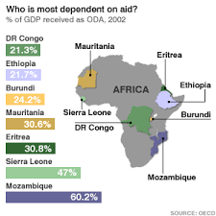
Figure #1. Aid dependency map displaying the countries with the most % of GDP as ODA in the African continent.
Importantly, it is not only the donor countries guilty of abusing foreign aid intended for humanitarian causes, since widespread corruption in recipient governments is an issue that must be recognized as well. Most notably, regions such as the Middle East and Sub-Saharan Africa have lost hundreds of billions of dollars through foreign aid, funneled into the pockets of corrupt political elites instead of public spending. Afghanistan, as a country ranked 166 out of 168 in the 2015 corruption perception index, especially highlights as an example of aid corruption. Political elites here, building up business empires and an intolerant political climate, have not been held accountable for the methods in which they spend their donor’s money. With leaders from the European Union pledging billions in aid, much of the money was lost at the infamous Kabul Bank scandal which saw almost $850m lost at what U.S officials describe as the “biggest per capita fraud” in history. Even with these funds knowingly going to suspicious insider loans and luxury casino visits under the name of shareholders, minimal punishments were carried out for these cabinet ministers and warlords. In another case, in the United States’ effort to fight the war on terror, the United States Agency for International Development (USAID) had cooperated with the Ministry of Health to establish basic levels of health care within the majority of Afghanistan’s population. Though there were visible improvements to life expectancy and the supply of medical equipment, the Ministry of Health still couldn’t show where roughly 25% of the U.S’s $236 million in investment went. Even with donors such as the EU and U.S highlighting this clear corruption epidemic in Afghanistan, the countries still have not placed any sort of conditional aid based on effective scrutiny, or examinations of the government’s cabinet members and other officials. Ultimately, nations have failed to hold the Afghan government accountable, and overall, corruption in developing countries has reduced the effectiveness and integrity of aid through pocketing funds for private matters rather than public spending.
Another case of such is Nepal, which has been a foreign aid recipient for over half a century ever since their joining of the Colombo Plan in 1952. This country, through its reliance of funding its agricultural and developmental projects with funds from other nations and international organizations, is a prime example of aid dependency—in the last decades of the 20th century, the percentage of GNP (Gross National Product) dedicated of foreign aid reached numbers over 20 percent with its debt levels increased as well. Unfortunately, even with this level of assistance, logistical and political barriers still prevent Nepal from developing to its full capacity. Through disaster relief efforts by the United Nations Development Program (UNDP) provided to rebuild the country after two major earthquakes in the 2010s, millions were poured into unspecified document lists as “professional services.” In its private sector, Nepal reportedly backs syndicates and cartels known to manipulate prices and control the country’s necessities—namely food, water, and energy—through monopolies, making it thoroughly difficult to enact any real change. Furthermore, the budgets of vital aid projects are poorly allocated and organized, with payment records even being misreported. All of these issues decrease the efficiency of the multitude of capital investment projects that countries—namely the European Union, Britain, and the United States—originally intended for economic development. Disturbingly, due to these events of known political corruption and mismanagement of resources, countries have become reluctant to provide as much aid through a loss of confidence.
Criticisms of the World Bank and IMF
Countries, however, are not the only source of mismanagement in foreign aid. The world’s leading organizations in foreign aid supply, namely the IMF and World Bank, have also been criticized of mishandling its economic resources. Due to the IMF providing loans on the condition of initiating various economic policies, such as establishing higher interest rates or reducing government borrowing, this type of intervention has in fact exacerbated numerous macroeconomic situations in the past. One such example is the Asian financial crisis in 1997, with threatened to become an international economic meltdown. With the IMF insisting on a contractionary fiscal policy—cutting spending and raising taxes, that is—this only deteriorated the economy into a recession with increased bankruptcies. The focus of the IMF at liberalizing economies, furthermore, has been criticized as increasing corruption as well. Allowing the privatization of 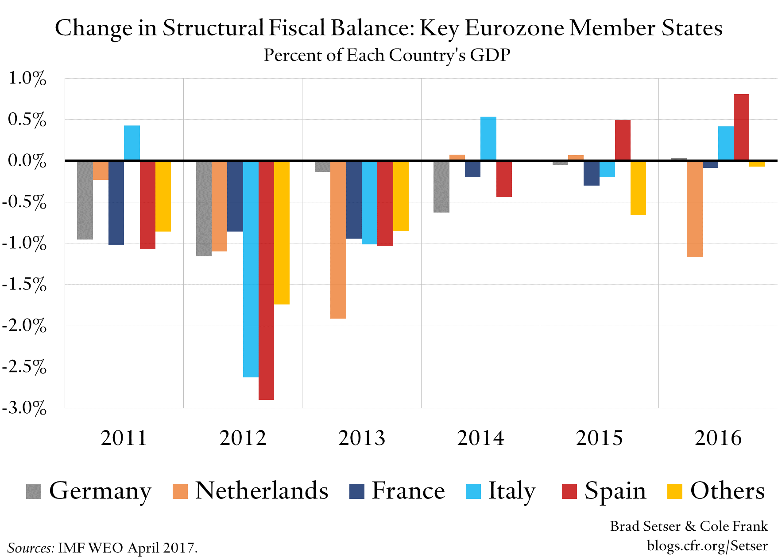
Figure #2. Graph displaying contrasting effects on fiscal balance with applied IMF principles.
the economy can not only create opportunities for lobbying and bribery, but can also reduce the ability of the state as a whole to combat internal corruption. Overall, due to the IMF’s failure to understand the economic conditions and dynamics of particular countries, their insistence on structural adjustment and blanket reforms has led to, on occasion, worsening economic situations.
Most recently, evidence from a policy research paper has documented elites capturing foreign aid given by the World Bank through examining offshore bank accounts. Alarmingly, some of the most aid- dependent nations have had significant deposits to offshore accounts, all for the benefit of ruling bureaucrats and their cronies. The study concluded with suggesting a 7.5% leakage rate of economic aid, on average, for the highly-aid dependent country.

Geopolitics
Considering the influence of geopolitical factors is crucial to studying the concept of foreign aid, providing explanations as to why some countries choose to abuse the foreign aid they give to other nations and why receiving nations mismanage the aid that is given. This section will help clarify the foreign policies and motivations of the most relevant countries involved in all forms of aid, particularly on how military and economic superpowers change and exploit geographical regions around them in accordance to their ideological beliefs and commercial wants.
United States of America
Ever since the earlier instances of aid from the 20th century, the United States remains as a key contributor to worldwide economic and military aid. Foreign assistance given by the United States is very consistent with their strategic interests regarding natural resources, defense, and the promotion of democracy. Since the Cold War era, the United States’ participation in development projects, particularly around the reconstruction of Japan and the rebuilding of many European powers in WWII’s aftermath, were all in the interest of reducing Soviet influence. In the 1970s, notable amounts of foreign aid were also given to countries such as South Korea and Taiwan, both of which now promote free-market principles in a democratic system (though this cannot be all credited to the U.S itself). More recently, with these nations now becoming prominent trading partners and military allies, the U.S is now facing the challenge of China in an arguably bipolar world (a world where the majority of influence is held between two nations) with its differing economic models and interests.

People’s Republic of China
Historically, China has also created its own external foreign assistance programs to help countries with similar ideological beliefs—namely, economic and military assistance was given to Vietnam and North Korea in the 1950s to alleviate their struggles with Western nations. After the crucial Reform and Opening-Up Policy in the late 20th century, however, China had begun to make its foreign aid policies more ambiguous and seemingly geared to worldwide humanitarian development. One of the country’s most notable contributions to aid is the Belt and Road Initiative, aiming to connect Asian regions to African and European ones through trade networks. With these efforts at stimulating economic growth, China has not only been able to successfully acquire more opportunities of soft power—that is, power through the appeal and preferences of other nations, but has also expanded its cultural influence on the world. To this end, the illustration of China as a nation with a socialist-capitalistic economy upholding select Western values is their strategy for attaining global leadership.
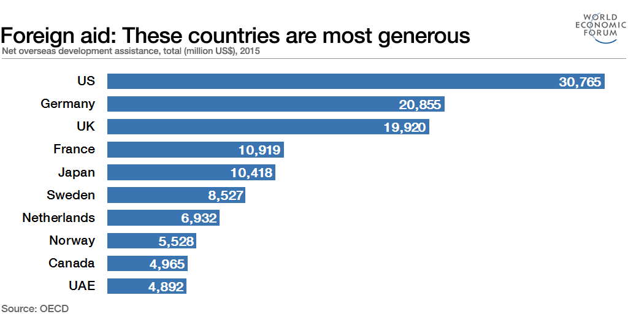
Figure #3. Graph displaying the major donators of overseas developmental assistance (million US$). While these countries are the top donators, they aren’t necessarily the “most generous”—rather, the countries donating the largest percentages of their GNI include Sweden, the United Arab Emirates (UAE), and the UK.

Transparency International
Apart from the IMF and World Bank, both key international organizations already discussed in this report, Transparency International has also provided notable contributions to the cause of combating foreign aid abuse and mismanagement. Particularly, the creation of the Corruption Perceptions Index (CPI) has been widely used as foundational evidence for worldwide action—by calculating the corruptness of public sectors based on the perception of experts and executives, this organization has been able to highlight misconduct and place it onto the international agenda. Furthermore, the creation of the International Aid Transparency Initiative (IATI) has also been able to promote accountability worldwide, participating in events such as whistleblower protection and citizen empowerment.

Previous Attempts to Solve the Issue
The mismanagement of foreign aid is a particularly broad topic that requires reformation in multiple facets of foreign aid in order to completely reduce misconduct and strengthen the effectiveness of assistance. Thus, while the UN and other international organizations have not taken actions or provided documents solving the issue as a whole, there still are numerous attempts at solving specific components of foreign aid.
The IMF, firstly, has taken steps to better its policies in terms of alleviating poverty in the world’s lowest-income countries—increased efforts at transparency is an integral part of facilitating concrete change as well. During the global financial crisis in the late 2010s, the IMF had approved reforms increasing its ability to lend and financially support the most impoverished nations. These loan resources, being substantially heightened, also included zero-interest concessional loans, extended several years into the future. Importantly, this organization has also improved its surveillance mechanisms in recent decades, adding the Global Financial Stability Report and World Economic Outlook as part of its library of resources monitoring the stability of the financial system. Unfortunately, due to performance issues with suggested economic policies in countries in need of assistance, and other criticisms regarding loans being too intrusive and counterproductive, the IMF has been widely viewed as an organization incapable of alleviating economic crises, much less foreign aid.
The Transparency International’s foreign aid affiliate, IATI, has taken direct action on the issue of countering foreign aid through tracking financial resources. Especially, case studies such as the Madagascar case study conducted by this organization revealed millions of dollars in funding for humanitarian aid previously unknown to the government. Improving the planning of aid and the coordination of Non-governmental organizations (NGOs) with state governments specifically, is an integral part at solving this issue. However, when considering the reach of this organization’s access to data and surveillance when considering issues of national sovereignty, and referencing to the campaign’s failures at addressing the regions in the world with most aid mismanagement and diversion problems, this attempt to solve the issue is clearly limited in creating change as well.

Relevant UN Treaties and Events
- UN General Assembly Resolution 1995 (A/RES/49/233) — calling for the strengthening and oversight of peacekeeping operations in the aftermath of the UN’s failure to contain the Rwandan genocide.
- UN General Assembly Resolution 2001 (A/RES/55/235) — deciding the expenses used and financing of peacekeeping operations, recognizing that less economically developed countries have limited capacities at funding such operations.
- UN General Assembly Resolution 2011 (A/RES/65/284) — emphasizing the implementation of the New Partnership to strengthen the growth and economic development of Africa.

Possible Solutions
Currently, justice systems in some of the world’s most corrupt countries are unable to pressure and respond to corrupt individuals themselves--even organizations such as the IMF and UN are close to powerless in this regard. Though the UN Security Council may be able to implement economic sanctions as a method of soft power, this approach would only set back countries—especially LEDCs—even further. Decreasing a nation’s commercial engagement through sanctions, when a nation already poorly manages its economic resources, would only serve to do more harm than good. Furthermore, the UN framework itself, with respect to the veto power given to the permanent 5 nations (that being Britain, China, France, Russia, and the United States) creates ideological barriers that prevent positive change. To this end, it is safe to say that worldwide institutions dealing with accountability (as of now) are unable to address this very issue. A new systematic approach, or organization, must be created in order to fully tackle this problem.
One enticing but seemingly improbable proposal is the creation of an International Anti-Corruption Court (IACC) modelled on the existing International Criminal Court (ICC). This organization may be beneficial for a variety of reasons, one being that the justice systems in affected countries are unable to hold corrupt political figures accountable themselves. An IACC is a solution to this problem, assisting these countries by strengthening domestic justice systems and deterring future aid misconduct as a symbol of anti-corruption. In a world where corrupt officials are able to stay in power through controlling the military, prosecutors, and tribunals, a court of international origin—whose sole purpose is to impartially investigate—can potentially end this vicious cycle of impunity. While in court, associates of criminal officials should be offered incentives (such as protection and shortening of prison sentences) in exchange for disclosing information about law violations and waste/diversion in funds to encourage whistleblowing. However, though this vision may sound appealing in practice, delegates must consider the many political questions regarding feasibility and execution if they were to choose this topic.
First, for the IACC to have jurisdiction over any country in the first place, that country would need to voluntarily agree to an investigation. Here, when it is already in the interest of the corrupt to evade punishment domestically, delegates must give these officials an incentive to join the IACC in order for them to submit to an international trial. Such incentives can include making participation in the IACC a condition for receiving large amounts of aid, joining trade organizations, and participating in any other agreements/treaties that interest that particular nation. Threats of soft power through diplomatic sanctions or an arms embargo could be used to coerce corrupt leaders into joining as well. Even through the assumption that a particular nation will join, international prosecutors cannot conduct investigations through wiretapping or inspecting financial records in the first place due to the issue of national sovereignty—that is, the idea that countries themselves have the full right to govern themselves without any outside interference. In consideration of these barriers, delegates must critically negotiate with authorities dealing with domestic law enforcement and create pathways for international tribunals to generate positive change.
Another solution that would directly benefit a nation that mismanages its aid in particular is through taking advantage of the expertise of international organizations such as the IMF to create better aid management plans for countries. In 2016, an IMF fund was created for the sole purpose of assisting countries in managing their natural resources through technical and financial assistance, training, and diagnostic assessments. This would help advertise particular nations as more capable of using their aid resources efficiently, which will very likely increase the amount of foreign aid a particular nation receives from countries. In the end, foreign aid is just like investment in that countries, just like individual investors, want to believe that they will obtain benefits through giving—with the countries/companies being invested into being able to more capacity, the growth of that body would be worth the transaction in the long run. Therefore, simply giving MEDCs and organizations such as the World Bank a reason to provide aid would be an effective solution in itself.
In a purely economic perspective, the issue of foreign aid is overwhelming tied to dependency as well—foreign aid as a concept and issue only exists because of inequality and mismanagement in the first place. Therefore, measures must be taken to reduce aid dependency, by producing a skilled domestic workforce and increasing the commerce of a particular country. Firstly, to heighten the creation of jobs, delegates should address incentives to improving the quality of education, paired with heightened and committed investment into the private sector. Delegates should also encourage countries to work with relevant international organizations such as the IMF to spend GDP on strategic sectors that a country specifically specializes in—that is, economic diversification. Overall, these changes to a nation’s economy and workforce should be primarily through the decisions of the country itself, not through the suggestions of international organizations or other countries. If any nation is successful in doing so, then that nation has also successfully eliminated much of its aid dependency.

Bibliography
“Aid Effectiveness .” Data, data.worldbank.org/topic/aid-effectiveness.
Baldwin, David A. “Foreign Aid, Intervention, and Influence: World Politics.” Cambridge Core, Cambridge University Press, 18 July 2011, www.cambridge.org/core/journals/world-politics/article/foreign-aid-intervention-and-influence/B80B9624832DC5BEB1C549475F3B3511.
Bell, Thomas. “Nepal's Failed Development.” Asia | Al Jazeera, Al Jazeera, 22 Mar. 2015, www.aljazeera.com/indepth/opinion/2015/03/nepal-failed-development-150322052502920.html.
Carl, Schudel. “Corruption and Bilateral Aid: A Dyadic Approach.” JSTOR, Sage Publications, Aug. 2008, www.jstor.org/stable/27638623?read-now=1&seq=1#page_scan_tab_contents.
Cheng, Cheng. “The Logic Behind China's Foreign Aid Agency.” Carnegie Endowment for International Peace, carnegieendowment.org/2019/05/21/logic-behind-china-s-foreign-aid-agency-pub-79154.
Christopher , Fariss. “The Strategic Substitution of United States Foreign Aid.” JSTOR, Oxford University Press , Apr. 2010, www.jstor.org/stable/24909807?seq=1.
Cox, Simon. “Where Is Nepal Aid Money Going?” BBC News, BBC, 21 May 2015, www.bbc.com/news/world-asia-32817748.
“The Development and Transformation of China's Foreign Aid.” The Development and Transformation of China's Foreign Aid | Center for Strategic and International Studies, www.csis.org/development-and-transformation-chinas-foreign-aid.
Edwards, Sebastian. “Development and Foreign Aid: A Historical Perspective.” VOX, CEPR Policy Portal, 28 Nov. 2004, voxeu.org/article/development-and-foreign-aid-historical-perspective.
Guilbert, Kieran. “UK Should Cut Aid to Nepal If ‘Endemic’ Corruption Persists: Report.” Reuters, Thomson Reuters, 27 Mar. 2015, www.reuters.com/article/us-britain-nepal-aid-corruption/uk-should-cut-aid-to-nepal-if-endemic-corruption-persists-report-idUSKBN0MN00F20150327.
“How We Are Funded Peacekeeping.” United Nations, United Nations, peacekeeping.un.org/en/how-we-are-funded.
Maipose, Gervase S. “Aid Abuse and Mismanagement in Africa: Problems of Accountability, Transparency and Ethical Leadership.” SpringerLink, Palgrave Macmillan, London, 1 Jan. 1970, link.springer.com/chapter/10.1057%2F9780333982440_5.
Malik, Kenan. “As a System, Foreign Aid Is a Fraud and Does Nothing for Inequality | Kenan Malik.” The Guardian, Guardian News and Media, 2 Sept. 2018, www.theguardian.com/commentisfree/2018/sep/02/as-a-system-foreign-aid-is-a-fraud-and-does-nothing-for-inequality.
“Nepal.” Transparency.org, www.transparency.org/en/countries/nepal.
Shah, Anup. “Foreign Aid for Development Assistance.” - Global Issues, www.globalissues.org/article/35/foreign-aid-development-assistance.
Stevens , Poe. “Human Rights and US Foreign Aid: A Review of Quantitative Studies and Suggestions for Future Research.” JSTOR, The John Hopkins University Press, Nov. 1990, www.jstor.org/stable/762497?seq=1#metadata_info_tab_contents.
“U.S. Foreign Assistance in the Age of Strategic Competition.” U.S. Foreign Assistance in the Age of Strategic Competition | Center for Strategic and International Studies, 31 July 2020, www.csis.org/analysis/us-foreign-assistance-age-strategic-competition.
Wallace, Tim. “Foreign Aid Corruption Paper Causes Storm at World Bank.” The Telegraph, Telegraph Media Group, 18 Feb. 2020, www.telegraph.co.uk/business/2020/02/18/foreign-aid-corruption-paper-causes-storm-world-bank/.
Williams, Victoria. “Foreign Aid.” Encyclopædia Britannica, Encyclopædia Britannica, Inc., 12 Mar. 2020, www.britannica.com/topic/foreign-aid.

