Forum: Environment Commission
Issue: Developing sustainable prevention measures to combat the proliferation of wildfires
Student Officer: Emma Zhou
Position: Deputy President of the Environment Commission

Introduction
In recent years, the wildfires in Australia have alone caused at least 33 deaths and 27.2 million acres burned. Thousands of homes there have been destroyed in the destruction of the fires, causing a large number of people looking for a place to stay (BBC). But Australia is not the only one affected by the drastic effects of wildfires. The Amazon rainforest, the United States, and countries all over the world have suffered from wildfires.
Over the past decades, there has been a rapid increase in wildfires. Many countries are facing the environmental effects caused by wildfires. These country’s environments are being polluted by the fires and they lose many of their resources. Homes got destroyed, animals have been killed, and lives were lost in the process.
The wildfires are caused because of many different reasons, either set on accident or on purpose. For example, accidental fires may be caused by carelessly throwing away cigarettes or having unsupervised fires, while some fires are started on purpose for other reasons. In some countries, farmers deliberately set fire to their crops to make space for new ones, repeating this process every year. Both ways are extremely harmful to the country itself and neighboring countries because of the heavy smoke. Heavy smoke causes many health risks that is damaging to the lungs once inhaled, and it causes premature death. In all cases, wildfires generally need three things to start and spread: high temperatures, oxygen, and flammable materials (leaves, shrubs, dead branches, etc.) (National Park Service).
Sustainable prevention is made more difficult because of rising temperatures worldwide. Ever since 1880, the temperature has already risen 1.9°F (1.09°C) (NASA). Wildfires have rapidly increased over the years because of the warmer climate and the aspects that led to it, such as releasing greenhouse gases into the air. Wildfires are also directly impacted by deforestation and the effects have worsened. Both climate change and deforestation have become huge problems that lead to the rapid increase of fires across the globe. Countries are working together to stop the wildfires and the effects, but there are still other ways to approach the issue and improve the current situation.

Definition of Key Terms

Wildfire
The Food and Agriculture Organization of the United Nations defines a wildfire as any ‘unplanned and uncontrolled wildland fire which regardless of ignition source may require suppression, response, or other action according to agency policy.’

Sustainable prevention measures
Sustainable prevention measures for wildfires target the root cause of them. This must be done in a sustainable way, so that potentially scarce resources such as water, or potentially harmful chemicals sometimes dropped by airplanes, are not constantly required. There are a variety of ways to target the root cause in order to avoid further damage from the fires. Targeting the root cause should be the main source of action to prevent the proliferation of wildfires, but there also needs to be solutions to mitigate the environmental effects after a wildfire has begun
Proliferation
Proliferation is the rapid increase of spreading. This chair report addresses the proliferation of wildfires across the globe.

Root Cause
The root cause represents how something is caused. For wildfires, their root cause is from unsupervised campfires, cigarettes, burning crops, warm climate, and many other ways. A lot of the root causes are accidental, but some are done on purpose.

Reforestation
Reforestation is to fill an area with trees. This is normally done because of deforestation and the side effects, so reforestation is the solution to stabilize the environment.

Afforestation
Afforestation is the process of making a new forest by planting trees in a completely empty piece of land. While afforestation is similar to reforestation, afforestation focuses more on an empty piece of land instead of planting trees in a place with a few trees left.

History & Developments

History

Wildfires caused by natural means, such as lightning strikes, have always been a part of human history. But as agricultural practices such as burning palm oil plantations have become more common, there has been an increase in human responsibility for wildfires. Furthermore, increasing global temperatures have exacerbated natural weather patterns such as drought and high temperatures and provided more opportunities for wildfires to start and spread.

Devastating wildfires have ravaged forests in the United States, Brazil, Australia, and many other countries, but the frequency and severity of the problem have escalated in recent years.

The Camp Fire
The Camp Fire of 2018 was the worst wildfire California had ever faced. There were many other wildfires, but this was caused by the increase in temperature and climate change. California has adapted to the warm and dry climate since climate change became more and more intense. At least 48 people were killed because of the Camp Fire, with 150,000 acres and 18,000 buildings destroyed (Time).

Australia Fires
Australia, because of its hot and dry climate, has faced many dangerous, extreme fires in the past few decades. However, the 2019 fire that struck Australia was one of the most destructive fires it faced. People were killed, animals became endangered, and homes got destroyed in the flames. The smoke from the wildfires drifted across the region and also affected faraway places such as New Zealand. Australia gained a lot of support from other countries such as Canada and the United States. For example, there were more than 2,000 firefighters combatting the proliferation of wildfires in Australia alone. The military also helped extinguish the fires and helped the citizens. Additionally, donations from various organizations, countries, and citizens have been made to help rebuild infrastructure, rescue those affected by the fire, and save animals (BBC).

Amazon Fire
The Amazon, the largest rainforest in the world and home to 10% of the world’s species, has also faced extremely destructive wildfires. Their wildfires mainly start for agriculture and to plant new crops. The farmers use a technique, where they would burn off the old crops to replace them with new ones. This technique created several fires, which harmed all the wildlife in the rainforest. The fire started recently, in 2019, and it spread over the rainforest and harmed 17% of the entire area.

Geopolitics
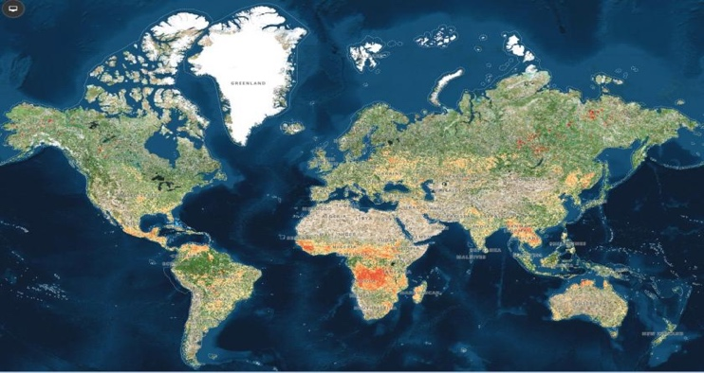

Ratio of Active Fires frequency per square kilometer for the period 01/10/2019 to 26/08/2019 produced by GRID Geneva. Data accessed in August, 2019 at https://modius.gsfc.nasa.giv/data/dataprod/mod14.php

In this image, the lighter the color represents the less fires the areas face. Whereas the redder areas represent how hot and dry the climate is, which produces more wildfires.

Australia
Australia faced some of the worst wildfires in the past few decades. Due to the dry climate, fires are easier to spread. Natural causes, such as lightning strikes, are the main source of these fires, but some are spread because people deliberately set them. Even though there are natural causes to why wildfires start, there needs to be more action on how to help wildfires started by human action. These wildfires killed a large number of people and endangered many animals native to Australia. It is estimated that around half a billion animals have suffered and been burned by the fires. A lot of animals more native to Australia have been going extinct because of the flames and smoke spreading across the area. Furthermore, a lot of people are getting harmed in the fires. Their homes were destroyed in the fires, so a lot of resources are directed towards getting them help. For example, the Morrison administration has donated more than a billion dollars to rebuild places affected by the fires (CNN).
Also, because of all the dangerous consequences of the fires, New South Wales, Victoria, and the state of Queensland all declared a state of emergency (CNN). The fires spread smoke all over the country and across the world, harming citizens’ health.

Indonesia
Indonesia is already heavily polluted with the amount of smoke coming from fires deliberately set to continue agricultural practices. The country is well-known for setting fire to their crops to plant new ones, thereby adding more smoke to the air every time new crops need to be planted. This process of burning crops to plant new ones has already burned more than 800,000 acres of land across Indonesia. Famers gain palm oil from their crops, which is extremely important to many of their resources. Due to how much the country relies on palm trees, they repeat the process of burning crops every year. The smoke from the burning has already drifted to neighboring countries because of too little control over the practices of these farmers.
However, the nation did start to employ more people to combat the fires and they also created new laws to prevent the proliferation of fires. The police are now required to arrest those that have started these fires and have prohibited the practice of burning old crops to plant new ones (Washington Post).

Brazil
Brazil is also facing many problems and consequences with wildfires. The fires started there are also because they needed to replace the old crops with new ones by burning them. The wildfires start frequently, and was a problem back in 2005, even when climate change was not as serious as it is now (BBC).
Furthermore, the Amazon rainforest located there provides a lot of resources, stabilizes the world’s temperature, and is home to millions of species. It is the biggest rainforest on earth and without it, the world will lose many species only found there, plants used for medicine, and a lot more (World Wild Life). But deforestation has become a huge problem that is one of the main causes of these wildfires. Brazil had tackled deforestation by protecting areas and banned a lot of people from going there. The government enforced several laws that have worked and stopped many people from destroying the forests by deforestation. The government also supported research that helped farmers, so they could adjust to more sustainable ways for farming where trees do not need to be cut down. Even though there have been a lot fewer deforestation problems, there are still ways to improve their actions.
Because of the wildfires, the president of Brazil, Jair Bolsonaro, implemented the army in the Amazon and prohibited anyone from setting fire in the Amazon for 60 days. This method proved to be successful and the fire spread less rapidly. However, although it did stop the burning for 60 days, they have not tackled the root cause enough: deforestation. There are now organizations working with the government of Brazil to help distinguish these fires and combat the proliferation of them (BBC).

California
California suffers from many extreme human-started fires. Because of the dry and warm climate, wildfires spread much easier. 270,000 acres have already been burned back in 2019 because of the wildfires, and there were approximately 735 destroyed infrastructures (Los Angeles Times). The Camp Fire was the worst wildfire California has faced, and it was because of the increasing climate and the dry environment. There were other causes of fires: electric use, natural causes, and unattended campfires.
The country is doing a lot to help and to improve on methods of stopping the proliferation of wildfires, such as: implementing firefighters, engines, and aircraft to fight the wildfires. However, their current actions are not enough. California’s national forests rarely restrict people from entering, which increases the probability of starting the fires.

Previous Attempts to Solve the Issue
In order to combat the proliferation of these wildfires, countries have taken a variety of actions to extinguish them and prevent future wildfires. All of the countries facing wildfires have implemented more firefighters in the region, so they could extinguish the fires. Some countries, such as Brazil, have implemented the military into their regions for this job. On the other hand, other countries have enforced aircraft and high-level technology.
Furthermore, countries are also using research to improve on their attempts at extinguishing wildfires. More and more countries are using aircraft since it is more efficient and more advance in technology. A lot of the research goes into finding out more about how fires change in different environments with different circumstances. Additionally, they also try to improve the quality of their firefighting resources and technology to make sure it could extinguish the fires efficiently and effectively. Furthermore, these researches look into how dangerous and destructive the fire might be, so they could warn the citizens and keep everyone safe (United States Environmental Protection Agency).
However, countries are not the only ones combatting the proliferation of wildfires. The Missoula Fire Sciences Laboratory, San Dimas Technology and Development Center, and NASA all research on the behavior of fires and how to combat them (United States Department of Agriculture).

Relevant UN Treaties and Events
- International Decade for Natural Disaster Reduction, February 25th, 1988 (A/RES/42/169
- United Nations Framework Convention on Climate Change (opened for signature 4 June1992, entered into force 21 March 1994) (UNFCCC)

- Non-legally binding instrument on all types of forests, GA Res. 62/98 (31 January 2008) para 6

- Non-legally binding authoritative statement of principles for a global consensus on the management, conservation and sustainable development of all types of forests, UN Doc.A/CONF.151/26 (Vol. III) (Rep. of the United Nations (UN) Conference on Environment and Development, 14 August 1992)

- United Nations Strategic Plan for Forests 2030 adopted by UN General Assembly April, 2017, creating six Global Forest Goals and 26 associated targets.

Possible Solutions
Although many actions being taken already, there are many more feasible solutions to combat the proliferation of these wildfires.
First, it is significant to combat the root cause of these wildfires. There have already been attempts to stop fires from spreading even more, but to stop fires from starting in the future, there need to be long-term solutions. To stop the proliferation of wildfires, it is crucial for international cooperation. With the help of other nations, the fires can gradually decrease over time. Nations should engage in scientific research partnerships both regionally and as part of the United Nations system. By working with other countries, they can support each other with resources and enough people to help extinguish the wildfires damaging their region.
Second, climate change plays an important role in starting the fires because of the hotter temperature. Fires spread easier when the climate is hotter and drier, which means that countries should focus on trying to mitigate the effects of climate change. Countries should put their effort into changing to clean energy and relying less on fossil fuels. Not only could this help reduce climate change, but it could also stop the spreading of fires.
Third, more research is required to combat the proliferation of wildfires and help out the citizens. With more research, there could be more solutions targeting different ways to stop the fire and how to reduce the health risks from the smoke still in the air. There is already a lot of research going on to find out how these fires start and where might be a safe place for citizens to go to escape the fire. The U.S. Forest Service, International Association of Wildland Fire (IAWF), National Wildfire Coordinating Group (NWCG), The National Interagency Fire Center (NIFC), are all institutions that help prevent the proliferation of wildfires.
It is important for governments to monitor what is being done and how they could improve. Local and national governments need to closely monitor data, and the United Nations Environment Program (UNEP) has set up The World Environmental Situation Room 2.0 to help relevant officials to share data and strategies. This is part of the One Global Partnership which has gathered more than a thousand datasets and made them available online.
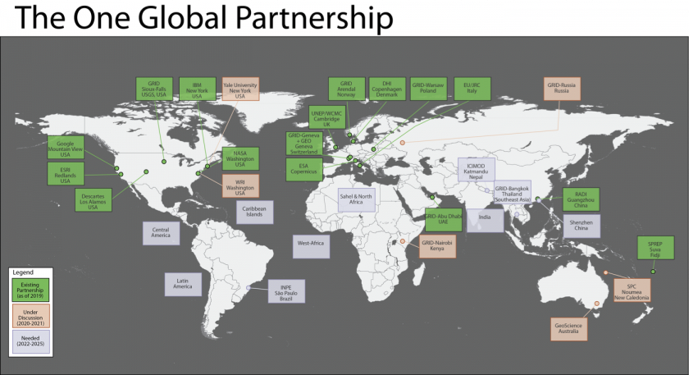

Wildfire situation room One Global Partnership. Image by UNEP
Another excellent source of data is the Global Forest Watch, which monitors forests globally and sends out alerts when it sees wildfires break out, which can lead local officials to take action within 24 hours. A lot of problems governments face is the lack of monitoring in these places, which causes an increase in accidental fires or just deliberate fires.
Nations should also create or strengthen forest maintenance procedures, which can include creating fire-breaks such as roads in an area where wildfires are likely, and regular forest maintenance, including reducing flammable material from the forest floor, protection, restoration, reforestation, and afforestation. Nations should also increase the number of both protected forests and sustainably managed forests. (United Nations Strategic Plan for Forests, 2030). In some cases, a controlled burn, where areas adjacent to forests are burned in a monitored fashion to prevent spread, can be effective, as can mandating safe zones, free from vegetation, between forests and human settlements.

Bibliography
Agencies & Organizations. (n.d.). Retrieved July 24, 2020, from https://research.cnr.ncsu.edu/blogs/firechasers/resource/agencies-organizations/

“Amazon Fires Increase by 84% in One Year - Space Agency.” BBC News, BBC, 21 Aug. 2019, www.bbc.com/news/world-latin-america-49415973.

Australia fires: A visual guide to the bushfire crisis. (2020, January 31). Retrieved July 10, 2020, from https://www.bbc.com/news/world-australia-50951043

Australia fires: What's being done to fight the flames? (2020, January 23). Retrieved July 10, 2020, from https://www.bbc.com/news/world-australia-51008051

Brazil's Success in Reducing Deforestation. (n.d.). Retrieved July 24, 2020, from https://www.ucsusa.org/resources/brazils-success-reducing-deforestation

Calma, J. (2019, August 28). Everything you need to know about the fires in the Amazon. Retrieved July 10, 2020, from https://www.theverge.com/2019/8/28/20836891/amazon-fires-brazil-bolsonaro-rainforest-deforestation-analysis-effects

February 25, 2. (2020, February 27). The Amazon Is Still on Fire. Retrieved July 10, 2020, from https://www.nrdc.org/experts/jessica-carey-webb/amazon-still-fire

Fire Research. (n.d.). Retrieved July 10, 2020, from https://www.fs.usda.gov/science-technology/fire/fire-research

Food and Agriculture Organization of the United Nations (FAO), Fire management glossary (online) <http://www.fao.org/forestry/firemanagement/87925/en/> accessed 28 August 2015.

Forest Fire Prevention Tips. (n.d.). Retrieved July 08, 2020, from https://portal.ct.gov/DEEP/Forestry/Forest-Fire/Forest-Fire-Prevention-Tips

GAO-17-357, WILDLAND FIRE RISK REDUCTION: Multiple Factors Affect Federal-Nonfederal Collaboration, but Action Could Be Taken to Better Measure Progress. May 2017, www.gao.gov/assets/690/684545.pdf. Accessed 9 July 2020.

GLOBAL FOREST GOALS AND TARGETS OF THE UN STRATEGIC PLAN FOR FORESTS 2030. www.un.org/esa/forests/wp-content/uploads/2019/04/ Global-Forest-Goals-booklet-Apr-2019.pdf. Accessed 9 July 2020.

Hughes, R. (2019, October 12). Amazon fires: What's the latest in Brazil? Retrieved July 08, 2020, from https://www.bbc.com/news/world-latin-america-49971563

Human-caused ignitions spark California's worst wildfires but get little state focus. (2020, January 05). Retrieved July 10, 2020, from https://www.latimes.com/environment/story/2020-01-05/human-caused-ignitions-spark-california-worst-wildfires

International cooperation in wildland fire management. (n.d.). Retrieved July 08, 2020, from http://www.fao.org/3/y5507e/y5507e02.htm

International Decade for Natural Disaster Reduction : resolution / adopted by the General Assembly. digitallibrary.un.org/record/152704?ln=en. Accessed 9 July 2020.

International Relations for Reducing Wildfire Impacts – Some History and Some Thoughts. www.fs.fed.us/psw/publications/documents/psw_gtr261en/ psw_gtr261_001.pdf. Accessed 9 July 2020.

Irfan, U. (2019, August 30). Why it's been so lucrative to destroy the Amazon rainforest. Retrieved July 10, 2020, from https://www.vox.com/energy-and-environment/2019/8/30/20835091/amazon-rainforest-fire-wildfire-bolsonaro

Martinez, G. (2018, November 14). Camp Fire Is the Deadliest Wildfire in a Century. Retrieved July 10, 2020, from https://time.com/5453710/california-camp-fire-deadliest-wildfires-us-history/

Mellen, R. (2019, September 18). Wildfires in Indonesia have ravaged 800,000 acres. Palm oil farmers are mostly to blame. Retrieved July 08, 2020, from https://www.washingtonpost.com/world/2019/09/18/wildfires-indonesia-have-ravaged-acres-palm-oil-farmers-are-blame/

(n.d.). Retrieved July 10, 2020, from http://www.fao.org/3/xii/0829-b3.htm

Safe and Effective Wildfire Response. (n.d.). Retrieved July 24, 2020, from https://www.fs.usda.gov/managing-land/fire/response

Satellite Data Record Shows Climate Change's Impact on Fires – Climate Change: Vital Signs of the Planet. (2019, September 11). Retrieved July 10, 2020, from https://climate.nasa.gov/news/2912/satellite-data-record-shows-climate-changes-impact-on-fires/

Sustainability and Wildland Fire The Origins of Forest Service Wildland Fire Research. May 2017, www.fs.usda.gov/sites/default/files/fs_media/fs_document/sustainability-wildlandfire-508.pdf. Accessed 9 July 2020.

The UN in Brazil calls for efforts to fight forest fires. (2019, September 03). Retrieved July 08, 2020, from https://en.unesco.org/news/brazil-calls-efforts-fight-forest-fires-3

UN Environment. (n.d.). Governments, smart data and wildfires: Where are we at? Retrieved July 08, 2020, from https://www.unenvironment.org/news-and-stories/story/governments-smart-data-and-wildfires-where-are-we

United Nations strategic plan for forests, 2017-2030. www.un.org/esa/forests/ wp-content/uploads/2016/12/UNSPF_AdvUnedited.pdf. Accessed 9 July 2020.

“What Animals Live in the Amazon? And 8 Other Amazon Facts.” WWF, World Wildlife Fund, www.worldwildlife.org/stories/what-animals-live-in-the-amazon-and-8-other-amazon-facts.

Wildfire Causes and Evaluations (U.S. National Park Service). (n.d.). Retrieved July 08, 2020, from https://www.nps.gov/articles/wildfire-causes-and-evaluation.htm

Wildland Fire Research to Protect Health and the Environment. (2019, December 18). Retrieved July 10, 2020, from https://www.epa.gov/air-research/wildland-fire-research-protect-health-and-environment

WILDLAND FIRE RISK REDUCTION Multiple Factors Affect Federal-Nonfederal Collaboration, but Action Could Be Taken to Better Measure Progress. May 2017, www.gao.gov/assets/690/684545.pdf. Accessed 9 July 2020.

Yeung, J. (2020, January 14). What you need to know about Australia's deadly wildfires. Retrieved July 08, 2020, from https://www.cnn.com/2020/01/01/australia/australia-fires-explainer-intl-hnk-scli/index.html

