Forum: Security Council I
Issue: Measures to ensure geopolitical stability in the Sahel
Student Officer: Sherissa Wu
Position: President of Security Council I

Introduction
Over the last few decades, the Sahel’s growing list of conflicts has attracted international media coverage and captured the focus of supranational organizations like that of the UN. Within its borders, African nations face issues like the resurgence of irredentism that threatens stability and pitches groups against each other in a fight for the possession of territories and scarce resources. In the Sahel, a confluence of interrelated events and different issues compound each other, wracking the region in far-reaching consequences. First, climate induced changes and unsustainable practices like deforestation have turned previously fertile lands barren, forcing pastoralists into a scramble to search for fresh pasture and water. The consequent famines, droughts, and rising tensions between farmers and landless herders have placed millions of individuals in permanent states of food insecurity. Second, the resurgence of armed groups and the mobilization of socially excluded minorities into state soldiers to combat security threats has rekindled violence and placed hundreds of thousands of lives at risk. Terrorist organizations, organized crime syndicates, and criminal networks continue to exploit porous borders and lax regulations in the illicit trade and proliferation of Small Arms and Light Weapons (SALWs). Third, the governance of incapable and weak administrations with little to no law enforcement has incited the efforts of ethnic militias to massacre entire religious populations. With high ranking officials often colluding with ethnic majorities, there is little to no rule of law or redress for victims of hate fueled attacks. Democratic principles are crumbling as elections are interrupted and presidential candidates lose their core constituencies because of failures to ensure security and promote economic development. By virtue of the modern state system, neighboring countries are also affected by the conflicts that happen within other Sahelian states. Through the disruption of commerce and transportation routes, refugee flows, and the movement of jihadist groups, few issues are confined within any one nation. Geopolitical instability continues to upheave societies across the Sahel.

Definition of Key Terms
The Sahel
The Sahel is a region situated in north central and western Africa that stretches from Senegal to Eritrea. It extends from the Atlantic coast to the Red Sea coast and sits on the southern border of the Sahara Desert. The region includes Senegal, Mauritania, Mali, Burkina Faso, Niger, Nigeria, Chad, Sudan, and Eritrea. The Sahelian climate is semi-arid and semi-grassland, which has severe implications in terms of inconsistent climatic patterns and the mass migration of people from rural areas into urban centers to escape these conditions.
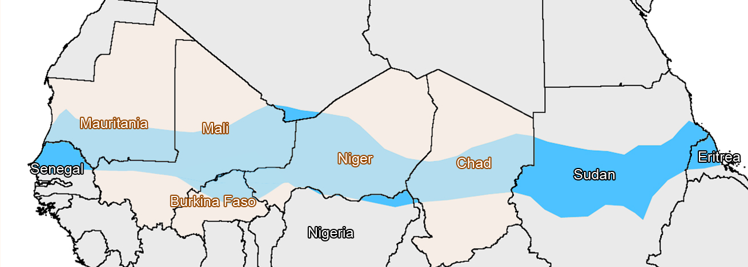

Figure #1: Map of the Sahel
Geopolitics
For the purposes of this report, “geopolitics” entails the struggle for political power related to geographical territories. Geopolitics references human and geographic influences on international relations. While the term is used most frequently regarding the interactions of nations with foreign countries, geopolitics can be analyzed through two dimensions: intra-state geopolitics, or the internal geopolitics of a nation, and inter-state geopolitics, or the exchanges between a nation and its immediate neighbors and/or foreign countries. The geopolitics of a nation include politically drawn borders, geographic features i.e. mountains, oceans, rivers, or lakes, and the general landscape of a nation. An example of geopolitical tension is Israel and surrounding Arab nations – the proximity of Israel to encroaching Arab nations, Israel’s lack of natural barriers for protection towards the north, Israel’s desire to hold onto Syria’s captured Golan Heights, and its small size, coupled with the Mediterranean Sea at its back making it impossible to hide or retreat, has a causal relationship with the defensive and territorial nature of Israel.
Tuaregs
The Tuaregs are Berger nomadic people – an ethnic confederation that is primarily Muslim. They inhabit the Sahara in North African countries like Algeria, Mali, and Burkina Faso, although the majority of the Tuaregs reside in Niger. While the Tuaregs are composed of subsets of different ethnicity and allegiance, the majority maintain a degree of aligned interest in terms of representation and independence. (see geopolitics section for interests)

History & Developments

2012 Sahel drought

For years, the Sahel has had a series of devastating droughts and famines. Millions go hungry and the ultra-rich are often the sole beneficiaries of soaring food prices. In 2012, a widespread drought that affected the entire Sahel region was made worse by stimulants like carbon emissions and greenhouse gases. The symbiosis between farmers and herders who brought with them natural fertilizer from their cattle that benefited farmers’ crops was broken when the competition for resources and fertile land escalated into violence. Abused by each other and by mercantile elites, herders and farmers were often recruited into rebel groups or terrorist networks to serve as soldiers in interlinked hostilities. While various jihadist groups were slowly on the rise, inter-communal violence began tearing apart nations from the inside.

Tuareg rebellions in Mali

Background of the conflict
The Sahel straddles an extremely vast expanse of land teeming with different ethnicities and cultures. A lot of the history of respective nations is deep rooted in the divergence of belief systems and the often-indentured servitude and repression of minorities. However, certain events serve as key junctures connecting conflicts that transcend national lines and political divisions; they affect the entirety of the Sahel. While disputes have always existed to some extent between different religious groups of individual Sahel nations, civil unrest and rebellion has turned Mali into the birthplace and epicenter of Sahelian conflicts.
After gaining independence from French rule, Mali suffered from decades of dictatorial rule and several coups d’état. Through policies of co-opting and pandering to the interests of powerful elites, social and economic issues were deprioritized. Leaders had vested interests in solidifying hierarchies, so long as they remained on top. Mali’s geography and place within the Sahelian belt expedited its downward spiral into states of acute climate and resource crisis, exacerbating the effects of the inequitable distribution of resources and corruption within the country. Distrust between minorities in the north and the homogenous majority backed government in the south grew. Unfortunately, even after the establishment of democracy in 1991, a lot of these issues continued. Under President Amadou Toumani Touré in the early 2000s, Mali was broken into fiefdoms in which politically affiliated parties acted with impunity in exchange for a stake in their profits. Previously in the late 1990s and a few other times before, Tuareg rebellion forced Mali to initiate strategies of decentralization to placate rising Tuareg opposition in the north. After augmented security and judicial reform, the majority of the Tuareg forces were disbanded or served in Gaddafi’s Libyan army after fleeing Mali to Libya. For a time, the Tuaregs who stayed within Mali had their wishes for a recognized political identity and the right to be combatants in Mali’s national army appeased. However, this Malian unity did not last. In response to deteriorating relations with democratic authorities in Mali’s capital Bamako and disintegrating Tuareg representation in politics, a much more insidious Tuareg rebellion was brewing.
The 2012 Tuareg Rebellion

By valuing the Tuaregs for their resourcefulness as soldiers in his quest to assert control over the Sahara, Gaddafi welcomed the displaced minority into his country. After Muammar Gaddafi’s capture and downfall in Libya, Tuaregs who had formerly fought for the dictator returned back to Mali, bringing with them a vast quantity of Libyan weapons and a newfound desire for restitution. The returning Tuaregs, after joining forces with Tuareg minorities still in Mali and Islamist organizations, effectively waged war against the Malian government. They intended to establish an independent northern Mali, otherwise known as Azawad. The rebellion was led by the National Movement for the Liberation of Azawad (MNLA) that was comprised of Tuaregs who had previously fought in Gaddafi’s army. The MNLA also enlisted the help of formerly nomadic Tuaregs to aid them in their hopes of ousting incumbent president Amadou Toumani Touré. The Tuaregs indirectly achieved their goal. Mutinying Malian soldiers in Touré’s own army attacked the capital of Bamako in a show of their displeasure over Touré’s misguided and halfhearted attempts at addressing the Tuareg rebellion. President Amadou was forced into hiding, and after French intervention in Mali, new dialogue began regarding future presidential elections under interim guidance. Even after the rebellion ended, anti-government rhetoric still lingered.

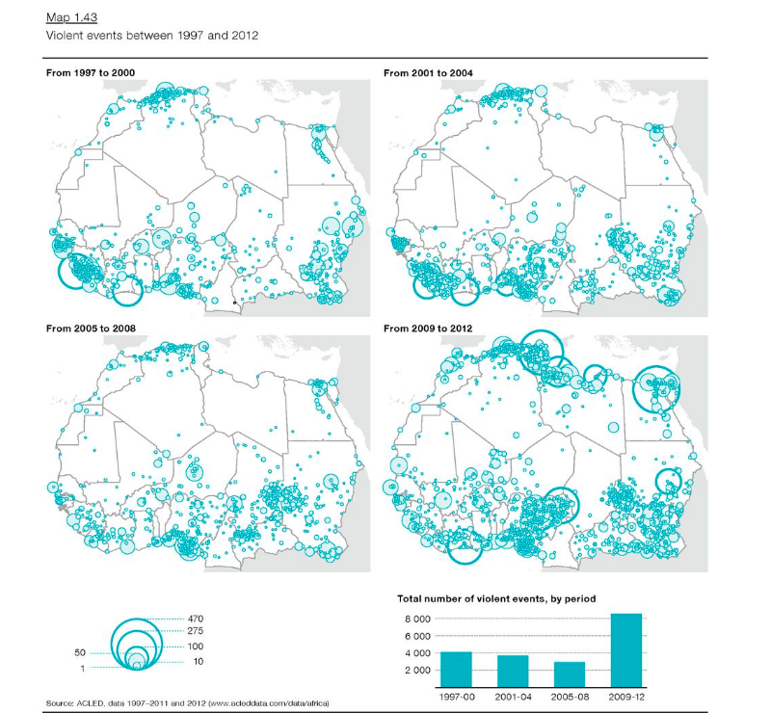

Figure #2: Progression of violent events

The regional repercussions of geopolitical instability

Niger: The Fulani join the fray

After the dust settled and a tenuous peace between the Malian government and the Tuaregs was achieved with adequate French support, the Tuaregs turned their attention away from their political enemies and focused on their ethnic ones – groups like the Nigerien Fulani. In November of 2013, a Tuareg chief got into a violent row with a Nigerien Fulani that ultimately ended with the chief’s death. Following this incident, angry Tuareg forces slaughtered nearly 50 Fulani along the Mali-Niger border in a bid for vengeance. This was a crucial tipping point that catalyzed the conflict that ensued. Hundreds of Fulani turned to Islamism and jihadist organizations as a method to arm and train themselves against sporadic and increasingly frequent Tuareg raids and attacks. While previous French intervention claimed to have disbanded these groups, the organizations metastasized and regrouped their efforts after adapting to the tactics used against them. In particular, Al-Sahrawi recruited a lot of Fulani youth into the Movement for Unity and Jihad in West Africa (MUJWA) by tapping into their rising sense of injustice and resentment at the Tuaregs.

Nigeria: The rise of Boko Haram

In reaction to rising ideological and religious differences in Nigeria and also in response to growing terrorist activity in bordering nations, Boko Haram resurged to join the ensuing chaos that fellow organizations were wreaking. In January of 2012, a bombing in Kano killed 180 people, making the attack the deadliest to date. Later that year, several targeted attacks at churches in Kaduna, a city on the border between the Muslim north and the Christian south, killed more than 100 individuals. Boko Haram also began attacking telecommunications networks and companies in an effort to inspire fear. At the same time that Boko Haram was terrorizing Nigeria, over 8 million people were receiving relief aid in the Lake Chad Basin and other key provinces. Displaced farmers and aimless herders fortified Boko Haram and other jihadist groups, and became foot soldiers fighting in their endless war. Depreciating currencies, stagnating economies, migration, and terrorism ruined the lives of millions.

Burkina Faso: Societal unrest fells the government

As bordering countries were collapsing, Burkina Faso also faced its own challenges. In 2014, a series of riots and demonstrations spread across Burkina Faso as protestors flocked to the streets to march against President Blaise Compaoré’s aims to rework the constitution to extend his years in office. After the burning of multiple government buildings, Compaoré issued a state of emergency and fled Burkina Faso. When Compaoré later resigned, an interim government was founded. Multiple administrations made attempts in maintaining a transitional government, although military subversion and grassroots protests against the system made it almost impossible to lead. In calling for free and transparent elections and democratic ascensions to power, the military issued a statement that Lieutenant Colonel Zida was unanimously elected to lead the transition period. For the next few years, the African Union threatened the military with sanctions in order to motivate Zida into handing power over to the civilians. In 2015, an election was held that established a peaceful yet temporary atmosphere in Burkina Faso.

The escalation of organized violence

From the period 2012 to 2018, violence and Islamism were steadily on the rise. While 2012 was viewed as one of the worst years for Sahelian conflict, 2018 was a year of unprecedented violence. Over four times the amount of deaths was experienced in 2018 in comparison with 2012, with over two thirds of these deaths concentrated in Mali. In Mali, increasing disputes between herders and farmers and the looming presence of evolving terrorist organizations killed over 880 individuals, more than eight times larger than the death toll of Mali’s civil war in 2012. In Burkina Faso, jihadist activity spiked to a figure over four times larger than the previous year. Groups linked to Al- Qaeda reinvigorated their efforts at striking government forces, and a state of emergency was declared there as well. In Niger, border violence, protests, and riots more than tripled. In response to a new tax law and a rising cost of living, over 30 protests were registered in Niger in 2018, as compared to 11 in 2017. Regional tensions were also escalating between Nigerien Fulani and Malian Tuaregs and other aboriginal groups within Burkina Faso. Meanwhile, in Nigeria, farmer-herder violence became even deadlier than the likes of Boko Haram attacks. In various cities, violent escalation aligned with electoral cycles and weather patterns as herder militia grappled with other groups for control over land. Fulani herdsmen started engaging with government forces in efforts to address the manipulative nature of elitism. Poverty and food insecurity in all of these nations reached record highs. Even as these conflicts have gone into 2019 and an era of increasing international scrutiny, these trajectories of violence show no indication of slowing down.

Geopolitics
In the Sahel, civil relations are breached as international efforts overshadow regional initiatives and excessive militarization supersedes solutions directed towards systemic issues. The Sahel is a melting pot of different groups with various interests grappling for dwindling resources in assertions of power over the region. Territories and politics shape the way all of these groups interact with each other. With a lack of cohesive action and few endeavors to reach beyond dividing differences, terror abounds.

G5 Sahel Joint Force

The G5 Sahel Joint Force was created to address common issues through security, developmental, and political lenses. Burkina Faso, Mali, Mauritania, Niger, and Chad have pooled together national resources to combat trafficking and terror group flows over their borders. Their interests in the Sahelian conflict are to end it; the prolonged tensions and expansion of terrorist occupied territories stagnates economies and undercuts the ethos of presidents who are unable to tackle these issues alone. Additionally, a large part of their mandate includes fighting militants and decreasing radicalism. The G5 Sahel Joint Force works in conjunction with other existing programs in the region like the United Nations Multidimensional Integrated Stabilization Mission in Mali (MINUSMA), although geographical limitations on MINUSMA have impaired Joint Force operations in the past. The G5 is endorsed by the African Union Peace and Security Council, who helped create the force in 2017, and France, who has deployed troops in the region to engage jihadist fighters and help train regional battalions.

Boko Haram, Al- Qaeda, & the Islamic State

The interest Boko Haram, Al-Qaeda, and IS share in the conflict is the creation of a fundamentalist Islamic State. In the case of Boko Haram, through deeply embedded social and religious schisms in Nigeria, extremist ideology has festered in conditions of munity and animosity. Meanwhile, in the wake of instability in Libya, returning Tuareg mercenaries drastically expanded Al Qaeda and other Islamist terrorist groups with capable fighters and the contents of Libyan armories in addition to solidifying Tuareg secessionist efforts. Terrorist organizations like Boko Haram, Al Qaeda, and Al-Sahrawi have put aside territorial differences and allied with each other in the past to take control of key towns across Africa, cover more land, pillage villages, and terrorize civilians. These terrorist organizations have recruited minorities like the Tuaregs and the Fulani, who have often had no choice but to resort to lucrative albeit illegal human trafficking and drug trading to subsist and stay out of the civilian crosshairs of terrorist attacks. A common tenet of terror of all of these different organizations is their wish to thrive off of chaos and anti-establishment. A lack of order makes it far easier for these groups to profit off of the illicit trade of drugs and humans, as well as secure broader swathes of territory undisputed. Terrorist organizations have reopened old wounds in their strategic strikes. For example, through capitalizing on historic sectarian divisions, attacks like that on a church in Burkina Faso prelude the prophesied civil war between faiths that terrorist organizations preach to their followers. In the hopes of creating entirely new states governed not by the beliefs and interests of the people but by sharia law and criminal courts, reconciliation between groups actively trying to destroy existing institutions, and governments, has not been attempted to its fullest capacity.

Tuaregs

Since the first Tuareg rebellion in the 1960s and even before then, the Tuaregs have fought for better living conditions and political representation within Mali. After their efforts at being integrated into the Malian national army were rebuffed by multiple administrations, a large portion of the movement radicalized and formed the National Movement for the Liberation of Azawad (MNLA) by latching onto increasing nationalist sentiment as a means to garner support and sympathy for their cause. Since then, the radicalization of the rebellion has spilled over into nearby countries such as Niger and Burkina Faso. While both the nomadic Tuaregs and the MNLA lack an ally in the region, they have historically constituted a significantly large critical mass on their own; it is not crucial that they have one.

National Movement for the Liberation of Azawad (MNLA)

The MNLA is comprised mainly of Tuaregs who’d previously fought for Gaddafi. While a lot of their core interests are similar to other Tuareg communities, the MNLA in particular hopes to establish a northern identity through establishing an independent Azawad. In the past, the MNLA has allied with terrorist organizations to attack the government. Relations with these groups were abruptly cut off when the MNLA and jihadist organizations like Ansar Dine fought in the Battle of Gao, where the MNLA lost northern Malian territories to Ansar Dine and the Movement for Oneness and Jihad in West Africa. Currently, the MNLA is relatively inactive; their forces are dispersed to avoid governmental retaliation.

France

France has always been extremely invested in the affairs of its African allies. In particular, France is very involved in all initiatives in Mali, which was formerly under French colonial rule. In addition to leading many peacebuilding programs in the region including MINUSMA, Operation Barkhane, and the Sahel Alliance, France has also deployed its own troops in the region to push back rebel groups and fight back against terrorist organizations. While France claims to only have an interest in helping its allies, the way in which it has intervened and inserted itself into the conflict precedes neocolonialism and permanent occupancy.

Previous Attempts to Solve the Issue

There are a lot of existing ad hoc task forces dispersed throughout the Sahel with similar mandates. While their attempts are nominally different because they are directed towards different Sahelian nations, they are remarkably alike in that they utilize similar strategies to respond to conflicts that stem from the same underlying issues. A common fatal flaw these task forces and their operations share is using short term hard power to temporarily stunt terrorist organizations and, by consequence, gloss over important structural problems. The previous attempts to solve the issue are still active today. Since political will and resources are zero sum, previously employed initiatives like the ones below detract from real solutions.

Operation Barkhane

Operation Barkhane is a France-led operation tasked with combatting the rise of insurgencies and establishing peace in the Sahelian region. Operation Barkhane was originally launched as Operation Serval, to counter anti-government terrorists in Bamako, Mali’s capital city. Since then, the geographic focus of Operation Barkhane has widened so that the operation now maintains posts in Chad, Mali, and Niger. In 2018, Barkhane expanded its reach into Burkina Faso in response to increasing militant Islamist attacks. Barkhane is France’s largest overseas operation, with nearly 5,000 troops stationed in the Sahel and 600 million euros spent on the operation annually.

G5 Sahel Joint Force

The G5 Sahel Joint Force has 4 pillars its operations rest upon: combatting human and drug trafficking, restoring state authority and reuniting refugee families, delivering aid and humanitarian assistance to affected populations, and facilitating in the region’s development. The G5 Sahel Joint Force is supported by a coalition comprised of 26 countries and is also backed by the European Union. Even while the four pillars were created to be equally prioritized, there is an asymmetry in concentration. The G5 Sahel Joint Force disproportionately emphasizes combatting terrorism, leaving issues like economic improvement and social advancements underfunded and unacknowledged.

MINUSMA in Mali
MINUSMA, or the United Nations Multidimensional Integrated Stabilization Mission in Mali, is a peacekeeping mission in Mali that was established shortly after the 2012 Tuareg rebellion. MINUSMA is regarded as the world’s deadliest UN peacekeeping mission; 118 peacekeepers were killed in four years, and convoys are often attacked with bombs and explosive devices planted by terrorists. MINUSMA is an extremely controversial initiative that brings the topic of UN forces engaging in counterterrorism to the forefront of discussions. Critics argue that peacekeeping should primarily be about protecting civilians, not about trying to militarily defeat a group. MINUSMA’s now intrinsic role of combatting terrorism questions the supposedly impartial mandate of UN peacekeepers, making effective mediation much more difficult.

Relevant UN Treaties and Events
- UN Security Council Resolution (2056), July 2012
- UN Security Council Resolution (2071), Oct. 2012
- UN Security Council Resolution (2085), Dec. 2012
- Dec. 2012 – AFISMA deployed
- UN Security Council Resolution (2100), Apr. 2013
- UN Security Council Resolution (2391), Mar. 2017
- UN Security Council Resolution (2359), June 2017
- June 2017 – G5 Sahel Joint Force created and deployed
- UN Security Council Resolution (2374), Sep. 2017
- UN Security Resolution (2391), Dec. 2017
- UN Security Council Resolution (2423), June 2018
- UN Security Council Resolution (2432), Aug 2018
- UN Security Council Resolution (2480), June 2019

Possible Solutions
While there have been strides made with peace building efforts, possible solutions implemented herein must take into account where previous attempts have failed.
First, previous programs have largely been driven by foreign powers. This challenges indigenous ownership of the initiatives and often sidelines the nuances of domestic policy and ethnic differences in favor of internationally spearheaded military intervention. A consideration in solving the conflict is expanding the mandates of Regional Economic Communities (RECs) to encompass conflict management and collaboration on regional levels. While the existing G5 Joint Force attempts to do this, a lot of their deliberation is overseen by and vetted through the AU, EU, or France as an independent body. This undermines localized efforts, and also entrenches Sahelian nations in overdependence. A lot of initiatives are hard to achieve without sufficient funding. However, delegates should consider ways to maximize funds and/or government subsidization of issues without too many regional concessions being made.
Second, intercommunal violence and disputes are made worse by political manipulation. To solve this, nations should avoid segregationist legislation like that in Benue, Nigeria, where open grazing was outlawed, and it was a mandatory requirement for cattle to be moved by rail and road. More importantly, political officials should be forbidden from using ethnic militias for their own power and profit, like with the Fulani militia in western Niger.
Third, previous attempts at solving the conflicts have often emphasized excessive militarization and the government sanctioned weaponization of civilian populations as a means to retaliate against radical insurgents and/or rebel groups. Instead, peacebuilding approaches should be diplomatic and conciliatory, through peaceful negotiation and effective cooperation between intervening actors to reduce redundancy and benefit the greatest amount of people.
Fourth, most, if not all of the issues in the Sahel region are rooted in poverty and unemployment. With the changing climate and erosion of fertile lands, farmers, nomads, and civilian families turn to terrorist organizations and illegal trade to feed themselves. Not only does this give terrorist groups the unchecked ability to exploit civilian soldiers and subject them to dangerous conditions they have no choice but to comply with, this also expands the organizations and makes it harder to combat them. These issues require the equitable distribution of resources to solve them. The first way to do so is promoting the expansion of jobs and third party subsidized safety nets. In providing targeted food and income support in cooperation with existing World Bank or other initiatives, individuals can pursue modern jobs and join the advancement of societies. The second way to do so is either through infrastructural projects like distribution centers or through increasing taxes on the wealthy to promote welfare for the poor. In order to achieve the closest semblance of political and economic equality as possible, drastic action must be taken. This is a solution that will likely be extremely contentious, based on the different policies of the nations in the SC. However, a point to consider is that the richest individuals in the Sahel are often not entitled to their wealth by any talents, merits, or hard work of their own; in cases where capital was unjustly acquired, delegates should consider whether socialist policies of redistribution are, or are not, morally permissible. Additionally, humanitarian and developmental aid provided by agencies such as the International Committee of the Red Cross and others can have a marked impact on the livelihoods of citizens.

Bibliography
/@oecd. “Herders vs Farmers: Resolving Deadly Conflict in the Sahel and West Africa.” Medium, Medium, 18 Apr. 2018, medium.com/@OECD/herders-vs-farmers-resolving-deadly-conflict-in-the-sahel-and-west-africa-e096702b5055.
Al Jazeera. “Tuareg Rebellion Sparks Crisis in Mali.” News | Al Jazeera, Al Jazeera, 18 Feb. 2012, www.aljazeera.com/news/africa/2012/02/20122188513342701.html.
“Burkina Faso: Killings, Abuse in Sahel Conflict.” Human Rights Watch, 21 May 2018, www.hrw.org/news/2018/05/21/burkina-faso-killings-abuse-sahel-conflict.
Cocks, Tim. “Why Niger and Mali's Cattle Herders Turned to Jihad.” Reuters, Thomson Reuters, 12 Nov. 2017, www.reuters.com/article/us-niger-mali-security-insight/why-niger-and-malis-cattle-herders-turned-to-jihad-idUSKBN1DC06A.
Fessy, Thomas. “Mali Tuareg Rebels Declare Independence in the North.” BBC News, BBC, 6 Apr. 2012, www.bbc.com/news/world-africa-17635437.
“Mali Country Profile.” BBC News, BBC, 19 Apr. 2019, www.bbc.com/news/world-africa-13881370.
“Mapping Armed Groups in Mali and the Sahel.” Mapping Armed Groups in Mali and the Sahel, www.ecfr.eu/mena/sahel_mapping.
Meservey, Joshua. “Africa's Sahel Region Grows As Breeding Ground for Terror, Posing Critical Danger to U.S. and Allies.” The Heritage Foundation, www.heritage.org/africa/commentary/africas-sahel-region-grows-breeding-ground-terror-posing-critical-danger-us-and.
Patel, Nirav. “Africa in the News: Sudan, Benin, Nigeria, and Sahel Updates.” Brookings, Brookings, 3 May 2019, www.brookings.edu/blog/africa-in-focus/2019/05/04/africa-in-the-news-sudan-benin-nigeria-and-sahel-updates/.
“Problems in the Sahel Only Growing, Says ACLED.” Council on Foreign Relations, Council on Foreign Relations, www.cfr.org/blog/problems-sahel-only-growing-says-acled.
“Pursuing Elusive Stability in the Sahel.” SIPRI, www.sipri.org/commentary/topical-backgrounder/2019/pursuing-elusive-stability-sahel.
“Rebellion and Fragmentation in Northern Mali.” The Roots of Mali's Conflict, www.clingendael.org/pub/2015/the_roots_of_malis_conflict/2_rebellion_and_fragmentation_in_northern_mali/.
“States in the Sahel Have Unleashed Ethnic Gangs with Guns.” The Economist, The Economist Newspaper, 2 May 2019, www.economist.com/middle-east-and-africa/2019/05/04/states-in-the-sahel-have-unleashed-ethnic-gangs-with-guns.
Systems, eZ. “Sahel Watch: a Living Analysis of the Conflict in Mali.” The Broker - Connecting Worlds of Knowledge, www.thebrokeronline.eu/Articles/Sahel-Watch-a-living-analysis-of-the-conflict-in-Mali.
“The Sahel: One Region, Many Crises | Africa Renewal.” United Nations, United Nations, www.un.org/africarenewal/magazine/december-2013/sahel-one-region-many-crises.
“The Sahel: Promoting Political alongside Military Action.” Crisis Group, 12 Nov. 2018, www.crisisgroup.org/africa/sahel/mali/sahel-promoting-political-alongside-military-action.
“The World's Deadliest U.N. Mission.” The Washington Post, WP Company, www.washingtonpost.com/sf/world/2017/02/17/the-worlds-deadliest-u-n-peacekeeping-mission/?noredirect=on&utm_term=.586063814b33.
Tran, Mark. “Mali: a Guide to the Conflict.” The Guardian, Guardian News and Media, 16 Jan. 2013, www.theguardian.com/world/2013/jan/16/mali-guide-to-the-conflict.
“UN Documents for UNOWAS (West Africa and the Sahel).” Security Council Report, www.securitycouncilreport.org/un-documents/unowas-west-africa-and-the-sahel/.
“Understanding the G5 Sahel Joint Force: Fighting Terror, Building Regional Security?” Understanding the G5 Sahel Joint Force: Fighting Terror, Building Regional Security? | Center for Strategic and International Studies, 6 June 2018, www.csis.org/analysis/understanding-g5-sahel-joint-force-fighting-terror-building-regional-security.
“UNOWAS (West Africa and the Sahel) Chronology of Events.” Security Council Report, www.securitycouncilreport.org/chronology/unowas-west-africa-and-the-sahel.php.

Visuals Included
Figure #1: “Map.” OSES, 11 July 2016, oses.unmissions.org/map.
Figure #2: “Maps - Sahel and West Africa Club Secretariat.” RSS, www.oecd.org/swac/maps/.

