Forum: Environment Commission
Issue: Measures to reduce plastic waste in the world's ocean basins
Student Officer: Joy Ryu
Position: Deputy President of the Environment Commission

Introduction
Marine debris negatively impacts ocean wildlife and the economy, and it’s been a continuous global problem since the 1970s. In 2014, 15 to 51 trillion microplastic fragments were found on the surface of the ocean, weighing between 93,000 and 236,000 tons (“How Plastic Pollution”). As larger pieces of plastic break down into smaller pieces known as microplastics, they become easier to be consumed by marine creatures such as seals and turtles. As this occurs, the plastics often poison these animals, which, consequently, increases their chance of disease contraction and negatively impacts reproduction rates. Furthermore, these small pieces of plastic are passed on throughout the food web, affecting all organisms in the food chain, including humans. Marine debris may also become new habitats for certain species, adjusting the equilibrium in areas such as the seabed. For example, sea skaters have started to lay their eggs on plastic garbage on the seabed. This has led to a rise in the egg densities in North Pacific Subtropical Gyre. This may lead to consequences for species across the food web, such as crabs that feed on skaters and their eggs.
Scientists and the public are well aware of the abundant amount of marine waste present on the surface of our water and the hazard that it poses to ocean wildlife. However, according to surveys tackling the destination of environmental plastics, it appears that there is a substantial proportion of manufactured plastic that is unaccounted for. Over time, plastic waste in the coastlines dilute and disperse into the rest of the ocean, where UV rays and waves act on that plastic, clearing the surface of the water. However, as the plastic reaches the deep trenches, there is no more dispersal taking place, meaning that plastics are trapped in the deepest parts of the ocean (Gibbens et al.). Despite this, not many steps have been taken due to technical and financial limits.

Definition of Key Terms
Marine debris
Marine debris refers to all man-made, solid material that enters the ocean directly through littering or indirectly via rivers and streams. It includes any simple items, such as plastic wrappers and straws, that end up in the ocean and potentially harm marine life (“Marine Debris”).
Microplastic
Microplastics are very small pieces of plastic (5mm or smaller) in the environment, that result from the disposal and breakdown of larger pieces of plastic waste over time.
Ghost Gear
Ghost gear is fishing gear, such as nets, that has been lost or abandoned in the ocean. As ghost gear breaks down into microplastics, it is consumed by marine organisms such as whales, dolphins and turtles, poisoning them.
Ocean basin
An ocean basin is land that exists under the ocean below sea level. They are relatively inactive parts of the ocean, where deposits of sediment gradually collect. They may also be active areas, such as where the tectonic plates meet.

History & Developments
Plastic waste in the water
Since after World War II, marine waste has evolved from simple biodegradable material to synthetic non-biodegradable material. According to The UN Environment Programme (UNEP), the world’s output of plastic waste has increased more in the past decade than it had in the past 40 years, and, currently, 80 percent of all plastic waste in the ocean is from land-based sources, such as wrappers, straws, etc. (“Our Planet Is”; “Marine Debris”). Furthermore, according to the Stemming Tide Report from Ocean Conservancy, 75 percent of land-based plastic waste in the ocean is from littering into waterways. The rest of the plastic waste in the ocean is made up of small pieces of plastic that are collected but have escaped the waste system, indicating that there is still room for improvement in waste management systems. For example, in recycling plants, straws and plastic wrappers that are very small in size slip through the managing system, onto the floor, from which they are collected at landfills.

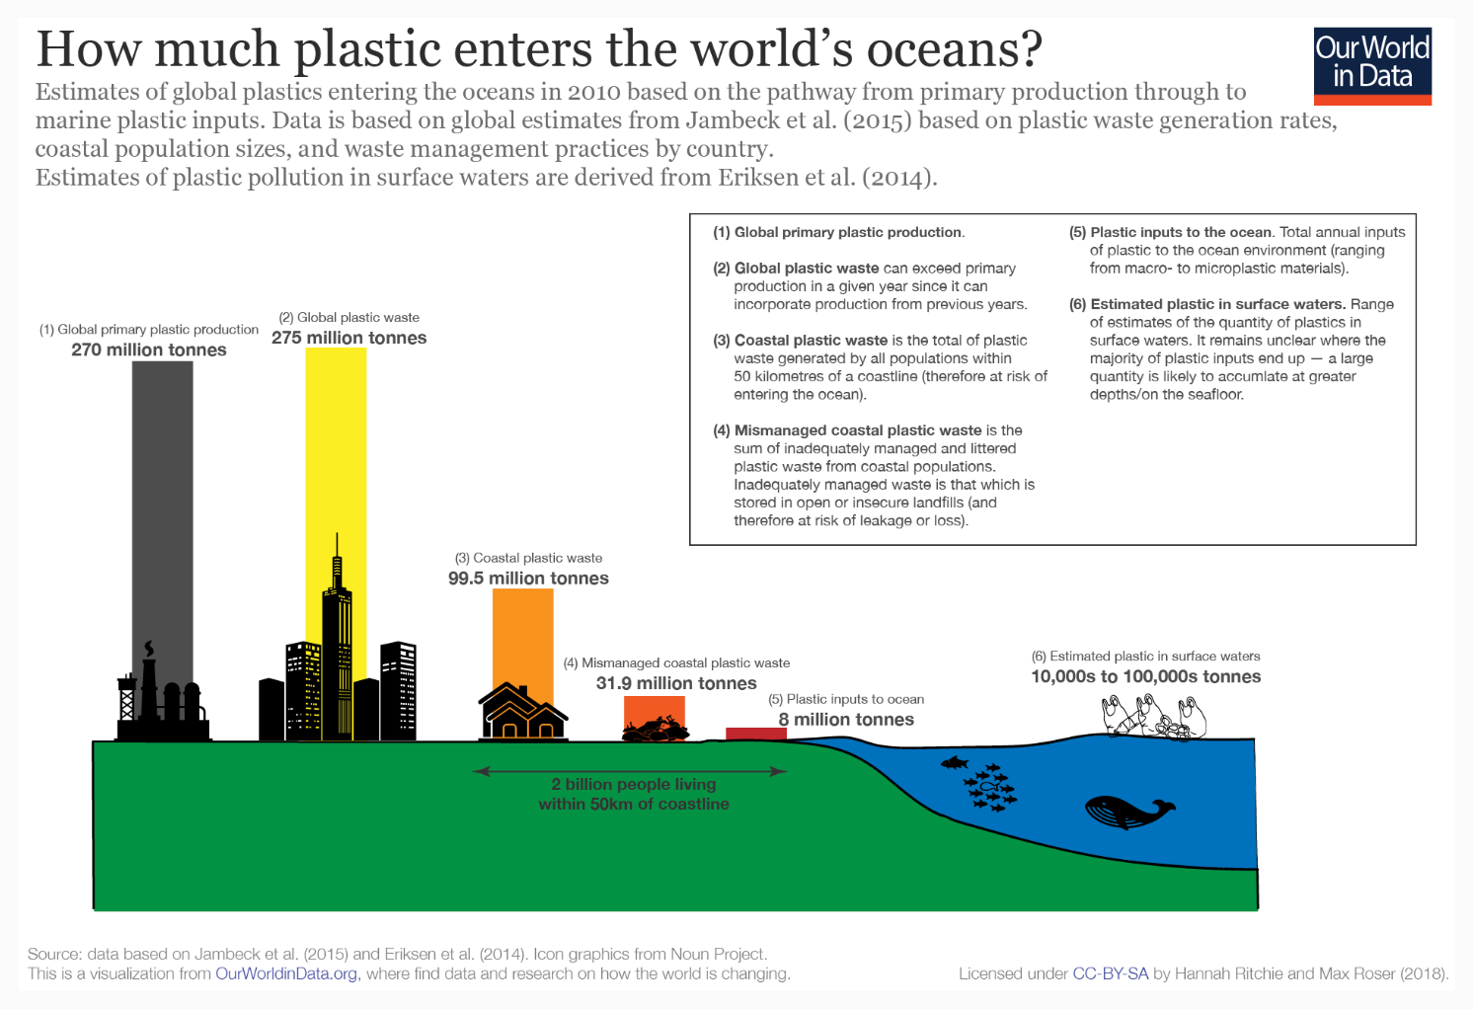
Figure #1: sources of plastic waste
Ghost Gear
According to World Animal Protection, each year, around 640,000 tonnes of fishing equipment is abandoned, killing more than 100,000 marine mammals and more than a million seabirds (Eco-Business). Ghost gear is made up of abandoned fishing nets from illegal fishers trying to avoid being caught. The nets are mostly death traps for any animal swimming through, cutting through their muscles as they move around them.
Microplastics
Plastic waste gets more and more dangerous as it breaks down into tiny particles and enters the food chain, harming animals and the ecosystems. An example of this is Styrofoam, which easily breaks down into tiny balls of plastic in the water. This harms the marine animals by getting into their bodies via consumption or by releasing harmful substances such as styrene monomer, one of the main causes of cancer, along with styrene dimers and trimer, which are chemicals known for being carcinogenic (Connor). Ingestion of microplastics may not only cause direct death, but also has several sublethal effects, such as difficulties capturing prey and digesting food, sensing danger, escaping from predators, reproducing, etc.

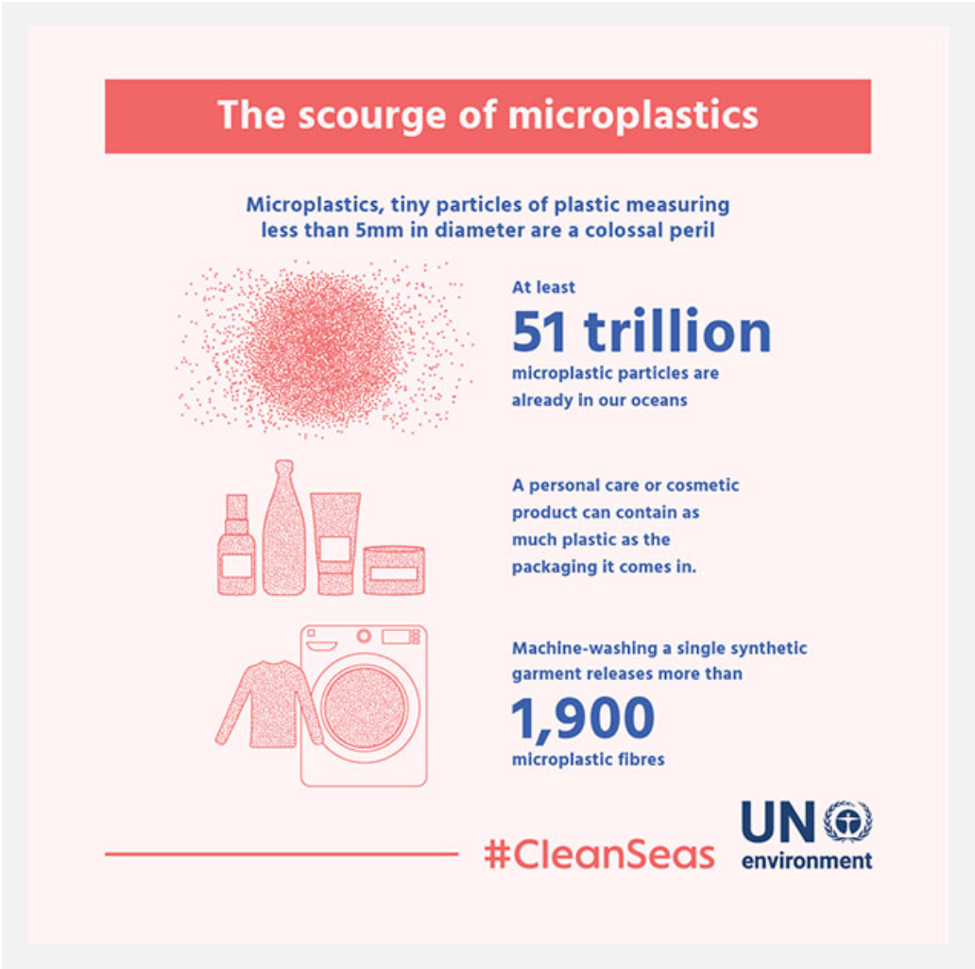
Figure #2: statistics on microplastics in the ocean
Release of toxins into the water
Although plastic is believed to be impossible to completely decompose, in the latest research, it is shown that when plastic is exposed to environmental conditions such as the sun and rain, it decomposes faster, leaching toxic chemicals into the sea and harming the marine ecosystem. When decomposing plastic is consumed, dangerous toxins are spread in the animal’s digestive system, causing adverse effects, which could lead to cancer, mutation and death.
Effects on the ecosystem
Effect on marine animals and the food chain
The environment and marine species are affected by plastic waste in various ways: by entanglement or ingestion of debris, contamination from toxic substances, or the creation of potential new habitats for colonization, etc. Half of the interactions between sea animals and debris is through entanglement or ingestion. The consumption of plastic may not only cause physical manifestations of harm such as cancer and mutation, it may also cause sublethal outcomes such as difficulties capturing and digesting food, difficulties in sensing hunger or predators, or difficulties in reproducing, etc. The particles from plastics are also passed on to other organisms through bio-accumulation throughout the food web. Microplastics are primarily being consumed by corals and zooplanktons, which are eaten by small fish, which are then consumed by other organisms in the food chain. During this process, the microplastic gets into the bodies of all of these animals, negatively affecting their behavior and hormone levels.
Moreover, plastics may be a habitat for some species, breaking the equilibrium of various marine habitats. These areas of accumulated plastic are often first colonized by microorganisms then by microbiota, crustaceans, fish, cnidaria and echinoderms.
Plastic waste in the ocean basin
On May 2019, an American undersea explorer and Dallas businessman spent four hours exploring the southern end of the Mariana Trench in the Pacific Ocean, as part of a mission to chart the world’s deepest underwater places. In the deepest and the most remote part of the world yet reached by humans, plastic bags and fragments of plastic wrappers were found. They were estimated to have spread from Mount Everest down to the rivers and the soil, into the deepest parts of the ocean (Locker). Moreover, tiny pieces of undigested plastic were found in the bodies of the marine species in the water basin, which contaminated their bodies. According to the journal, Nature Evolution and Ecology, “Deep trenches are contaminated by toxic chemicals such as polychlorinated biphenyls (PCBs) and polybrominated diphenyl ethers (PBDEs).” PCBs are harmful oily chemicals that have been used in the production of many consumer products but have been banned since 1979 due to their toxicity (Pappas). In research done in the Phoenix Islands Protected Area, in the middle of the Pacific Ocean, pieces of plastic were found in the guts of more than 70% of the amphipods, along with high levels of toxins called PCBs.
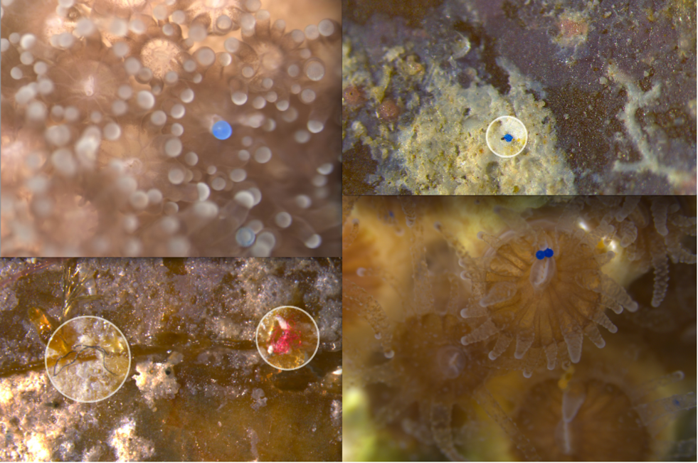
Figure #3: pictures of microplastic in coral and seagrass communities

Geopolitics
China
China, creating 8.82 million metric tons of ocean waste per year, scored top on the 2018 “Mass of Mismanaged Plastic Waste” chart. In the past few years, China has been the world’s leading destination for recycling rubbish, taking in bulks of scrap plastic and recycling them into higher quality materials. However, the environmental and health issues following unauthorized recycling businesses in China are at a concerning level: the cleansing process releases various pollutants into waterways, and burning scrap pieces of plastic gives off a concerning amount of toxic substances into the air; leftover piece of plastic that are not suitable for recycling are discarded directly into the waterbeds.
As a solution to its pollution and waste problems, China’s “National Sword” policy was legislated in January 2018, banning all recycling businesses from importing plastic waste from foreign countries into its national recycling processors. The policy was an effort to put an end to the contamination of soil through the disposal of toxic materials, such as plastic waste. Since then, China’s import of plastic waste has fallen by 99 percent, causing a global shift in where and how materials are processed. As a result, more waste is ending up in landfills, wich flows into the water through the soil and river streams. Like other marine debris, this then carries on to release toxins into the water and sink down to the ocean basin.
Instead, Chinese recyclers have relocated themselves in countries in Southeast Asia, especially in areas with a large Chinese-speaking minority. Large quantities of plastic from all around the globe is being redirected to countries in Southeast Asia, such as Malaysia. According to official data, plastic imports in Malaysia have tripled in a year to approximately 870,000 tons.
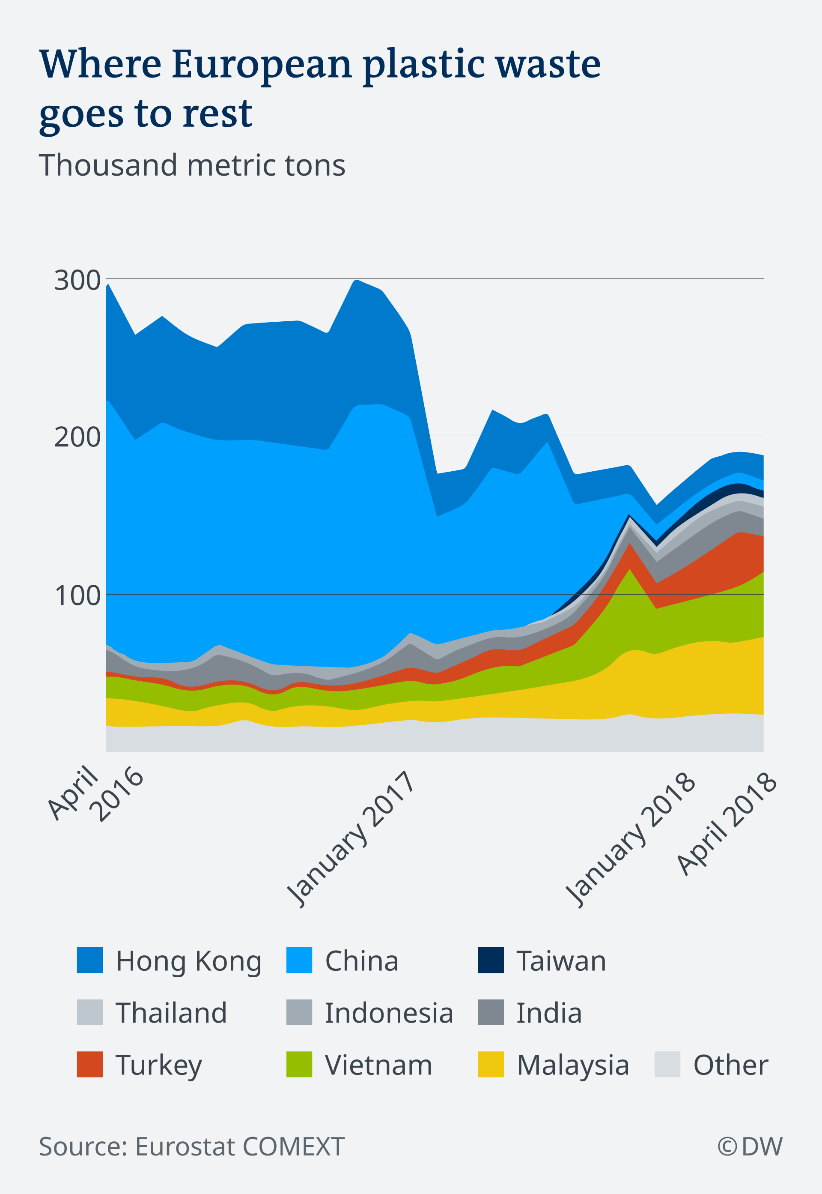
Figure #4: graph showing the effect of China’s ban in exporting waste on other countries
Indonesia
According to a Study by the University of Georgia, every year, approximately 3.22 million metric tons of plastic are disposed into the ocean nearby Indonesia, along with a further 8.82 million metric tons of China’s marine waste making its way into Indonesia’s oceans (Howard). Ranking second after China on the 2018 plastic waste list, Indonesia faces a huge plastic waste crisis.
Indonesia’s authorities are faced with the task of raising awareness about recycling and improving recycling systems in order to achieve their goal of reducing its plastic waste by 70 percent by 2025 (“'The Trash Never Stops'”). The Global Plastic Action Partnership (GPAP) is seeking ways to modify the current ‘take-make-dispose’ littering system into a circular economy, where all plastic goods are later recycled and reused (“Indonesia's Plastic Waste”).
However, the people’s reaction to these changes have been diverse. As the government banned the use of plastic bags in shops in Bali, shoppers and some shop owners started protesting and there are still illegal recycling businesses going on that are out reach of the government.
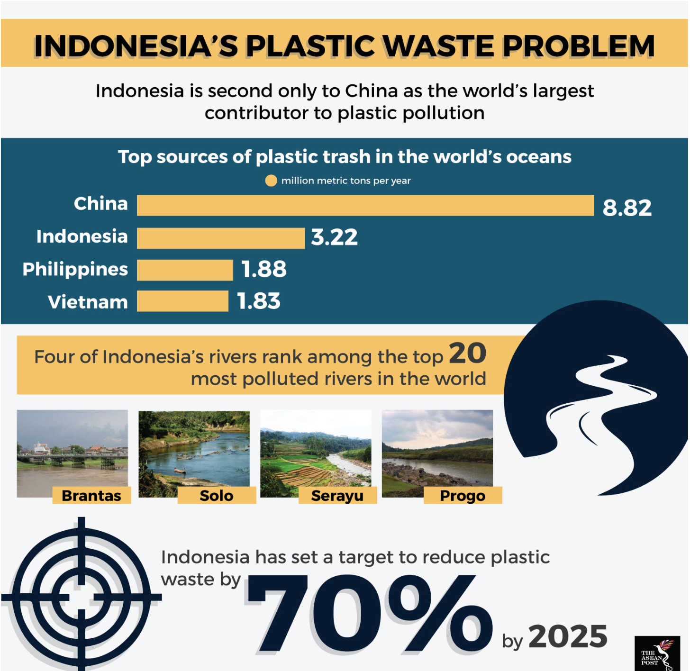
Figure #5: Indonesia’s plastic waste statistics
Germany
As one of the countries with the least plastic waste produced and most plastic recycled, Germany has used numerous methods to reduce plastic waste; they have a 5 step plan to reduce plastic waste. However, the amount of plastic being recycled in Germany is far less than expected. Since China’s ban on importing foreign plastic waste, German plastic waste has been seen in Malaysian garbage patches. Between January and October of 2018, Germany exported 114,000 tonnes of plastic rubbish to Malaysia, which was an increase of 125 percent (“The Plastic Trail”). Germany produced around 6.2 million tons of plastic waste, with just below half of it being recycled and one third of them being exported to Malaysia. Despite Germany being one of the champions in plastic recycling, not all plastic gets recycled; according to German statistics, only 15 percent is actually being recycled.

Previous Attempts to Solve the Issue
In October 29, 2018, 250 organizations, contributing to over 20 percent of the plastic produced around the globe, have come together to reduce waste and pollutions. The initiative is called “New Plastic Economy Global Commitment”, including members such as the city of Austin, H&M, Unilever, PespsiCo, L’Oréal, Nestle, and Coca-Cola. It is an initiative partnering with the United Nations and other organizations such as the World Wide Fund for Nature, the World Economic Forum, the Consumer Goods Forum, and 40 academic institutions. It aims to modify the world’s recycling system to a cycle, where plastic gets reused or repurposed instead of being thrown away directly into the ocean or landfills.
In October 26, 2018, a single-use plastic ban was approved by the European Parliament. The list included a ban on plastic products such as plastic cutlery, straws, drink stirrers, balloon sticks and beverage containers. The Parliament made sure the list of target plastic items had alternatives, such as mugs and stainless-steel straws. Plastic products with less available alternatives, such as cigarette filters, were targeted for a more gradual reduction.
In October 12, 2018, United States President Donald Trump approved a law to improve methods to clear the ocean from plastic. The legislation fosters ways to clean up plastic trash from the world’s oceans and urges federal trade negotiators to arrange with “leaders of nations responsible for the majority of marine debris” to improve management of ocean plastic waste.
In July 12, 2017, At the United Nations Environment Assembly in Nairobi, more than 200 nations came together to pass a resolution to eliminate plastic waste in the ocean. The resolution encourages nations to take action to prevent the production of marine debris and microplastics, to enforce recycling, and quantify and eliminate existing marine waste. The resolution is part of a declaration of the UNEP to promote reduction of waste, to enforce laws against ocean pollution, and encourage a circular economy. The resolution encourages the commitment of nations under the UN Sustainable Development Goals to "prevent and significantly reduce marine pollution of all kinds, in particular from land-based activities, including marine debris and nutrient pollution”.
In September 2015, the World Animal Protection Organization founded the Global Initiative dedicated to tackling the problem of ghost fishing gear on a global scale. This initiative calls upon governments, companies and non-governmental organizations (NGOs) to cooperate in order to rescue the marine life from ghost gears (Howard).

Relevant UN Treaties and Events
- Resolution on Marine Litter and Microplastics, December 5, 2017 (EA.3/L.20)
- London Convention on the Prevention of Marine Pollution by Dumping of Wastes and Other Matter
- MARPOL (International Maritime Organization)
- United Nations Conference on Environment and Development, December 22, 1989 (A/RES/44/228)
Possible Solutions
Over 136,000 marine animals are found caught in ghost gears every year (“To Stop the Deaths”). Currently, it is nearly impossible to identify the owner of fishing gear when abandoned in the sea. It is crucial to call on organizations and governments to ensure all fishing gear is tagged (marking the information such as the origin, ownership and capacity management). If all fishing equipment is properly tagged, fishing vessels would be incentivized to ensure the gear is not abandoned and enforcement agencies would be able to trace offenders. Moreover, this would further reduce illegal fishing as it would no longer possible to abandon fishing gears.
In order to prevent the destruction of untagged gear, nations must enforce laws regarding the disposal of untagged gear and increase the security in ocean borders and at fishing sites. It is crucial to educate the public on the enforced law and the importance of tagging fishing gear and therefore nations would be encouraged to cooperate with relevant organizations to create advertisements and online banners regarding the law.
Thirdly, nations must ensure that the international waste management law provides a solid legal framework that addresses illegal littering, waste businesses and illegal import and export of wastes. It is important that all nations work together and cooperate under one international regulation and therefore it is crucial for a clear law and regulation on the protection of the ocean basin.
Lastly, nations must aid and support projects and operations to clear the ocean basin and rescue damaged marine animals from ghost gear and microplastics. Nations must come together with organizations to discuss the responsibility of each nation.

Bibliography
“A/RES/44/228 United Nations Conference on Environment and Development.” United Nations, United Nations, www.un.org/documents/ga/res/44/ares44-228.htm.
Camps, Marc Arenas. “The Impact of Marine Debris on Nature.” All You Need Is Biology, 19 June 2017, allyouneedisbiology.wordpress.com/2017/06/11/impact-marine-debris/.
“China Produces about a Third of Plastic Waste Polluting the World's Oceans, Says Report.” South China Morning Post, 14 Feb. 2015, www.scmp.com/article/1711744/china-produces-about-third-plastic-waste-polluting-worlds-oceans-says-report.
Coastal Commission. “California Coastal Commission.” Ca, www.coastal.ca.gov/publiced/marinedebris.html.
Connor, Steve. “Scientists Uncover New Ocean Threat from Plastics.” The Independent, Independent Digital News and Media, 23 Oct. 2011, www.independent.co.uk/news/science/scientists-uncover-new-ocean-threat-from-plastics-1774337.html.
Deutsche Welle. “After China's Import Ban, Where to with the World's Waste?: DW: 05.04.2019.” DW.COM, www.dw.com/en/after-chinas-import-ban-where-to-with-the-worlds-waste/a-48213871-0.
Deutsche Welle. “UN Resolves to End Ocean Plastic Waste: DW: 07.12.2017.” DW.COM, www.dw.com/en/un-resolves-to-end-ocean-plastic-waste/a-41690999-0.
Eco-Business. “'Ghost Gear' Poses Grave Threat to Marine Wildlife and Food Security.” Eco, www.eco-business.com/opinion/ghost-gear-poses-grave-threat-to-marine-wildlife-and-food-security/.
“FEATURE: UN's Mission to Keep Plastics out of Oceans and Marine Life | UN News.” United Nations, United Nations, news.un.org/en/story/2017/04/556132-feature-uns-mission-keep-plastics-out-oceans-and-marine-life
Gibbens, Sarah, and Laura Parker. “Creatures in the Deepest Trenches of the Sea Are Eating Plastic.” Deep Sea Creatures in the Mariana Trench Eat Plastic, Study Finds, 28 Feb. 2019, www.nationalgeographic.com/environment/2019/02/deep-sea-creatures-mariana-trench-eat-plastic/.
Gray, Alex. “90% Of Plastic Polluting Our Oceans Comes from Just 10 Rivers.” World Economic Forum, www.weforum.org/agenda/2018/06/90-of-plastic-polluting-our-oceans-comes-from-just-10-rivers/.
Harrabin, Roger. “UN Commits to Stop Ocean Plastic Waste.” BBC News, BBC, 5 Dec. 2017, www.bbc.com/news/science-environment-42239895.
“How China's Plastic Waste Imports Ban Threw Recycling into Turmoil.” South China Morning Post, 23 Apr. 2019, www.scmp.com/news/china/politics/article/3007280/how-chinas-ban-plastic-waste-imports-became-earthquake-threw.
“How Plastic Pollution Is Affecting Seals and Other Marine Life.” World Animal Protection International, www.worldanimalprotection.org/news/how-plastic-pollution-affecting-seals-and-other-marine-life?gclid=CjwKCAjwvJvpBRAtEiwAjLuRPUtwKNTI658qzOfx9A-iHwJ9vhZu9BPD5d8CsEF43qRLKarp89dgjxoCcQsQAvD_BwE.
Howard, Brian Clark. “A Running List of Action on Plastic Pollution.” National Geographic, 10 June 2019, www.nationalgeographic.com/environment/2018/07/ocean-plastic-pollution-solutions/.
“Indonesia's Plastic Waste Problem.” The ASEAN Post, 6 July 2018, theaseanpost.com/article/indonesias-plastic-waste-problem-0.
Jakarta Post. “The Waste Challenge: Is Indonesia at a Tipping Point?” The Jakarta Post, www.thejakartapost.com/academia/2019/03/01/the-waste-challenge-is-indonesia-at-a-tipping-point-1551431355.html.
Leggett, Hadley. “Toxic Soup: Plastics Could Be Leaching Chemicals Into Ocean.” Wired, Conde Nast, 4 June 2017, www.wired.com/2009/08/plasticoceans/.
Locker, Melissa. “Undersea Explorer Goes Deeper than Any Solo Diver in History and Finds Plastic.” Fast Company, Fast Company, 13 May 2019, www.fastcompany.com/90348918/a-deep-sea-diver-found-plastic-at-the-bottom-of-the-mariana-trench.
“Marine Debris.” Thank You Ocean, thankyouocean.org/threats/marine-debris/.
Ndiso, John. “Nearly 200 Nations Promise to Stop Ocean Plastic Waste.” Reuters, Thomson Reuters, 13 Dec. 2017, www.reuters.com/article/us-environment-un-pollution/nearly-200-nations-promise-to-stop-ocean-plastic-waste-idUSKBN1E02F7.
“Ocean Plastics Pollution.” Ocean Plastics Pollution, www.biologicaldiversity.org/campaigns/ocean_plastics/.
“Our Planet Is Drowning in Plastic Pollution. This World Environment Day, It's Time for a Change.” #BeatPlasticPollution This World Environment Day, www.unenvironment.org/interactive/beat-plastic-pollution/.
Pappas, Stephanie. “Even at 36,000 Feet Deep, Ocean Creatures Have Plastic in Their Guts.” LiveScience, Purch, 16 Nov. 2017, www.livescience.com/60954-plastic-found-in-deepest-living-creatures.html.
Parker, Laura. “The World Agrees There's a Plastic Waste Crisis-Can It Agree on a Solution?” National Geographic, 26 Mar. 2019, www.nationalgeographic.com/environment/2019/03/un-environment-plastic-pollution-negotiations/.
“Plastic Pollution Affects Sea Life Throughout the Ocean.” The Pew Charitable Trusts, www.pewtrusts.org/en/research-and-analysis/articles/2018/09/24/plastic-pollution-affects-sea-life-throughout-the-ocean.
“Plastics in the Ocean Affecting Human Health.” Case Studies, 3 Aug. 2018, serc.carleton.edu/NAGTWorkshops/health/case_studies/plastics.html.
Pourriahi, Shahrzad. “German Government Sets out Plan to Reduce Plastic Waste.” Plastics News Europe, 28 Nov. 2018, www.plasticsnewseurope.com/article/20181128/PNE/181129932/german-government-sets-out-plan-to-reduce-plastic-waste.
“The Plastic Trail: How Germany's Recycling Ends up in Malaysian Dumps.” Handelsblatt, © 2019 Handelsblatt GmbH, 26 Feb. 2019, www.handelsblatt.com/today/politics/the-plastic-trail-how-germanys-recycling-ends-up-in-malaysian-dumps-/24037020.html?ticket=ST-3750609-JQHrB4kSdVjqaFO4hjbT-ap5.
Reeves, Sam. “China Plastic Waste Ban Throws Global Recycling into Chaos.” Phys.org, Phys.org, 23 Apr. 2019, phys.org/news/2019-04-china-plastic-global-recycling-chaos.html.
Ritchie, Hannah, and Max Roser. “Plastic Pollution.” Our World in Data, 1 Sept. 2018, ourworldindata.org/plastic-pollution.Stockton, Nick. “How Plastic Straws Slip Through the Cracks of Waste Management.” Wired, Conde Nast, 26 July 2018, www.wired.com/story/how-plastic-straws-slip-through-the-cracks-of-waste-management/.
“The Problem of Marine Plastic Pollution.” Clean Water Action, 20 Dec. 2017, www.cleanwater.org/problem-marine-plastic-pollution.
“The Problem of Ocean Trash.” Ocean Conservancy, 13 Sept. 2018, oceanconservancy.org/blog/2016/08/22/the-problem-of-ocean-trash/.
“'The Trash Never Stops': Indonesia Battles to Clean up Rivers.” Reuters, Thomson Reuters, 23 Jan. 2019, www.reuters.com/article/us-indonesia-environment-plastics/the-trash-never-stops-indonesia-battles-to-clean-up-rivers-idUSKCN1PH0CQ.
“To Stop the Deaths of Countless Marine Animals, We Need to Tag Fishing Gear.” World Animal Protection USA, www.worldanimalprotection.us/news/stop-deaths-countless-marine-animals-we-need-tag-fishing-gear.
Treat, Jason, and Ryan Williams. “We Depend On Plastic. Now, We're Drowning in It.” We Depend on Plastic. Now We're Drowning in It., 16 May 2018, www.nationalgpeographic.com/magazine/2018/06/plastic-planet-waste-pollution-trash-crisis/.Yin, Steph. “How Do Plastics Get to the Bottom of the Sea?” WHYY, WHYY, 3 May 2019, whyy.org/segments/plastic-in-the-deep-ocean/.

