Forum: General Assembly Third Committee
Issue: Alleviating the Socioeconomic Repercussions of an Aging Society
Student Officer: Teresa Shao
Position: Deputy President of the General Assembly Third Committee

Introduction

Introduction
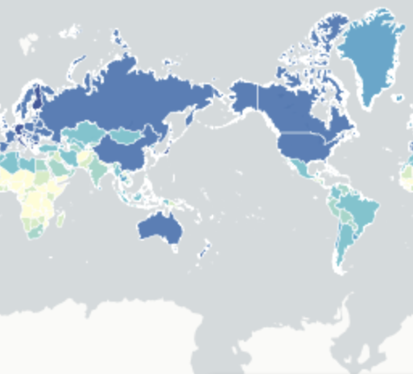
According to the World Population Prospects: the 2019 revision, a staggering 16% of the world population will be 65 or older by 2050, and in the United States and Europe, one in four people will be 65 or older by 2050. In 2018, the number of people 65 or above has outnumbered the number of children under five. This trend of a disproportionately large elderly population is an emerging reality for many countries around the world, and the far-reaching socioeconomic burdens of an aging population are grave.
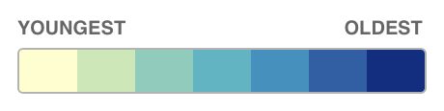
For the past two centuries, the quality of life has increased steadily for many around the world, but its potential consequences, including aging populations around the world, may not be as desirable. As education, sanitation, and housing improved and health-related technology made significant strides, the mortality rate has greatly decreased while life expectancy has steadily increased. At the same time, fertility has declined over time due to multiple reasons, such as improvements in contraception and more women becoming a part of the workforce. Increasing longevity and declining fertility have compounded to many countries facing the problem of an aging population.
Figure #1: This map shows the mean age of countries. The interactive map and the mean age for individual countries can be viewed at this link.
Although these advances have undoubtedly brought many benefits, countries could potentially fall victim to the same advances if effective action is not taken. The disproportionately large elderly population has serious implications on healthcare, pension systems, and economic development. The age-dependency ratio is exacerbated by the decreasing number of people in the working age. The problem of an aging population asks for careful reflections and revisions of the current retirement situation as well as coordinated steps forward.

Definition of Key Terms
Aging population
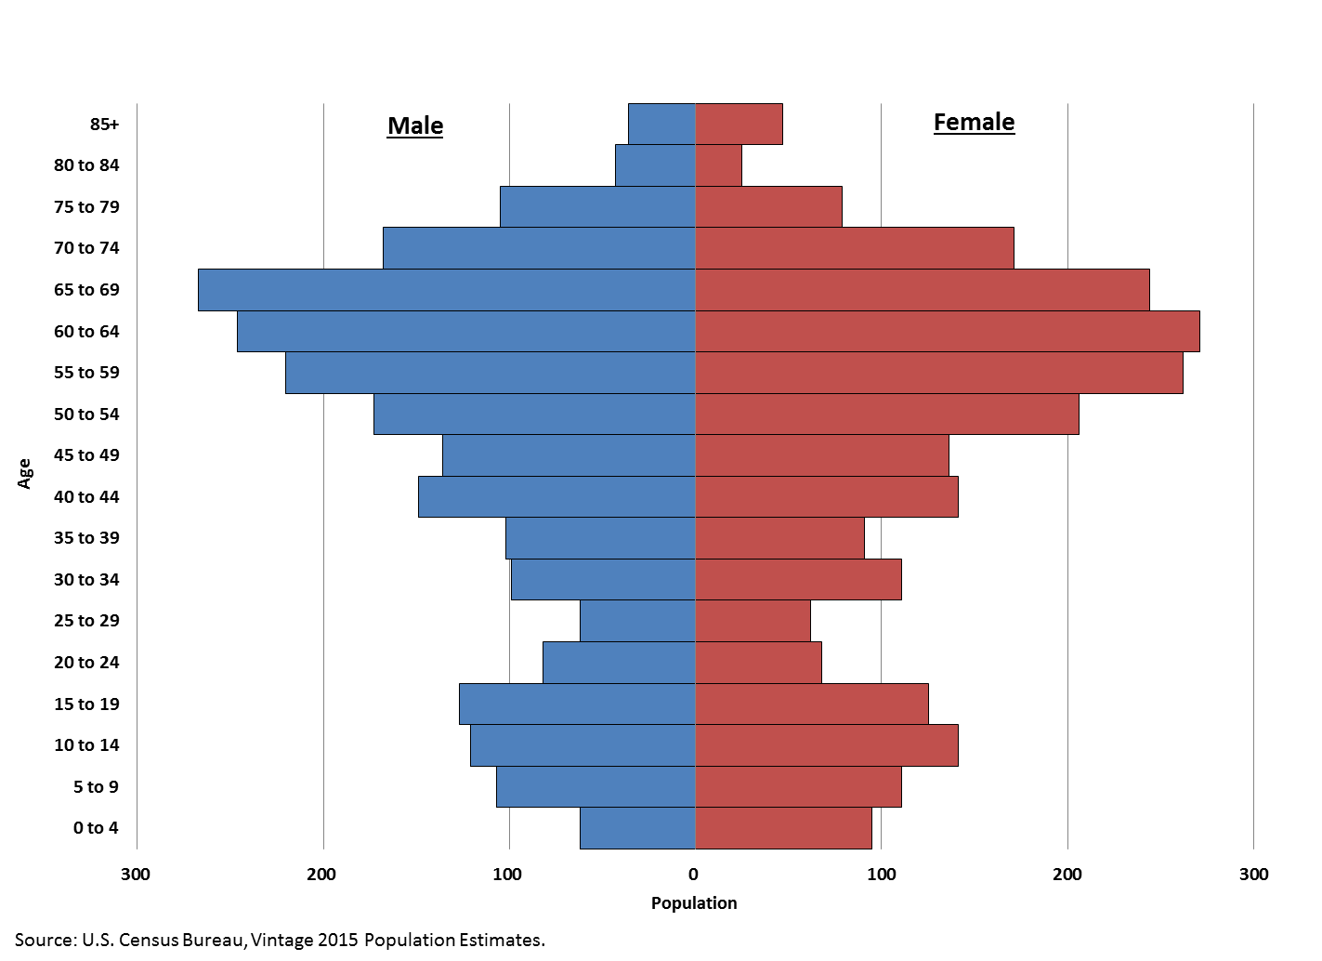
“Aging population” refers to the process by which the ratio of the elderly population to the working-age population increases. In other words, a country would have an aging population if the proportion of its population beyond the working-age increases while the proportion of its working-age population decreases. The diagram demonstrates this trend visually– the elderly population and the prospective elderly population are considerably larger in proportion than the other age groups.
Figure #2: This is a population pyramid. This particular diagram displays the population size in respect to gender and age groups.

Cohort
A cohort describes a group of people with common demographic characteristics, including but not limited to age, gender, and ethnicity.
Life expectancy
The average number of years a person in a population lives at a certain point in time.
Longevity
Longevity refers to a long life.
Pensions
Pensions are regular payments made to the retiree during a person’s retired life. The money for pensions for a person comes from an investment fund that the person or their employer contributes toward during the person’s working life. This term is not to be confused with an age pension, which, in most countries that provide it, means a government paid pension.
Superannuation
Superannuation is a regular payment by the employee to the aforementioned investment fund. Sometimes, the superannuation is put automatically by the employer into the fund out of the employee’s wage. Superannuation becomes the person’s pensions when the person retires.
Social Security
Social security describes any government program that offers monetary assistance to low or no income individuals. In most countries, social security encompasses retirement benefits.
Supplemental Poverty Rate
The supplemental poverty rate measures the number of people that rely on government assistance programs.
Age-dependency ratio
The age-dependency ratio refers to the ratio between economically dependent individuals and economically productive individuals. Usually, economically dependent individuals are categorized as under 15 or over 64, while economically productive individuals are defined as people between 15 and 64 years old.
Retirement Age
The retirement age is when most people retire from work and become eligible for social security benefits and pensions.

History & Developments

Causes

The Baby Boom
From the mid-1940s to early 1970s, many countries experienced a population boom, known as the Baby Boom. The countries where the Baby Boom occurred included industrialized Western countries, most Latin American countries, and a few Asian countries (Morocco, China, and Turkey). It is important to note that some countries, primarily consisting of less industrialized countries, did not experience a population boom. The Baby Boom marked a period of rapidly rising marriage rates and increasing fertility, which led to substantial increases in child births. As World War II ended and governments encouraged the growth of families through benefits, many were incentivized to marry and reproduce. The popular culture surrounding pregnancy, large families, and parenthood further promoted and contributed to the drastic rise in child births. However, this boom in population was temporary. Following the early 1970s, births began to decline, which became known as the baby bust. In fact, the annual population growth in 1968 was 2.1%, while the current population growth is roughly 1% per year. As the boomer generation, denoting the cohort born in during the Baby Boom, are currently reaching 60 years old and beyond, many countries that experienced the Baby Boom are now faced with a quickly growing elderly cohort and an alarming disproportion between the size of the elderly population and the rest of the population.
Decreasing fertility
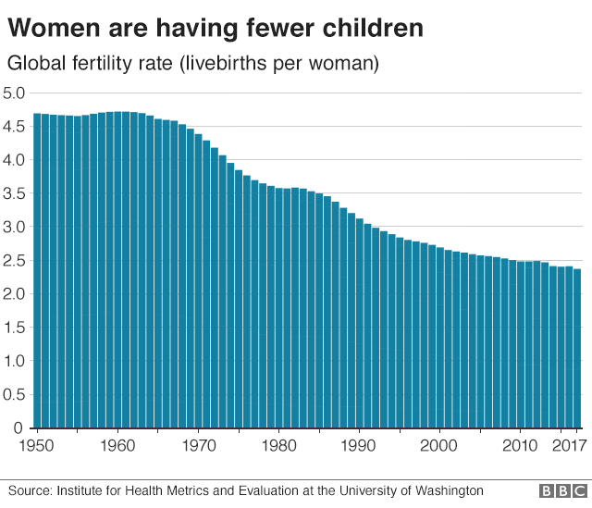
As briefly mentioned before, population booms are often merely temporary and followed by population busts. One primary cause of the current population bust is declining fertility. As more women are in education and work and the access to contraception increased, fertility rates fell. Moreover, because of how rapidly health-related infrastructure and technologies advanced, child mortality rates quickly declined as well, and hence, women saw less need to have as many children as possible. On the other hand, policies for population control have also led to the decline in child births. For instance, the One-Child Policy in China has marked a significant fertility decline. Because of the previous decline in fertility, many countries currently face the problem of a decreasing number of people entering the workforce as large groups of the boomer generation retire. As a result, the disproportion between the growing elderly population and the number of people entering the workforce is exacerbated. The coronavirus pandemic may have taken a heavy toll on fertility as well. Examining the sharp decline in fertility rate during the Great Recession and the 1918 pandemic, experts predict that the coronavirus pandemic may result in a similar effect.
Figure #3: This graph depicts the declining global fertility rate from 1950 to 2017.
Increasing longevity
Improvements in the quality of life, almost globally, have led to rising life expectancy and lower mortality rates. As vaccines and other health related advances were made, mortality due to infections — on a macro-level at least — has decreased drastically, resulting in reduced early and mid-life mortality rates. Improvements in education, sanitation, and housing also greatly lifted the quality of life for many, which allowed many to live longer. In fact, the World Health Organization reports that from 2000 to 2016, life expectancy has increased by an average of 5.5 years globally. Because of increased longevity, many of the baby boomers and others are now able to live beyond their 60s, which evidently increases the elderly population. This exacerbates the age dependency ratio because as the elderly population increases, there will be more people not working and potentially dependent on the working age cohort’s support financially.
Emigration
Another cause of augmenting the disproportion between the elderly and the rest of the population lies in emigration. The disparity in opportunities between countries results in the outflow of workers seeking to find better opportunities elsewhere. Because of the working population emigrating, a decline in the workforce and young people can be observed. For instance, this trend can be observed in Japan where the large number of emigrants has led to a shrinking and aging population. Another example is Portugal, where more than 27.9% of the population was older than 60 in 2017 and the percentage is set to rise to 41.7% by 2050, with one of the leading causes being the emigration of working-age people. In particular, emigration is a prevalent issue for some developing countries. As developing countries struggle due to poor domestic markets, workers migrate in search of higher paying jobs, leaving a potentially detrimental shrinking workforce.
Consequences
Straining Health Care Systems
An aging population burdens health care sectors due to the prevalence of health issues amongst the elderly. The Pharmacy Times projects that by 2030, more than 60% of the boomer generation will have at least one chronic condition. In addition, the number of people with health problems on the rise, with 1 out of 4 baby boomers expected to have diabetes by 2030. Clearly, health issues are pervasive amongst the people that will soon become part of the elderly population, and this will have serious repercussions on the healthcare systems of many countries as more people require care. In the United States, according to the US Census Bureau and the Centers for Medicare and Medicaid services, the total national health expenditure is set to increase by at least a billion because of an aging population. This can pose serious questions for the allocation of public spending. Other implications include leaving more people without adequate healthcare in comparison to the current situation. In developing countries, an aging population places even more stress on the healthcare system. For example, Burkina Faso, one of the poorest countries in the world, has recently found its already fragile healthcare system increasingly stressed by not only the elderly patients that have one chronic condition but the overwhelming numbers that have more than one chronic condition. Most of the time, those with more than one chronic condition tend to not get adequate treatment despite how the elderly population has grown much less in Burkina Faso in comparison to other countries. This example clearly demonstrates the potential dire consequences that many nations may face eventually. In short, the aging population will pose significant challenges to healthcare systems.
Burden on Retirement Programs
In addition to the high cost of healthcare programs, the disproportion between the elderly population and the working population strains retirement programs and benefits. In many countries, many people in the low-income strata rely heavily on government-funded retirement programs for benefits after they retire. Evidently, if more people are surpassing the retirement age, more people would need and, potentially, depend on the benefits that retirement programs provide. However, with a striking disproportion between the elderly and the working members of the society who pay taxes, these government programs can be easily strained and taxes may need to increase to support the growing elderly population. In the United States, the supplemental poverty rate for people above the age of 65 was a staggering 13.7% in 2015. Furthermore, this rate is projected to rise as more than two-thirds of working millennials in the United States do not have savings for retirement. Another example is the aging population in Spain. As the elderly population in Spain is expected to increase to more than one third of the entire population of Spain by 2050, balancing its state spending on pensions has become increasingly difficult. In other European nations where the impacts of the 2008 financial crisis continue to exist, such as Greece, Italy, and Portugal, governments have already begun to reform and cut pension programs for the elderly. Clearly, an aging population can easily overwhelm retirement programs, leaving the elderly with bare-bone retirement support.
The Question of Economic Development
Ultimately, an aging population poses substantial challenges to economic development. For instance, when more people retire, the labor force shrinks, which often slows the growth of a country’s GDP. When the labor force shrinks, the country may be less favorable for investment, further exacerbating the slowdown. Moreover, the working-age people would need to spend more money, both privately and in the form of taxes, to support the elderly in healthcare and retirement as public budgets become stressed by increased state expenditure on retirement programs. This means less money spent on many other sectors of the economy and thus, less growth in such sectors of the economy. In some countries, the economic effects of an aging population have already begun to manifest. For example, Germany faces drastic economic slowdowns due to numerous factors, with one of the primary factors being a rapidly aging population. In 2019, Germany’s economic growth decreased to a six-year low. In addition to Germany, as the working-age population of many developed EU Member States are estimated to decrease by roughly 20% between 2015 and 2055, the International Monetary Fund (IMF) predicts a slowdown of economic growth, if not economic declines, in the upcoming decades. More specifically, the IMF approximates an average decline in productivity of roughly 4% in the European Union due to the aging population in the European Union.

Geopolitics

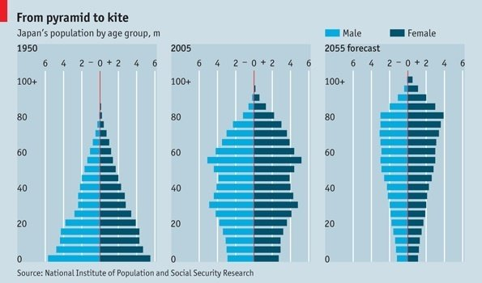
Japan
As of 2019, the Japan Times reports that more than 20 percent of Japan’s population is over 65 years old, making Japan the country with the highest percentage of people over 65. Moreover, by 2030, studies predict that one in every three people will be over 65 while one in every five people will be over 75. The aging of Japan over time is demonstrated in the chart on the left. Evidently, the aging population is an urgent issue that Japan faces, and the predicted impacts of an aging population on its economy are weighty. The IMF estimates that Japan’s average annual GDP growth could be damped due to its aging population by 1 percentage point over the next three decades. Moreover, as people over 65 retire with an insufficient working population to replace the retirees, the trend of a shrinking labor force is beginning to manifest. In Japan, there has also been an increasing need to care for the elderly. Compulsory taxes have steadily climbed as elderly care bills are implemented, and these taxes have often consumed workers’ rising incomes as well. The Abe administration has taken many steps to alleviate the impacts of its aging population, which are discussed in more details in the next section.
Figure #4: The three diagrams show Japan’s population distribution according to age groups over time.
Germany
Germany is another country facing a rapidly aging population. With the largest population among countries in the European Union as well as low fertility and death rates, the Department of Economic and Social affairs at the United Nations notes that in 2017, more than 28% of the German population was over 60 and estimates that by 2050, that number will reach 37.6%. Hence, Germany is one of the top three countries in terms of oldest average age and share of population over 65. As a result, Germany has sought to address this issue in multiple ways, including immigration.
Italy
An aging population is a major issue in Italy. Fertility has remained stagnant in Italy, with about 25% of women not having children. In addition, the death rate is found to be twice the fertility rate, meaning the overall population is shrinking. Furthermore, Italy’s share of the elderly population to the rest of its population (%) is the second largest in the world, and the number is projected to increase. Italy’s median age is 46 years old. During the coronavirus pandemic, experts hypothesize that Italy’s aging population may be correlated to the coronavirus’ deadly impacts in Italy. On the other hand, the its government has acted as well, for instance, through providing incentives for child birth and encouraging immigration.
Open-Ended Working Group on Aging (OEWGA)
Although there are many regional organizations, both governmental and non-governmental, one of the United Nations affiliated organizations is the Open-Ended Working Group on Aging, which was established by the General Assembly in 2010. The group focuses on the current international framework for the elderly; they also seek to identify gaps and unconsidered areas as well as how to best address them. Additionally, the group considers instruments and measures on an international level that can address the gaps observed. The group holds annual conferences on aging, though the eleventh session was postponed this year due to the coronavirus. This organization is a part of United Nations Department for Economic and Social Affairs.
Previous Attempts to Solve the Issue
Encouraging child birth
To address low fertility rate that leads to an aging population, countries have implemented policies that incentivize child birth. In Italy, the government plans to allow longer and smoother maternity leaves, allocate more money toward nursing centers, and provide financial incentives to boost its low fertility rate this year. Italy’s policies are centered around alleviating potential financial and emotional stress during pregnancy and early motherhood as well as, in general, incentivizing child birth. Similar previous policies have been effective. Referring again to the case of Italy, one region in Italy called Bolzano over the past years increased its fertility rate substantially, especially in comparison to the rest of Italy, by providing double the national financial aid to mothers in need. Similar strategies have been used in Japan and many other countries in attempt to improve mother’s experience with pregnancy and child care. However, the extension of these programs, especially to more disadvantaged communities, is important. Moreover, another important consideration is whether a country can afford such policies on a large scope. Some developing countries facing aging populations are slower to adopt policies like such due to the economic costs.
Superannuation and Pensions
Considering the cost of retirement, which includes expenses such as healthcare, it is important for the elderly to save during their working life so that they can live off their saving during retirement. Hence, many countries have policies regarding contributing to one’s superannuation to minimize the population that is dependent on state pensions. For example, Australia imposes a mandatory saving system where 9% of every citizen’s salary is automatically paid into their superannuation account along with a basic retirement income that 75% of Australian citizens qualify for. Apart from occupational schemes linked to salaries, Netherlands and Demark, the highest scorers on the global pension index in 2019, have occupational schemes linked to salaries that vary depending on the sector. These approaches to resolving the economic burden of the elderly are successful in alleviating future costs but may not be necessary or feasible depending on the characteristics of individual nations.
Increasing Retirement age
Another approach taken by countries is to raise the retirement age. Some countries, such as Australia, Canada, Spain, Germany, and France are increasing the retirement age and the age which people become eligible for state pensions. The motivation behind such policies is to keep people in the workforce for a longer period and to minimize the number of people dependent on state pensions and healthcare systems at one time. Although on a macro-scale, this approach may seem to be beneficial towards the economy as a whole, there is more debate regarding this solution on an individual level. For instance, low-income, low skilled workers that perform heavy manual labor jobs may find it difficult to continue working beyond 60 years old. Moreover, the life expectancy of low-income communities has not increased nearly as much as the average life expectancy. This means that low-income communities, despite paying taxes to fund many of the governmental pension programs, would be receiving less benefits because there is less time between the time they retire and the time they pass away.
Promoting Immigration
While many parts of Europe and some parts of Asia along with the United States are rapidly aging, the United States has a much brighter outlook than many of these other nations for one primary reason– immigrants. In the United States, the influx of immigrants maintains the size of the workforce. Moreover, since immigrants, for example, from Mexico tend to have more children than the average American household, immigrants also increase the overall fertility rate in the United States. A similar approach of encouraging immigration is also utilized by several other nations, for example, Germany. In Germany, the government actively welcomed waves of immigrants. However, a prominent problem faced by governments, like Germany, that seek immigration is that it has often been difficult for the immigrants to become productive members of the local workforce. For instance, from 2015 to 2016, a substantial influx of immigrants into Germany, consisted largely of refugees, took on average 5 years to be completely integrated into the workforce. In addition, it is important to note that whether immigrants are on net beneficial, considering their potential impact of alleviating an aging population, is heavily debated.
Relevant UN Treaties and Events
Year | Event
1882 | World Assembly on Aging adopted Vienna International Plan of Aging
1990 | Resolution 45/106: General Assembly designated 1 October to be the International Day of Old Persons
1991 | Resolution 46/106: General Assembly adopted United Nations Principle for Old Persons
1992 | International Conference on Aging adopted the Proclamation on Aging and declared 1999 as the International Year of Older Persons
2002 | Second World Assembly on Aging adopted the Madrid International Plan of Action on Aging

Possible Solutions
It is essential to note General Assembly resolutions are non-binding and not a form of legislation. Thus, solutions regarding pension reform, migration, and child birth should be considered from an international perspective rather than setting a universal retirement age, for example.
First, delegates may consider solutions on the topic of encouraging child births. Policies encouraging child births can potentially alleviate the burdens of an aging population since they may result in higher fertility rates and hence, counter shrinking working-age populations. Solutions can aim to facilitate pregnancy and early motherhood, especially for disadvantaged mothers. Specifically, solutions can target the challenging financial and emotional aspects of pregnancy and early motherhood that currently prevent mothers from having children. Another important aspect to consider are the cultural implications of such policies as these policies may not align with some cultural beliefs.
Second, although the General Assembly does not have the power to enforce a universal mandatory saving plan, for example, building on or creating organizations that help advise workers about saving could be immensely helpful when the workers reach retirement. In the United Kingdom, a 2013 HSBC Bank survey concludes that those that received advising saved almost twice as much as those who did not receive advising, though it is important to note confounding factors such as those with higher income being more likely to receive advising. Regardless, with proper saving systems enacted, it is likely that less people would be dependent on government relief as they age.
Another aspect delegates can consider is migration. Migration is a tricky solution considering how it has caused a shrinking workforce in some countries. At the same time, it is a solution that has potential– it can allow working-age people in countries with less resources and less threat of an aging population to find fruitful economic opportunities while the host country can minimize the impacts of its aging population. Carefully navigating and attempting to strike a balance between the harmful and helpful of solutions regarding migration is critical. Solutions regarding integrating workers into the workforce seamlessly can also be considered, though delegates should keep in mind that such solutions should not stray too far away from the issue at hand.
On the other hand, delegates can consider solutions regarding pension reform to alleviate the socioeconomic burden of the elderly. In terms of retirement age, solutions about raising the retirement age smoothly is critical, especially for low-resource communities. Such policies can also alleviate eventual healthcare costs resulting from people, especially those involved in manual labor, working longer. In the realm of healthcare for the elderly, the focus can be on providing support for disproportionately disadvantaged elderly populations. Because a strained healthcare system would most likely affect the disadvantaged communities first, solutions attempting to alleviate the pressure for these disadvantaged communities is critical. In addition, it is vital to address the root of these problems. For example, since a healthier cohort would burden healthcare systems less as they age, policies directed at improving the general health of the current working population may also alleviate future difficulties.

Bibliography
Agnew, Julie. “Briefs.” Center for Retirement Research, crr.bc.edu/briefs/australia%E2%80%99s-retirement-system-strengths-weaknesses-and-reforms-2/.
Angele Storey; Ngaire Coombs; Shayla Leib. Living Longer: Caring in Later Working Life. 15 Mar. 2019, www.ons.gov.uk/peoplepopulationandcommunity/birthsdeathsandmarriages/ageing/articles/livinglongerhowourpopulationischangingandwhyitmatters/2019-03-15.
“America’s Age Profile Told through Population Pyramids.” United States Census Bureau, 2016, www.census.gov/newsroom/blogs/random-samplings/2016/06/americas-age-profile-told-through-population-pyramids.html.
Boccia, Romina. “Pro-Con: Should the Retirement Age Go up?” The Heritage Foundation, www.heritage.org/social-security/commentary/pro-con-should-the-retirement-age-go.
“Countries With the Oldest Populations in the World.” Population Reference Bureau, 16 Mar. 2019, www.prb.org/countries-with-the-oldest-populations/.
Davies, Justine Ina, and Maria Odland. Global Health Is Changing as People in Low Income Countries Live Longer but with More Ailments. 25 May 2020, qz.com/africa/1860255/people-in-poor-countries-are-living-longer-but-with-more-diseases/.
Diplomat, Simran Walia for The. How Does Japan's Aging Society Affect Its Economy?13 Nov. 2019, thediplomat.com/2019/11/how-does-japans-aging-society-affect-its-economy/.
Folger, Jean. “Top Pension Systems in the World.” Investopedia, Investopedia, 27 Mar. 2020, www.investopedia.com/articles/personal-finance/042914/top-pension-systems-world.asp.
Gallagher, J. (2018, November 09). 'Remarkable' decline in fertility rates. Retrieved July 23, 2020, from https://www.bbc.com/news/health-46118103
“Glossary of Demographic Terms.” Population Reference Bureau, www.prb.org/glossary/.
Ingraham, Christopher. “Analysis | 'Covid Baby Bust' Could Lead to Half a Million Fewer Births next Year.” The Washington Post, WP Company, 17 June 2020, www.washingtonpost.com/business/2020/06/17/covid-baby-bust-could-lead-half-million-fewer-births-next-year/.
Khazan, Olga. “Immigration Is the Only Reason the U.S. Doesn't Have an Aging Crisis.” The Atlantic, Atlantic Media Company, 30 Jan. 2014, www.theatlantic.com/health/archive/2014/01/immigration-is-the-only-reason-the-us-doesnt-have-an-aging-crisis/283474/.
Life Expectancy around the World Has Increased Steadily for Nearly 200 Years.www.nature.com/scitable/content/life-expectancy-around-the-world-has-increased-19786/.
Life Expectancy. 15 May 2018, www.who.int/gho/mortality_burden_disease/life_tables/situation_trends_text/en/.
Loginov, Jen. The Aging of America: A Changing Picture of Work and Retirement. 25 Apr. 2018, cri.georgetown.edu/the-aging-of-america-a-changing-picture-of-work-and-retirement/.
Lee, Ronald. Cost of Aging. www.imf.org/external/pubs/ft/fandd/2017/03/lee.htm.
Perper, Rosie. “Italy, Now under Lockdown, Has Been Hit Hard by the Coronavirus Outbreak. It Also Has One of the World's Oldest Populations with 60% over Age 40.” Business Insider, Business Insider, 10 Mar. 2020, www.businessinsider.com/italy-coronavirus-old-population-cases-death-rate-2020-3 .
“Policy Overview: Health and Aging Policy Fellows Program: Shaping a Healthy and Productive Future for Older Americans.” Health and Aging Policy Fellows Program, 4 Sept. 2018, www.healthandagingpolicy.org/health-and-aging-policy/policy-overview/.
Meola, Andrew. “The Aging Population in the US Is Causing Problems for Our Healthcare Costs.” Business Insider, Business Insider, 18 July 2019, www.businessinsider.com/aging-population-healthcare.
Smith, Oliver. “Mapped: The World's Most Elderly (and Youngest) Countries.” The Telegraph, Telegraph Media Group, 12 July 2016, www.telegraph.co.uk/travel/maps-and-graphics/oldest-and-youngest-countries-populations/.
Takeo, Yuko, and Hannah Dormido. “Japan's Population Problem Is Straining Its Economy. The World Is Watching for a Solution.” Bloomberg.com, Bloomberg, 19 Sept. 2019, www.bloomberg.com/graphics/2019-japan-economy-aging-population/.
“United Nations Open-Ended Working Group on Strengthening the Protection of the Human Rights of Older Persons.” United Nations, United Nations, social.un.org/ageing-working-group/desa-ageing.shtml.
Van Bavel, Jan, and David S. Reher. “The Baby Boom and Its Causes: What We Know and What We Need to Know.” Population and Development Review, vol. 39, no. 2, 2013, pp. 257–288. JSTOR, www.jstor.org/stable/41857595. Accessed 1 July 2020.
Wagstyl, Stefan. “Germany's Demographic Dilemma.” Financial Times, Financial Times, 16 Nov. 2016, www.ft.com/content/a4d8316e-8566-11e6-8897-2359a58ac7a5.

